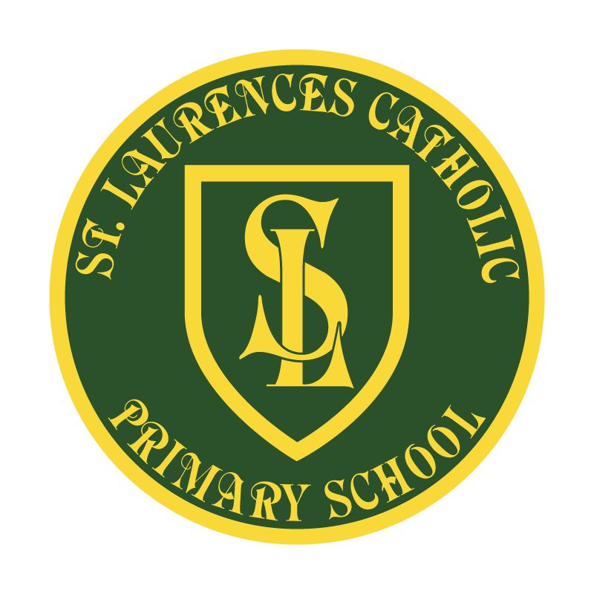

St Laurence’s Catholic Primary School

Policy Statement
For
Spiritual and Moral Development Policy
This policy was adopted on | October 2022
By name | Mr John Holmes
Position | Chair of Governors
Signature | J Holmes

Our Mission Statement
We aim to celebrate our partnership with the families we serve and the community we live in.
We aim to provide an education that enables each child to reach their full potential.
Our aim is the creation of an atmosphere where all are valued, gifts and talents are celebrated and the gospel values of love, respect and justice are at the heart of all we do.

Our Vision
Everyone feels a sense of belonging,
Has the opportunity to shine,
To enjoy their teaching and learning
But most of all – to dream big!

Spiritual and Moral Development Policy

‘Developing our gifts and talents for the good of all.’

Our school Mission Statement and the aims enshrined within it show very clearly our commitment to provide our children with the support, guidance and opportunities to develop both spiritually and morally throughout their time within our school.

Aim:
St Laurence’s Catholic Primary School offers opportunities for our children to develop spiritually, morally, intellectually, emotionally and physically, towards their full and unique potential, in the sight of God.

This policy links to the following:
*Behaviour Policy
*Schools Mission Statement
*RE Policy and handbook
*Come and See programme

Introduction:
The promotion of pupils’ spiritual, moral, social and cultural development provides the ‘why’ of education: it is an essential ingredient of a successful Catholic school.

The statutory requirement that schools should encourage pupils’ Spiritual, Moral, Social and Cultural development was first included in the Education Reform Act 1988. The Act began as follows:

‘The curriculum for a maintained school (must be) a balanced and broadly based curriculum which:
a) promotes the spiritual, moral, cultural, mental and physical development of pupils at the school and in society, and
b) prepares such pupils for the opportunities, responsibilities and experiences of adult life.’

The Act clearly recognised that there is more to life than achieving high standards in academic subjects. The task was described as:
‘…the training of good human beings, purposeful and wise, themselves with a vision of what it is to be human and the kind of society that makes that possible’.

Spiritual, Moral, Social and Cultural Development is at the heart of what education is all about – helping pupils grow and develop as people.

Opportunities for pupils to experience and learn about Spiritual and Moral Development in our school
It is an expectation at this school that all staff, in all subjects, can and should, make a contribution to the Spiritual, Moral, Social and Cultural Development of pupils through the taught curriculum and through the use of appropriate teaching and learning strategies e.g. discussion, reflection, pupil participation, circle time etc.

Definition of Spiritual Development:
Spiritual Development relates to the quest for individual identity and the search for meaning and purpose in our existence. It is associated with a dimension of life, which is not necessarily experienced through physical senses, but has much to do with feelings and emotions, and attitudes and beliefs and is, accessible to everyone. All areas of the curriculum should contribute to pupils’ spiritual development.

As a Catholic school, we place special emphasis on the specific teaching and beliefs of the Catholic faith, both within the daily life of the school and through the challenge of curriculum.

Spiritual development is a process of growth. God comes to meet us through people, places and events, and it is the individual’s response to these encounters with God that shape and determine our spiritual nature and growth.

We are all made in God’s image and likeness; therefore every meeting with someone is an encounter with God and an opportunity for spiritual growth. It is this recognising and responding to God that is a key element in spiritual development.

Spiritual Development in our school
Spiritual education helps pupils to acquire insights into their personal existence which are of enduring worth. It is characterised by reflection, the attribution of meaning to experience, valuing a non-material dimension to life and intimations of an enduring reality.

“Spiritual’ means ‘of the spirit’. Spiritual development, therefore, concerns the development of the essence of a unique child.

In the Catholic tradition, spiritual development is related to growth in faith. However Spiritual is not synonymous with ‘religious’; all areas of the curriculum may contribute to pupils’ spiritual development.

Spiritual development is concerned with how an individual acquires personal beliefs and values, especially on questions which are “at the heart and root of existence.” It is therefore also about what a school provides – through its curriculum, through Prayer and Liturgy, through its ethos and climate – to help individuals to make sense of these questions and about what it does to help form pupils’ response to life, to their various experiences and even to questions about the universe. Spiritual is very much at the heart of life within our school.

At St Laurence’s we:

• provide the children with many opportunities during personal prayer and reflection, assemblies, Collective Acts of Prayer and Liturgy and the celebration of Masses and RE lessons to encourage children to reflect upon their own faith and encourage them to respect other faiths and the religious beliefs of others;

• encourage and support our children to put Gospel message of love and forgiveness into practice in their everyday lives and put Christ at the centre. This is also recognised in our Class Codes of Conduct. The children are taught that forgiveness is very important and that they are given the chance to make a fresh start after they have taken the consequences of any action or wrong doing;

• believe and promote the understanding that we are all special and unique in God’s eyes so we encourage self- worth and self- esteem by showing respect for each other;

• help the children to understand and manage their emotions and feelings and if necessary provide additional support through pastoral support and reflection;

• encourage the children to use God’s given gifts and talents for the benefit of others especially those less fortunate than ourselves;

• encourage the children to care for God’s creation and learn to appreciate and develop a fascination and curiosity about the world in which we live;

• provide opportunities throughout the day to come together in various ways to pray;

• support the spiritual growth of families

Definition of Moral Development:
Moral development has at its foundation, values. Values are the principles that inform judgements as to what is morally good or bad. Attitudes to other people and their actions is the key part in our decision to how we respect these others and their actions.

Values both inform and influence behaviour and therefore are fundamentally important both to school life and wider society.

Moral education helps pupils to acquire knowledge, understanding, intentions, attitudes and behaviours in relation to what is right or wrong. The word “moral” is concerned with the fundamental judgements and precepts about how we should behave and act and the reasons for such behaviour; it includes intention, motive and attitude.

Moral Development:
Moral education is part of everyday daily life and is constantly reinforced by how we as adults act as role models for our children. The gospel values based upon “The Beatitudes,” is at the heart of all that we do.

Gospel values “are guarantees of peace and collaboration among citizens in the shared commitment to serving the common good,” Pope John Paul II (2004).

Class Code of Conducts are developed in partnership with the children across the school. The code of acceptable behaviour is consistently adhered to and implemented. A whole school, consistent approach to behaviour is very important. Our children need to feel that they are being treated fairly by all staff and children.

All adults in the school are aware that children learn by example. All adults therefore aim to demonstrate respect in their relationships with each other and with the children in their care. This is demonstrated informally through daily interactions with colleagues and pupils.

The School Council recognises the value of pupils’ opinions and good behaviour is rewarded.

Moral education helps pupils to acquire knowledge, understanding, intentions, attitudes and behaviour in relation to what is right or wrong.
Moral development is concerned with understanding the difference between right and wrong and with committing ourselves to doing what is right because we want to do right.

People who are developing morally listen to their conscience, the inner sense informed by their upbringing, experiences, faith and religious beliefs and are prompted to do what is right out of love for others, respect for ourselves and regard for the world in which we live.

At St Laurence’s we:

• encourage and support positive relationship between all members of our school community. Our school mission statement reflects this;

• good behaviour is acknowledged and rewarded on a daily basis in class and at playtimes through a class system of rewards;

• expect high standards of behaviour and help the children to understand that there are consequences for their actions. We have a culture of forgiveness and consideration for others and encourage all pupils to take responsibility for their actions;

• encourage the children to take on roles of responsibility throughout the whole school to support others e.g. School Council, Change4Life or Year 6 Buddies;

• celebrate achievements weekly, half-termly and at end of year award events to recognise how children have enriched the school life;

• teach the children about right and wrong and to tell the truth and respect others and understand the rules within school and the wider community

Moral Development in our school is promoted throughout the whole curriculum. Pupils are provided with opportunities and encouragement to:
*think critically – understanding the difference between fact and opinion, informing themselves about key social, political, economic and legal issues, evaluating evidence for and against different sides in a debate and making informed decision about their own positions (English, PSHE, History)

*acquire and develop appropriate values and attitudes – those that enhance willingness to participate and help others to participate where necessary

*discuss and debate – exercise reason in debate and develop an understanding of the powerful influences on public opinion represented by the political parties, the church and other faith communities, the media and other organisations.

*Participate in democratic processes such as school councils, committees and discussion groups.

*Participate in the life of the wider community through charity work, taking on positions of responsibility and sharing their talents.

REVIEW OF POLICY
The effectiveness of this policy will be reviewed annually by the Senior Leadership Team and every three years by the Governing Body. If changes are made to the policy, the Governing Body will ratify amendments.
Signed: J Holmes Designation: Chair of Governors
Date: October 2022

