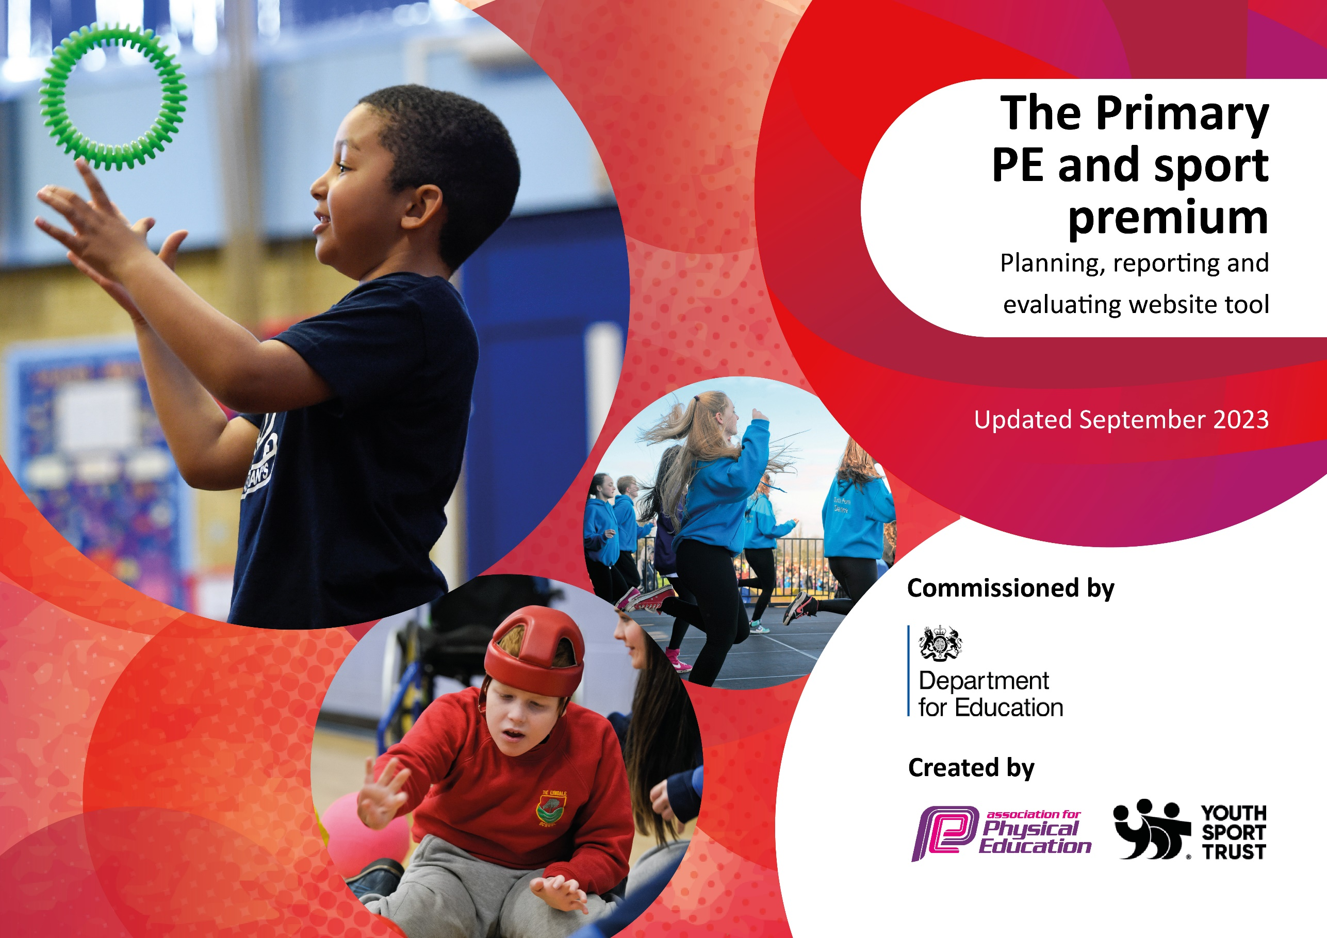
St Laurence Catholic
Primary School
2023-2024

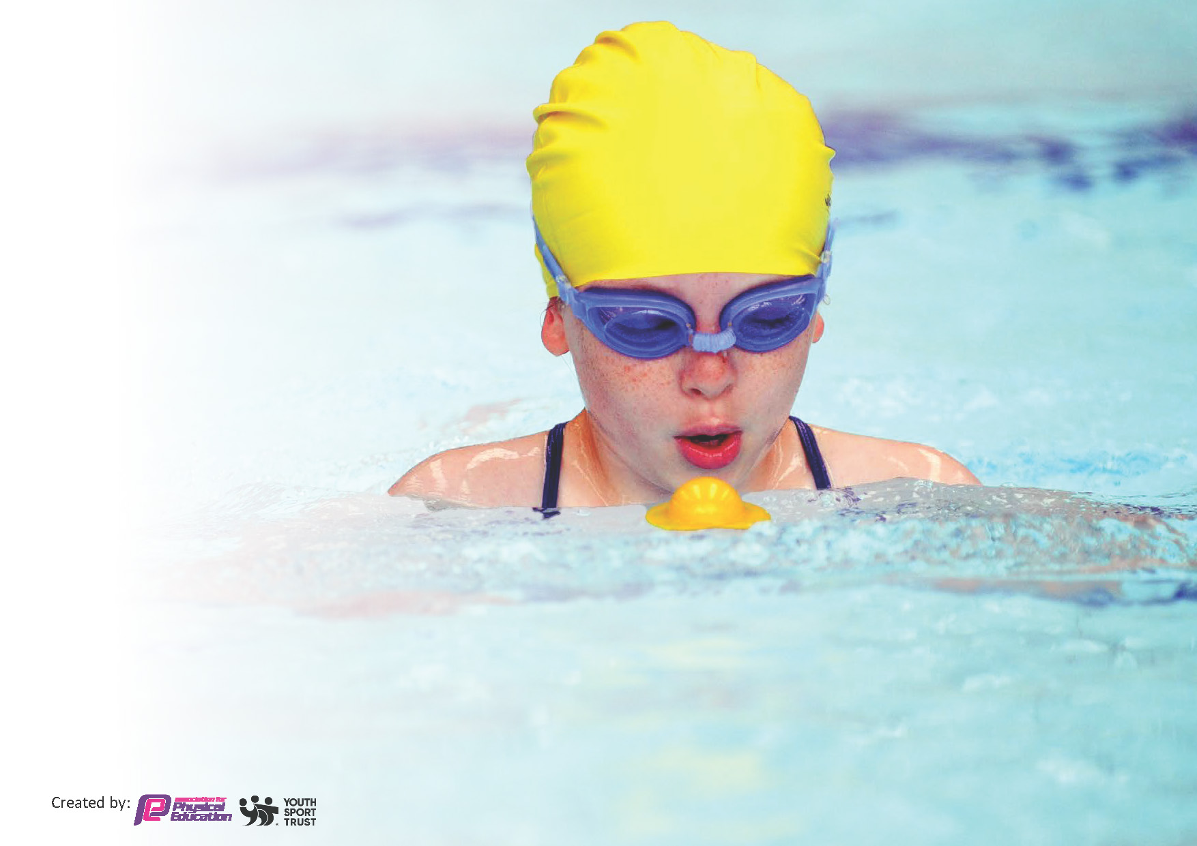
This template can be used for multiple purposes:
by:
- It enables schools to effectively plan their use of the Primary PE and sport premium
- It helps schools to meet the requirements (as set out in guidance) to publish information on their Primary PE and sport premium
- It will be an effective document to support Ofsted inspections enabling schools to evidence progress in Physical Education (PE) and evidence swimming attainment, which forms part of the PE National Curriculum. We would recommend schools consider
the Intent, Implementation and Impact of any spend, as examined within the Education Inspection Framework.

It is important that your grant is used effectively and based on school need.

Schools must use the funding to make additional and sustainable
improvements to the quality of the PE, School Sport and Physical Activity (PESSPA)
they offer. This means that you should use the Primary PE and sport premium to:

- Build capacity and capability within the school to ensure that improvements made now will benefit pupils joining the school in future years
- Develop or add to the PESSPA activities that your school already offers.

The Primary PE and sport premium should not be used to fund capital spend projects; the school’s core budget should fund these. Further detail on capital expenditure can be found in the updated Primary PE and sport premium guidance.

The Primary PE and sport premium guidance, outlines 5 key priorities that funding should be used towards. It is not

necessary that spending has to meet all the key priorities, you should select the priorities that you aim to use any funding towards.

Although completing this template is not a requirement for schools, schools are required to publish details of how they spend this funding. Schools must also outline what the impact this funding has had on pupils’ PE and sport participation and attainment and how any spending will be sustainable in the future. All funding must be spent by 31st July 2024.

The Department for Education has worked closely with the Association for Physical Education (afPE) and the Youth Sport Trust (YST) to develop this template and encourages schools to use it. This template is an effective way of meeting the reporting requirements of the Primary PE and sport premium.
Review of last year’s spend and key achievements (2022/2023)

We recommend you start by reflecting on the impact of current provision and reviewing your previous spend.

Activity/Action | Impact | Comments
Implementation of the Daily Mile at least 3 times a week.  In-school physical activity programme for KS1 and KS2 children and parents through Family Fitness once a week.  Improved quality and variety of PE resources and equipment within school.  All of our extracurricular activities are free and completed by staff within school.  Separate sports days were organized for KS1 and KS2 pupils, allowing children greater opportunities to participate. Separate sport days also ensures that events are suitable for the participating year groups.  The purchase of the colour run event promoted healthiness and happiness around the school bringing the whole community together to participate in the run.  The purchase of Scoot fit days in KS1 and KS2 was able to develop children’s notor skills through balancing and strengthening the core.  To encourage all pupils to partake in regular exercise. We also encouraged the children to partake in healthy eating program, which aided healthy lifestyles. | This had a massive impact on all who participated. Children were more active around school and therefore creating a healthier lifestyle for all children.  This has a positive impact on both physical and mental well -being of parents and children. In addition it builds further community link between school and families.  By doing this it enabled the children to complete a wider range of sporting activities within school. Children are more active during break times and lunch times.  The impact of this suggests extra- curricular activities are important in developing soft (especially social) skills as well as being associated with a range of other positive outcomes (e.g. achievement, attendance at school).  The children really enjoyed this day and it created positive attitudes towards health and well-being. It also enhanced communications with parents as they also participated within the day.  Children really enjoyed the colour run event and this had a massive impact on all of the children’s well – being and staff members within school and the recommended hour of physical education that week.  The children really enjoyed this event and are looking forward to doing it again next year. This activity had an enormous impact on the children’s gross motor skills.  By doing this the school received for the eighth year in a row the school games platinum certificate, which was presented to the school on completion of the competition calendar and PE tasks throughout the year. | Try to increase Daily Mile participation to at least 4 times a week in the near future if possible.  As it was a huge success we have been able to offer the family fitness sessions to the parents and children within the community once again this year.  Further discussions with the school council and lunchtime supervisors of what to purchase in the future.  Children really enjoyed this event and we are looking forward to purchasing and completing this event again in the next academic year.

Key priorities and Planning
This planning template will allow schools to accurately plan their spending.

Action – what are you planning to do | Who does this action impact? | Key indicator to meet | Impacts and how sustainability will be achieved? | Cost linked to the action
To use Everton in the Community for a further year. (ETIC)  To purchase scoot fit days for children within KS 1 and KS2This will support children with their physical, fine and gross motor skills.  To continue to provide sports clubs that are not part of the curriculum for lower key stage 2, e.g. Quidditch, Indian Dance.  To continue to provide extra- curricular activities for all year groups in several skilled areas.  As a school we will continue to encourage all children to participate in competitive sport and any involvement in clubs outside of school is highlighted and celebrated. We have built up a strong relationships with several community based clubs outside of school.  Year 6 cohort are able to perform safe self-rescue in different water-based situations | Everton in the community PE coach supported staff and upskilled them in different sports and activities throughout the year. Children are more actively engaged with the EITC coaches in school.  By purchasing Scoot Fit we found out that it reduces stress on the bones and joints making movement easier, more comfortable and more sustainable than running. Scoot Fit can be regarded as a core activity helping develop and improve agility, balance, co-ordination, muscle strength and endurance greatly benefiting any other sporting activity. This had an enormous impact on the pupils developing their motor skills. In terms of the children’s fine motor skills, this has impacted on their writing skills in KS1 to enable the children have more strength within their hand muscles.  The children really enjoyed our Quidditch day event which was supplied through ENRICH and also the Dawali dance workshop which was provided by the West End Schools. By providing both workshops to the children had a massive impact on their health and well-being along with meeting the daily exercise needs. Quidditch provided our children with leadership skills, social gains, self-confidence, and pride, along with a positive sporting experience, all of which have been recognized in more mainstream sports.  The children have taken part in the following activities; Football, Basketball, Dance, Boxing, Dodgeball and Table-Tennis. The children have said that they really enjoy the different sessions provided by the staff. By taking part in all of the above activities, the children have gained a wealth of new PE skills and knowledge as well as gaining physical and mental stimulation. They have gained new friendships within different year groups as well gaining independence and team-building skills.  Our relationship with Quarry Green FC and Kirkby Town FC along with LMSOD and Shissasay Dance has become even stronger over the years therefore they will continue to use our school field and sports hall for a number of events throughout the year. Even more children from the school this year are beginning to participate in a wider range of sports outside of school hours which is helping grow confidence and the health and well -being of every child who attends. Pupils from all year groups now compete at a local level with teams progressing to competition finals in all fields mentioned.  During the autumn term, Swimming teachers from Knowsley Leisure Centre as well as the PE Lead/Year 6 teacher have supported the children to be able to perform a range of strokes as well as perform safe self-rescue techniques. This has impacted our children’s confidence to be able to use this swimming skill for the future and to hopefully develop their love of swimming to continue this in the community. This will benefit children and families when going on holiday as well as having confidence to be able to swim effectively. | Key indicator 3: To increase confidence, knowledge and skills of all teaching staff in teaching PE and school sport.  Key indicator 4: Broader experience of a range of sports and activities offered to all pupils  Key indicator 2 and Key indicator 4 -The engagement of all pupils in regular physical activity – the Chief Medical Officer guidelines recommend that all children and young people aged 5 to 18 engage in at least 60 minutes of physical activity per day, of which 30 minutes should be in school.  Key indicator 4 –broader experience of a range of sports and activities offered to all pupils.  Key indicator 5: Increased participation in competitive sport.  Key indicator 4 –broader experience of a range of sports and activities offered to all pupils. | Everton sports coach to continue to work upskilling teachers within years 2/3 this year. This has had a massive impact on the teachers as it will build confidence, knowledge and skill base throughout the year. This will be monitored by PE lead through Planning, observations, assessment and consultation with the EFC coach.  This activity had a tremendous impact on the children. This included, fine and gross motor improvement. In general PE lessons, children are more able to balance and have a much better base in co-ordination skills. Handwriting has improved after speaking with KS1 staff. As well as all of this, the children have really enjoyed taking part in the scoot fit sessions. Therefore we are looking to purchase it again in 24/25.  More pupils meeting their daily physical activity goal, more pupils encouraged to take part in PE and Sport Activities.  By taking part in a range of extra-curricular activities, more pupils within the school were meeting their daily physical activity goal. During pupil voice sessions with the PE lead, children have asked if we could increase the amount of certain sessions per week in a variety of different areas.  Our next steps are to further promote these links with our local clubs and move further afield with other sporting communities, which will include Beth Tweedle gymnastics school and Knowsley Vale and Towerhill Boxing  Our Year 6 children are focused on during their swimming sessions to meet standards in swimming, This is also followed up in the summer term to have ‘catch-up sessions’ with trained swimming instructors from Knowsley. | £1000 per term  (£6000 per year)  £1170  £1300 for both workshops  £250  (£675 put aside for summer catch up lessons.)

Key achievements 2023-2024
This template will be completed at the end of the academic year and will showcase the key achievements schools have made with their Primary PE and sport premium spending.

Activity/Action | Impact | Comments
*To be completed in July.

Swimming Data
Meeting National Curriculum requirements for swimming and water safety.
Priority should always be given to ensuring that pupils can perform safe self-rescue even if they do not fully meet the first two requirements of the National Curriculum programme of study

Question | Stats: | Further context  Relative to local challenges
What percentage of your current Year 6 cohort can swim competently, confidently and proficiently over a distance of at least 25 metres? | 62% | 38% We had a number of pupils who missed swimming lessons during the term which means some pupils have never attended due to illness or attended fewer swimming lessons because of attendance issues.
What percentage of your current Year 6 cohort can use a range of strokes effectively [for example, front crawl, backstroke, and breaststroke]? | 70% | Feedback from swimming instructor along with swimming objectives proforma informed us that the year 6 cohort were using a range of strokes at the end of the sessions. The children who have not completed the range of strokes will attend swimming sessions in the summer term before leaving primary school.

What percentage of your current Year 6 cohort are able to perform safe self-rescue in different water-based situations? | 70% | The percentage of children who were able to perform a safe self- rescue is stated overleaf. The cohort performed this activity whilst being observed by the swimming instructor and class teacher. It was later signed off on the document given by the leisure centre.
If your schools swimming data is below national expectation, you can choose to use the Primary PE and sport premium to provide additional top-up sessions for those pupils that did not meet National Curriculum  requirements after the completion of core lessons. Have you done this? | Yes/No | We will look to send back those pupils who cannot swim competently, confidently and proficiently over a distance of at least 25 metres in distance using a range of strokes back to the local pool for top up lessons in the summer term.
Have you provided CPD to improve the knowledge and confidence of staff to be able to teach swimming and water safety? | Yes/No | Several teachers have now completed online swimming courses which has given them confidence in this area when attending our annual swimming lessons at our local leisure centre. We are looking to certify more staff members within school this year through ASA by using online courses. Additional to this, when staff members have attended or will attend Knowsley Leisure Centre with their cohort of children, they will have further CPD whilst watching and supporting the trained swimming instructors to deliver their sessions.

Signed off by:

Head Teacher: | Sarah Jane Carroll
Subject Leader or the individual responsible for the Primary PE and sport premium: | Barry Grant PE coordinator
Governor: | John Holmes (Chair of Governor)
Date: March 2024

