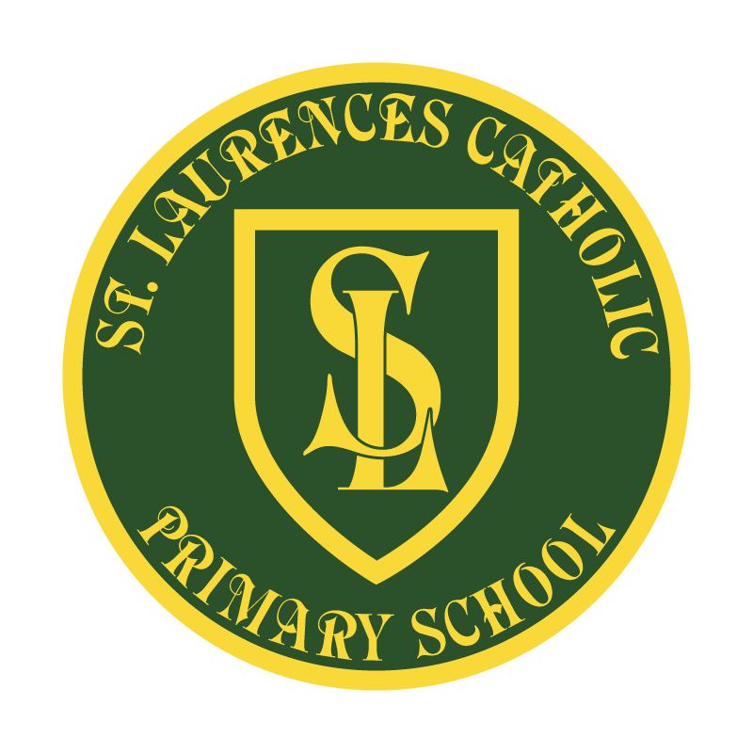

St Laurence’s Catholic Primary School
Policy Statement
For
SMSC

This policy was adopted: | September 2019
By name: | Mr John Holmes
Position: | Chair of Governors
Signature: | J. Holmes

Our Mission Statement
We aim to celebrate our partnership with the families we serve and the community we live in.
We aim to provide an education that enables each child to reach their full potential.
Our aim is the creation of an atmosphere where all are valued, gifts and talents are celebrated and the gospel values of love, respect and justice are at the heart of all we do.

Our Vision
Everyone feels a sense of belonging,
Has the opportunity to shine,
To enjoy their teaching and learning
But most of all – to dream big!
Social, Moral, Spiritual and Cultural (SMSC) Policy
At St. Laurence’s Catholic Primary School we recognise that the personal development of pupils, spiritually, morally, socially and culturally (SMSC) plays a significant part in their ability to learn and achieve. We therefore aim to provide an education that provides pupils with opportunities to explore and develop:
- their own values and beliefs
- spiritual awareness
- high standards of personal behaviour
- a positive, caring attitude towards other people
- an understanding of their social and cultural traditions
- an appreciation of the diversity and richness of the cultures

SMSC is a dimension of the whole school experience which makes the curriculum relevant, stimulating, creative and fun. It enriches each subject and the ethos of St. Laurence’s and is an essential ingredient of school success. The SMSC policy provides the school with the opportunity to meet our Public Sector Equality Duty (PSED) to:
- Eliminate unlawful discrimination, harassment and victimisation and other conduct prohibited by the Act.
- Advance equality of opportunity between people who share a protected characteristic and those who do not.
- Foster good relations between people who share a protected characteristic and those who do not.

Guidelines
All curriculum areas have a contribution to make to the child’s spiritual, moral, social and cultural development and opportunities for this will be planned in each area of the curriculum. All adults will model and promote expected behaviour, treating all people as unique and valuable individuals and showing respect for pupils and their families.
The school community will be a place where pupils can find acceptance for themselves as unique individuals and where forgiveness and the opportunity to start again is fundamental to the ethos of the school. Pupils should learn to differentiate between right and wrong in as far as their actions affect other people. They will be encouraged to value themselves and others.
Pupils should understand the need for rules and the need to abide by rules for the good of everyone. School and classroom rules should reflect, reiterate, promote and reward

acceptable behaviour and provide opportunities to celebrate pupils’ work and achievements.
All curriculum areas should seek to use illustrations and examples drawn from as wide a range of cultural contexts as possible. This will be reflected in teacher’s planning and purchasing decisions.

General Aims
- To ensure that everyone connected with the school is aware of our values and principles.
- To ensure a consistent approach to the delivery of SMSC issues through the curriculum and the general life of the school.
- To ensure that a pupil’s education is set within a context that is meaningful and appropriate to their age, aptitude and background.
- To ensure that pupils know what is expected of them and why.
- To give each pupil a range of opportunities to reflect upon and discuss their beliefs, feelings and responses to personal experience.
- To enable pupils to develop an understanding of their individual and group identity.
- To enable pupils to begin to develop an understanding of their social and cultural environment and an appreciation of the many cultures that now enrich our society.
- To give each pupil the opportunity to explore social and moral issues, and develop a sense of social and moral responsibility.
Spiritual Development
As a school we aim to provide learning opportunities that will enable pupils to:
- Sustain their self-esteem in their learning experiences.
- Develop their capacity for critical and independent thought.

- Foster their emotional life and express their feelings.
- Experience moments of stillness and reflection.
- Discuss their beliefs, feelings, values and responses to personal experiences.
- Form and maintain worthwhile and satisfying relationships.
- Reflect on, consider and celebrate the wonders and mysteries of life.

Moral Development
As a school we aim to provide learning opportunities that will enable pupils to:
- Recognise the unique value of each individual.
- Listen and respond appropriately to the views of others.
- Gain the confidence to cope with setbacks and learn from mistakes.
- Take initiative and act responsibly with consideration for others.
- Distinguish between right and wrong.
- Show respect for the environment.
- Make informed and independent judgements.

Social Development
As a school we aim to promote opportunities that will enable pupils to:
- Develop an understanding of their individual and group identity.
- Learn about service in the school and wider community.

Cultural Development
As a school we aim to promote opportunities that will enable pupils to:
- Recognise the value and richness of cultural diversity in Britain, and how these influence individuals and society.
- Develop an understanding of their social and cultural environment.

- Develop an understanding of Britain’s local, national, European, Commonwealth and global dimensions.

As a school we recognise the importance of these values because:
- People, staff and pupils achieve better when they feel valued.
- Our beliefs and values influence the way we behave and the community that we live in.
- Education is about the development of the whole person.

Teaching and Organisation
Development in SMSC will take place across all curriculum areas, within activities that encourage pupils to recognise the spiritual dimension of their learning, reflect on the significance of what they are learning, and to recognise any challenges that there may be to their own attitude and lifestyle. Teachers will inspire pupils through the enthusiasm for and modelling of learning. Teachers at St. Laurence’s will use creative strategies and challenging questions to engage pupils in their learning and relate it to their own experiences.
All curriculum areas should seek illustrations and examples drawn from as wide a range of cultural contexts as possible.
Class discussions, SMSC Lessons, assemblies and circle time will give pupils opportunities to:
- Talk about personal experiences and feelings.
- Express and clarify their own ideas and beliefs.
- Speak about difficult events, e.g. bullying, death etc.
- Share thoughts and feelings with other people.
- Explore relationships with friends/family/others.

- Consider others needs and behaviour.
- Show empathy.
- Develop self-esteem and a respect for others.
- Develop a sense of belonging.
- Develop the skills and attitudes that enable pupils to develop socially, morally, spiritually and culturally – e.g. empathy, respect, open mindedness, sensitivity, critical awareness.

Many curriculum areas provide opportunities to:
- Listen and talk to each other.
- Learn an awareness of treating all as equals, and accepting people who are physically or mentally different.
- Agree and disagree.
- Take turns and share equipment.
- Work co-operatively and collaboratively.

Extra-Curricular Activities
Personal development is also enriched through a wide range of extra-curricular activities (Sport, Music and Choir, Creative Clubs) which provide opportunities for SMSC and for inspiring pupils to broaden their experience and horizons.

Links with the wider community
- Visitors are welcomed into school.
- The development of a strong home-school link is regarded as very important, enabling parents, teachers and the wider community to work in an effective partnership to make sure that we give our pupils the best possible environment in which to grow, flourish and learn.

- Mini Vinnies – Children will work with Miss Branegan to support the wider community through their faith.

- Pupils will be taught to appreciate their local environment and to develop a sense of responsibility and belonging to it.

REVIEW OF POLICY
The effectiveness of this policy will be reviewed annually by the Senior Leadership Team and every three years by the Governing Body. If changes are made to the policy, the Governing Body will ratify amendments.
This policy was reviewed: September 2019
Signed: J.Holmes
Designation: Chair of Governors
Date: 12.9.17

