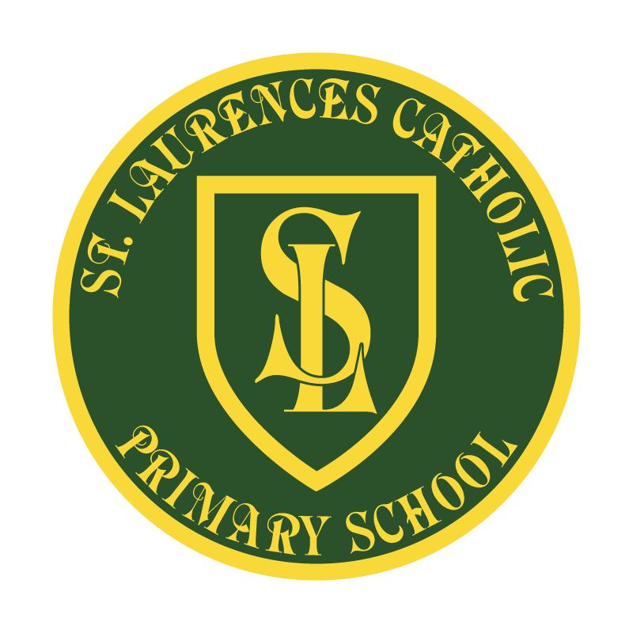

St Laurence’s Catholic Primary School

Policy Statement

For

PRESENTATION & MARKING

This policy was adopted on | September 2021
By name | Mr J Holmes
Position | Chair of Governors
Signature | On behalf of  St Laurence’s Primary School  ANNUAL REVIEW

Our Mission Statement
We aim to celebrate our partnership with the families we serve and the community we live in.
We aim to provide an education that enables each child to reach their full potential.
Our aim is the creation of an atmosphere where all are valued, gifts and talents are celebrated and the gospel values of love, respect and justice are at the heart of all we do.

Our Vision
Everyone feels a sense of belonging,
Has the opportunity to shine,
To enjoy their teaching and learning
But most of all – to dream big!

ST LAURENCE’S CATHOLIC PRIMARY SCHOOL

PRESENTATION AND MARKING POLICY

PRESENTATION

EYFS

- Weekend news book is used for children to write in after a weekend of activities. Examples of writing are put into here.
- Tapestry is also used as a communication home to parents and is presented on- line through a portal.

English and other books:
Y1
- All work to be dated with clear learning objective shown.
- No felt tips to be used in any books.
- Date and title to be underlined and left aligned.
- Pre made date and titles for younger children should adhere to above.

Yr2-6
- Use of DUMTUMS throughout all books.
- Date
Underline
Miss a line
Title
Underline
Miss a line
Start
- Reflections back to the teacher, and errors corrected, to be completed in purple pen or pencil.

Maths books:
- Short date to be used in Maths books.
- Codes to be used for learning objectives in Maths, these link to NC.
- All maths work in pencil.
- Corrections to be completed in pencil.
- Date to appear in Roman Numerals in Years 4, 5 and 6.
- No felt tips to be used in any books

Any sheets, worksheets, pictures etc. that are stuck into books MUST be trimmed beforehand and always stuck in neatly. These must be kept to a minimum, and not overused.

MARKING
General rules:

- All marking in green pen.
- All marking to be grammatically correct and punctuated correctly.
- All marking should model the school’s handwriting expectations.
- Teacher will acknowledge whether the child has met learning objective by marking to the right of this: M (met) NM (not met) or PM partially met. This will be circled to stand out.
- An arrow will appear underneath the children’s work to provide a next step:
- At least once a week in Maths and English.
- For all other subjects (besides Religion) a next step will be given to one group per week (groups meaning: ALL WB, WT, WA and W+).
- A positive sticker or stamp will also be used to recognise the children’s efforts on a regular basis to acknowledge the good work a child has completed.
- If staff feel it is appropriate they may write a short, succinct comment. (Please note this is not mandatory)
- Any exemplary work may be sent to the Subject or Key Stage Lead, Deputy Headteacher or Headteacher for praise.
- Marking to be completed with the children to give instant feedback where possible.

EYFS
- Verbal Feedback throughout all learning activities.
- Feedback will be given via Tapestry – our online Learning Journal.

Maths (Years 1 – 6)
- All correct work to be marked with a tick.
- Incorrect answers to marked with a dot – and corrected in pencil.
- Incorrect answers must not be erased.
- Corrected work to be completed by children in pencil.

Years 2 – 6
The following codes to be written in the margin to develop writing skills, in all subjects except Maths and R.E.
G – Grammar error (to include tense errors, incorrect sentence construction)
P – Punctuation errors (Incorrect or lack of capitalisation, missing punctuation, incorrect use of punctuation etc)
S - Spelling error
/ - New paragraph

Religious Education
ALL Religion work needs to have a positive comment beneath the children’s work and a next step whenever possible.
Comments must use driver words: Recognise, Talk About, Describe, Ask, Give Reasons, Make Links, Show Understanding, Engage and Respond, Identify and Explain, Explain.
Annotate if the objective has been met as above.

Extended Writing
Extended writing will take place once a week through all subjects.
Mark according to above.
All extended writes will have a comment, sticker or stamp to acknowledge efforts.
Assessed pieces (one per half term) will be moderated using moderation criteria (one per child) to identify coverage and gaps in knowledge. This also aids teacher judgements for assessment purposes.

Year 2 – 6: elements identified from the relevant year group will be highlighted in green.

REVIEW OF POLICY
The effectiveness of this policy will be reviewed annually by the Senior Leadership Team and every three years by the Governing Body. If changes are made to the policy, the Governing Body will ratify amendments.

This policy was reviewed: September 2021

Signed: Mr J Holmes on behalf of the governing body

Designation: Chair of Governors

Date: 16th September 2021

