Support for children that may have lost a loved one during the Coronavirus outbreak.
These resources have been put together from a variety of sources to support children and families during this difficult time.
In the coming weeks, more children and young people will face bereavement through the effects of the coronavirus (COVID-19) or for other reasons. These resources offer guidance on how to speak to children about illness, death and dying, and also signpost parents to online support services, resources and books where they can find further advice and support during this difficult time.

Telling a child that someone important has coronavirus
Hopefully there will be time, even if only a short time, to prepare a child for the news that someone important has coronavirus. Here are some guiding words:
“I have something important to tell you. [Name] has become ill, and s/he has the illness called ‘coronavirus’. S/he is feeling ill, has a bad cough and feels hot. The illness means that s/he needs to stay in hospital. We won’t be able to visit them for at least a week. Perhaps you’d like to draw a picture/make a card/send a message to let her/him know you’re thinking about them. The doctors and nurses are all working really hard to get [name] better and we’re all hoping that s/he will be well again soon.”

Talking to children about the death of someone close
When talking to a child about the death of someone close, the language used, and the child’s need for information and understanding, will vary according to their age and developmental stage and the specific cause of the death. However, the child’s basic needs will always remain the same.
Although COVID-19 is a shocking new situation, our general guidance on talking to children about the death of someone close holds true. Put simply this would be:
- Use simple, direct language appropriate to their level of understanding
- Use the terms ‘died’, ‘dead’, and ‘death’ – euphemisms such as ‘we’ve lost Grandpa’ or ‘Grandma has gone to another place’ are confusing. Children are helped to understand by hearing the language that fits this new experience.
- Keep children informed about what has happened and what will happen (e.g. about the funeral)
- Check how much they have understood
- Answer questions openly. If you don’t know an answer, say you will find out and come back to them. If you feel the answer is too difficult for them to hear, explain that honestly
- Repeat explanations more than once
- Reassure them that they are not to blame
- Allow and encourage the safe sharing of feelings and thoughts
- Listen to their feelings, worries, memories.

Ways to explain to a child that someone has died
Some suggested words:
“We know that all living things will die someday. Flowers, animals, trees, butterflies, people all die eventually…”
“… however, the great majority of people will die when they are very old.”
“Occasionally, someone will die before they are old because, for example, of an accident or serious illness.”
“When someone dies, their body stops working and they are no longer able to do the things they could when they were alive, such as move or talk or hug or play.”
“Sadly, [name] has died. Everyone wishes they had not died and had lived for many more years. However, their body was not able to keep working and so they died. Their heart stopped beating, their lungs stopped breathing and their brain stopped thinking, and so they died.”
“We are very healthy and we’re going to do all we can to keep that way, because I want to

Explaining that someone has died through coronavirus
There are some complicating factors about deaths from COVID-19 that may affect children
- Unpredictability: It’s not only very old, very frail people who are dying. The person they know may have been a little frail before they contracted the virus or they may have appeared perfectly well.
- Suddenness: People may sicken and die quite rapidly; children will have little time to adjust to a rapidly changing future.
- Distance: Children won’t be able to spend time with their dying relative, won’t be able to touch or hug them or even be in the same room.
- Fear: People may react to the news that this person had died with instinctive fear rather than instinctive comfort.
- Separation: Children and young people will be physically distant from those who might support them – friends, teachers, wider family.
- Support structures: The current disruption of normal routine may mean children and young people have fewer places in which to switch off and focus on something else: for example, school, sports club, etc.
- Anger: Children and young people may feel angry about things they perceive to have contributed to this death: people being slow to self-isolate, lack of ventilators etc.
- Anxiety: While children and young people will worry about other family members dying after any death, in the present situation, such anxiety is sharper and less easy to soothe.
- Lack of ‘specialness’: More and more people will be or will know someone affected by a death due to coronavirus. The death of a child’s important person won’t receive as much attention as before this crisis.
- Constantly reminded: It will be hard for children to avoid hearing other stories of people affected by coronavirus.
- Absence of rituals: With heavy restrictions on funerals, children and young people will have less chance to ‘say goodbye’ in a formal sense
Some of these factors can make it more complicated to talk about. For example, it will be harder to explain why their special person died, (when perhaps someone else with similar symptoms didn’t) as there is much still unknown about how the virus works. It may also feel harder to assure children that other people they know won’t die yet.

Telling a child or young person that someone they know has died through coronavirus
“I have something very sad and difficult to tell you. [Name] died. You remember I told you that s/he had this illness called ‘coronavirus’ and that everyone was doing all they could to make them better? Sadly, despite all that [name] and the doctors and nurses did, the illness became too strong and their body could not get better. Their lungs stopped working and their heart stopped beating and they died.”

Talking to children about the death through coronavirus of other people/people they don’t know
Children and young people will also be aware of people outside their family and circle of friends who have the virus and there will be people they have heard of who might die. This is likely to make children wonder about the safety of those close to them. Acknowledging their anxiety is important, alongside realistic reassurance.
“It seems so shocking, doesn’t it, that [name of public figure] has died from the coronavirus? I know we didn’t know them, but it still feels very sad. I wanted to say that, here in this family, we are doing all the right things to avoid catching the virus. I know it can get dull sometimes but my job is to keep you safe and we’ll do all we can to keep us all well.”

Balancing truth and reassurance
One continual challenge for parents and carers supporting children facing bereavement or those who have been bereaved is hitting the right mixture of truth and reassurance. Children are expert at knowing if they are not being told the truth; if there are things that seem too difficult to share, explain that.
Equally, they will know the difference between genuine and false reassurance. Rather than saying “nobody we know is going to die”, maybe consider saying: “from all I’ve heard, it is extremely unlikely that anyone we know will die and we will do everything we can do to keep safe.”

Look after yourself
Super-parents or super-carers don’t really exist. Simply doing the best you can at this time is all that your children need. Take time to look after yourself too.

How has coronavirus affected funerals?
The national response to the coronavirus (COVID-19) outbreak means that children and young people who have a loved one die in this period probably won’t have the chance to make the choices they normally could.
The most important thing that parents and carers can do is to reduce the impact these enforced changes have on children’s experiences. A good start is to acknowledge that things will need to be different but will still be full of meaning and depth.
“Because of this outbreak of the virus, lots of things are having to change. As you know, schools are mainly closed and I’m now working from home. One of the things that has changed is how we can hold a funeral.”

What about memorial services?
Some people are already planning to hold memorial services at a later date for people who die during this period. A memorial service can be planned slowly, with input from children and young people, and can provide a helpful opportunity to remember and celebrate the person who lived (as well as mourn the person who died). This also gives people time to jot down a few memories and stories on postcards or Post-It notes or share electronically and to find some old photographs to bring to share with children – either then or at a later time.

What if children/family can’t attend the funeral?
If the child or young person is not able to attend the funeral, there are several ways to still make the experience special and deeply meaningful.
“Because of all the changes being made to keep people safe and prevent this virus spreading too far, we won’t all be able to go to Grandpa’s funeral. However, we’ve had a think and have some ideas on how you can still be part of it…”
- If only a couple of people from the same household can attend the funeral in person, children and young people can follow the same order of service from home. This could be at the same time, or later when the relative who attend the funeral can share what happened as the family follows the service together.
- Some places of worship and crematoria are live streaming funerals so people can watch online from home.
- It may be that family members cannot be in the same location but want to be together for the funeral so you could video call each other.
- Photographs can be taken to show children and young people to help them understand what happens at a funeral. Photographs that are helpful include: the outside of the place where the funeral is being held; the hearse; the coffin (or equivalent); any flowers or decoration; the interior of the place (with permission).
- Keepsakes from the funeral service can be very meaningful for children. For example, some flowers from the tributes to press and keep; a leaf from one of the trees in the grounds; a pebble from the surrounding area; the order of service.
- Children can participate by contributing to some of the choices within the ceremony. For example, they could choose a piece of music, select a poem, or suggest flowers.
- Children could write and/or draw cards to be placed on or in the coffin or choose a toy or something meaningful to be placed with the person’s body.
- They could also write a tribute to the person who died which can be read by the person taking the service or by whoever is able to attend.

The wider family and friends may be feeling especially helpless to support the bereaved family from a distance. As well as sending thoughts and keeping in touch, sharing memories of the person who died is a practical and important way to help. These can be shared at the time of the funeral and also kept as a store of memories for the children to explore over time.

Here’s a starter that could, for example, be emailed or sent to friends and family on social media:
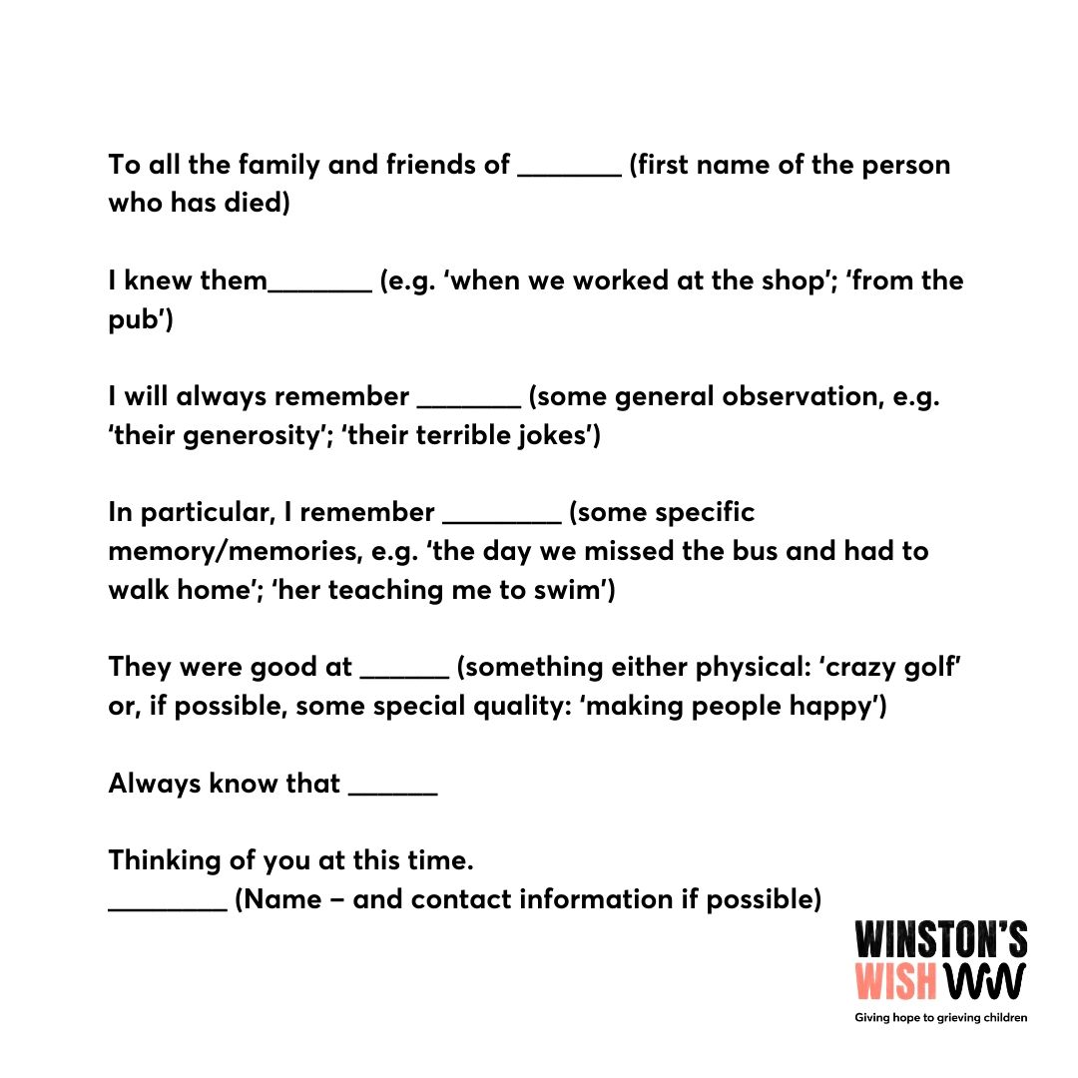
Although wider family and friends may not be able to attend a funeral they may still want to honour and remember a loved one by creating an online tribute fund. You can set up an online tribute fund to remotely post pictures, videos or music, prayers, light a candle or share memories.

What about observing faith and cultural practices during the coronavirus pandemic?
It will be particularly difficult for children and young people whose culture or faith requires certain practices to be performed in particular ways for the person who has died. Churches, mosques, synagogues and other places of worship are closed to the public although faith leaders can still conduct services in places such as a crematorium or graveside. Children and young people may believe that their loved one has not been treated appropriately and may need reassurance, using the language of faith, that everything that is being done is respectful and necessary.
It may help to look for opportunities to pray together. Think about the points in the day when your family naturally comes together and consider taking a moment to pray at these times. Praying together may help and support the family to share their memories and their love for the person that has died.
Dear Lord,

As a butterfly graces our lives with a moment of fragile beauty
So too has our (grandma/aunt/uncle…)
blessed you and our family with their life and unique spirit.
May they find peace in you
and know that they live on in the hearts of all that they touched.
Send your Spirit to give us courage
Send your Spirit to give us direction
Send your Spirit to bring us peace
Through Jesus Christ our Lord

Amen

Dear God of love and mercy,

Embrace all those whose hearts today
overflow with grief, unanswered questions
and such a sense of loss
Grant them the space to express their tears
Hold them close to you through the coming days
and fill them with your healing Spirit.

Amen

How can you support a bereaved child or young person at this time?
Keep talking and keep listening to what children are saying about not being able to attend the funeral
Acknowledge that this is a strange and difficult time, even without the restrictions cause by the virus; children will be relieved to have their concerns noticed.
Keep children informed (where possible and within their understanding) about what will happen to their relative’s body and how the funeral will take place. Below are links to articles with suggestions on how to explain funerals, burials and cremations.
Reassure children. This is a worrying time for children anyway and the combination of bereavement and concern about the effects of the virus may make them particularly anxious about ‘not doing things right’. Reassure them that their relative knew they were loved and cared for… and not attending the funeral is the right thing to do at this time.
To my parent or carer, please…
Some of our bereavement group members have come up with a list of suggestions about how parents and carers can support their bereaved child. You may find some of these helpful:
- Talk things through with me in an open and honest way, remembering to listen to me.
- How can I be included in the funeral, what things can I do on the day that will help me to say goodbye. Include me and give me choices.
- Phone my school and inform them about what’s happened. Perhaps arrange a phone call so I can identify a member of staff who will be willing to support me over the phone or secure email throughout this time.
- Allow me to say how I feel and do not be offended if I am angry with you or do not want to talk.
- Please take into consideration that I may not grieve in the same way as you or my siblings.
- If I look like I’m feeling lonely please ask me how I’m feeling.
- Remind me that I am not to blame and that it’s not my fault.
- Help me to remember my loved one. Talk to me about the happy times we shared. Help me not to forget my special person.
- Let me keep something that belonged to my special person. Remind me that it’s important to keep it in a safe place.
- Hug me, just hug me so I feel safe.
- Tell me I’m doing nothing wrong when laughing and having fun. Tell me it doesn’t mean I’m forgetting about my loved one.
- Tell me it’s normal to feel jealous of my friends who have not lost someone.
- Allow me time to be on my own, sometimes I may just need some time out.
- If you see that I’m struggling in a way that I’m inflicting pain on myself, help me, talk to me about where we can get help and please don’t feel like you have failed as a parent.

Reaching out for support

https://rainbowsgb.org -Liverpool Archdiocese Education Department has a bereavement programme called Silver Linings which is available from Fr Des Seddon –(Schools can contact him through their Diocesan Officer)

The Winston’s Wish Helpline is continuing to operate during this period and can offer guidance, support and information, call 08088 020 021. (To protect staff, the Helpline is currently operating a remote service, please leave a message on the answering machine and one of their experienced practitioners will call you back.
You can also email on ask@winstonswish.org or use our online chat. Our Winston’s Wish Crisis Messenger is available 24/7 for urgent support in a crisis. Text WW to 85258.
www.onceuponasmile.org.uk Tel: 0161 711 0339
www.childbereavementuk.org Tel: 0800 02 888 40
helpline@cruse.org.uk -Cruse Bereavement Care
jo@samaritans.org – Tel: 116 123
www.childline.org.uk Tel: 0800 1111
Books:
NB: For younger children these should be shared with support from an adult
Early Years
Someone I know Has Died- Trish Phillips
Missing Mummy- Rebecca Cobb- Amazon
I Miss You- Pat Thomas -Amazon
When Dinosaurs Die- Laurie Krasny-Brown-Amazon
5-7 Years
Remembering - Diane Leutner
Waterbugs and Dragonflies- Doris Stickney- Amazon (Christian Perspective)
Badgers Parting Gift- Susan Varley- Amazon
Stewarts Tree – Cathy Campbell- Amazon
8-14 Years
The Memory Tree- Britta Treckintropp-Amazon
What on Earth Do You Do When Someone Dies? – Trevor Romaine & Elizabeth Verdick – Amazon
Grief Encounter- Shelley Gilbert- Amazon (Book and workbook)

Other articles you might find helpful:
Ways to manage your anxiety about coronavirus

Reference: Sources of information

winstonswish.org internet research
onceuponasmile.org internet research -Leaflet for parents
childbereavementuk.org internet research

