Please see information below to support your child’s learning during our school closure/child’s absence from school:
Religion
Reconciliation – Choices
Check Google Drive in ‘Choices’ folder for activities relating to this topic.
What do the words choice and consequence mean?
How do we make choices?
Do all choices have consequences?
On a grid record some choices you have had to make.
Say what choice you have made. Was it a good choice or wrong choice? What were the consequences for you or other people?
Choice | Good or Wrong | Consequence

Free Online Activities
Top Marks Website for all subjects, this provides a wide variety of games and fun activities to support learning.
https://www.topmarks.co.uk/

Tynker – Programming
https://www.tynker.com/
Hour of code – Programming

STEM – Science activities
https://www.stem.org.uk/resources/community/collection/12535/year-3-plants

Language Angels – Spanish
www.languageangels.com
Username: StLaur1266
Password: lahome
See our school website for topics that would usually be covered at this time of year underneath our curriculum tab.
Science – Light and Shadows
Watch this clip about light sources. A light source is anything that makes its own light. Look around your home and make a list of light sources. Are the objects natural or manmade? https://www.bbc.co.uk/bitesize/clips/zjkc87h
Is the moon a source of light?
Research this question and see if you can find the answer.

Maths
Try to complete ‘Maths Key Skills’ sheets posted on Google drive.
Continue to practise calculations with 2 and 3 digit numbers (add, subtract, multiply and divide).
For example: 356 36
+144 x 6
Introduce 2D and 3D shapes.
How many 2D and 3D shapes can you name? How many sides do they have? How many vertices? How many edges? How many faces? Check Google Drive for maths related activities.
Try to complete maths activity sheets posted on Seesaw and Google drive.
English
Please see Reading Comprehensions. Read carefully and complete questions in full sentences.
Read as often as possible, question your child to develop their understanding of what they have read.
Practise spellings and writing sentences with Y3 & 4 words.
Practice handwriting. New sheets on Google drive.
Power of Reading – On Google drive in Power of Reading folder there are activities to complete.
SPAG Activities.
- Complete grammar and punctuation tests. These can be found on Google drive and the answers are attached.
- Complete ‘correct the spelling mistakes’ activity.
Project
Geography – Extreme Earth
This half term we would usually be starting our Extreme Earth topic.
Volcanoes
A volcano is an opening in the Earth’s crust that allows magma, hot ash and gases to escape. Volcanoes can look like mountains or small hills, depending on what type they are.
Watch this video clip to find out more about volcanoes.
https://www.bbc.co.uk/bitesize/topics/z849q6f/articles/zd9cxyc
Complete this volcanoes labelling sheet, which can be found on
Google drive.
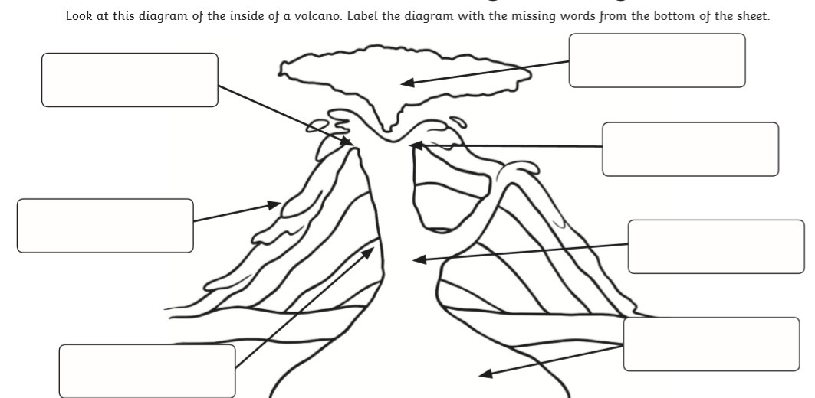
Create a volcano collage and label the different parts.
Remember to use the Epic app. This has lots of information books which will support your child when completing their projects.

