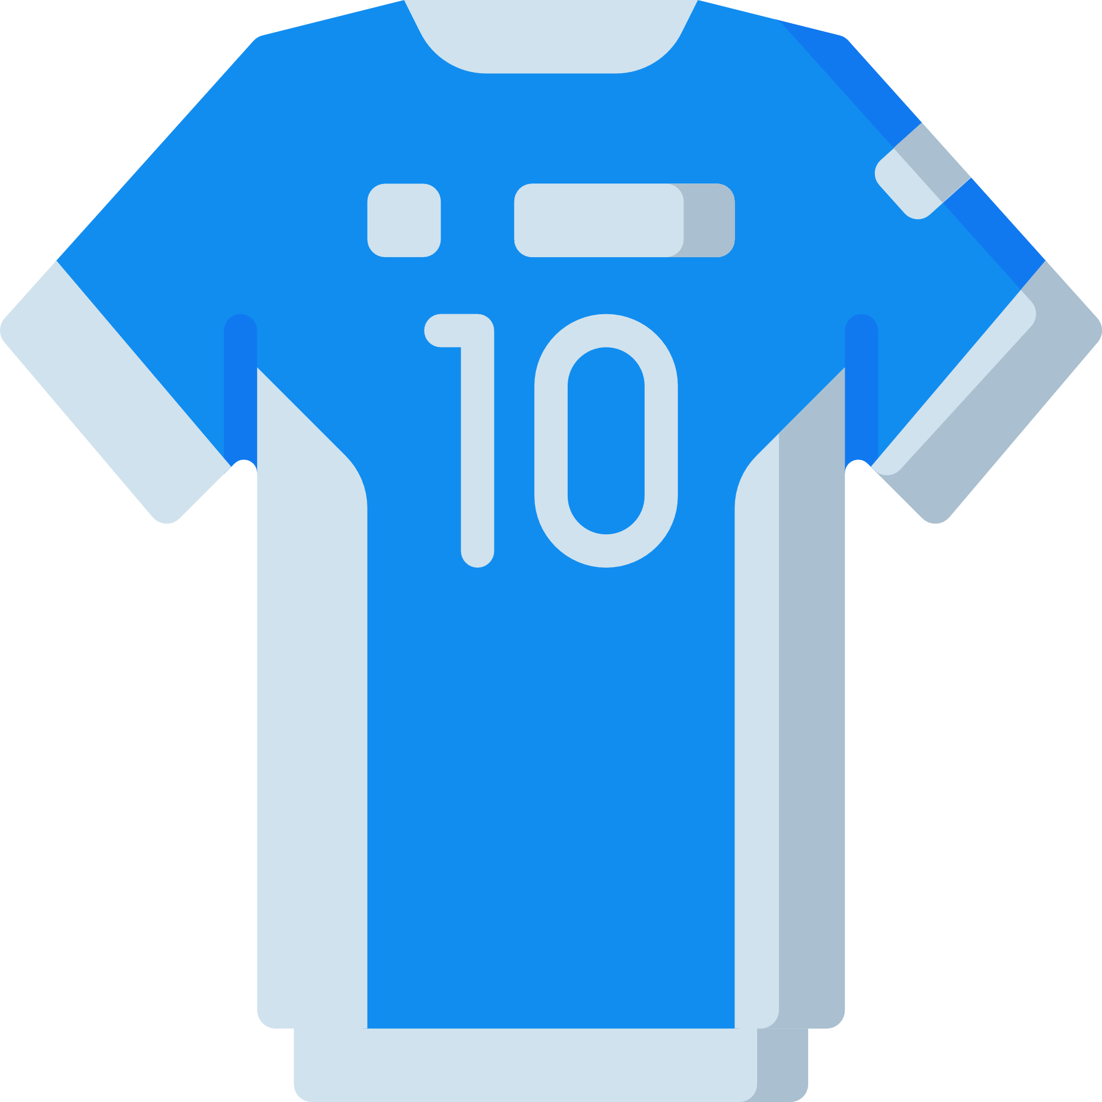

**Being a representative**

Think about a time when you were asked to represent somebody or something. If you haven’t represented anyone or anything before, think about what or who you would like to represent.

* What was it?
* What did you have to do?
* What did you wear?
* How did it make you feel?

________________________________________________________________________________________________________________________________________________________________________________________________________________________________________________________________________________________________________________________________________________________________________________________________________________



Picture

Remember to include interesting vocabulary and vary your sentence structure and punctuation.