

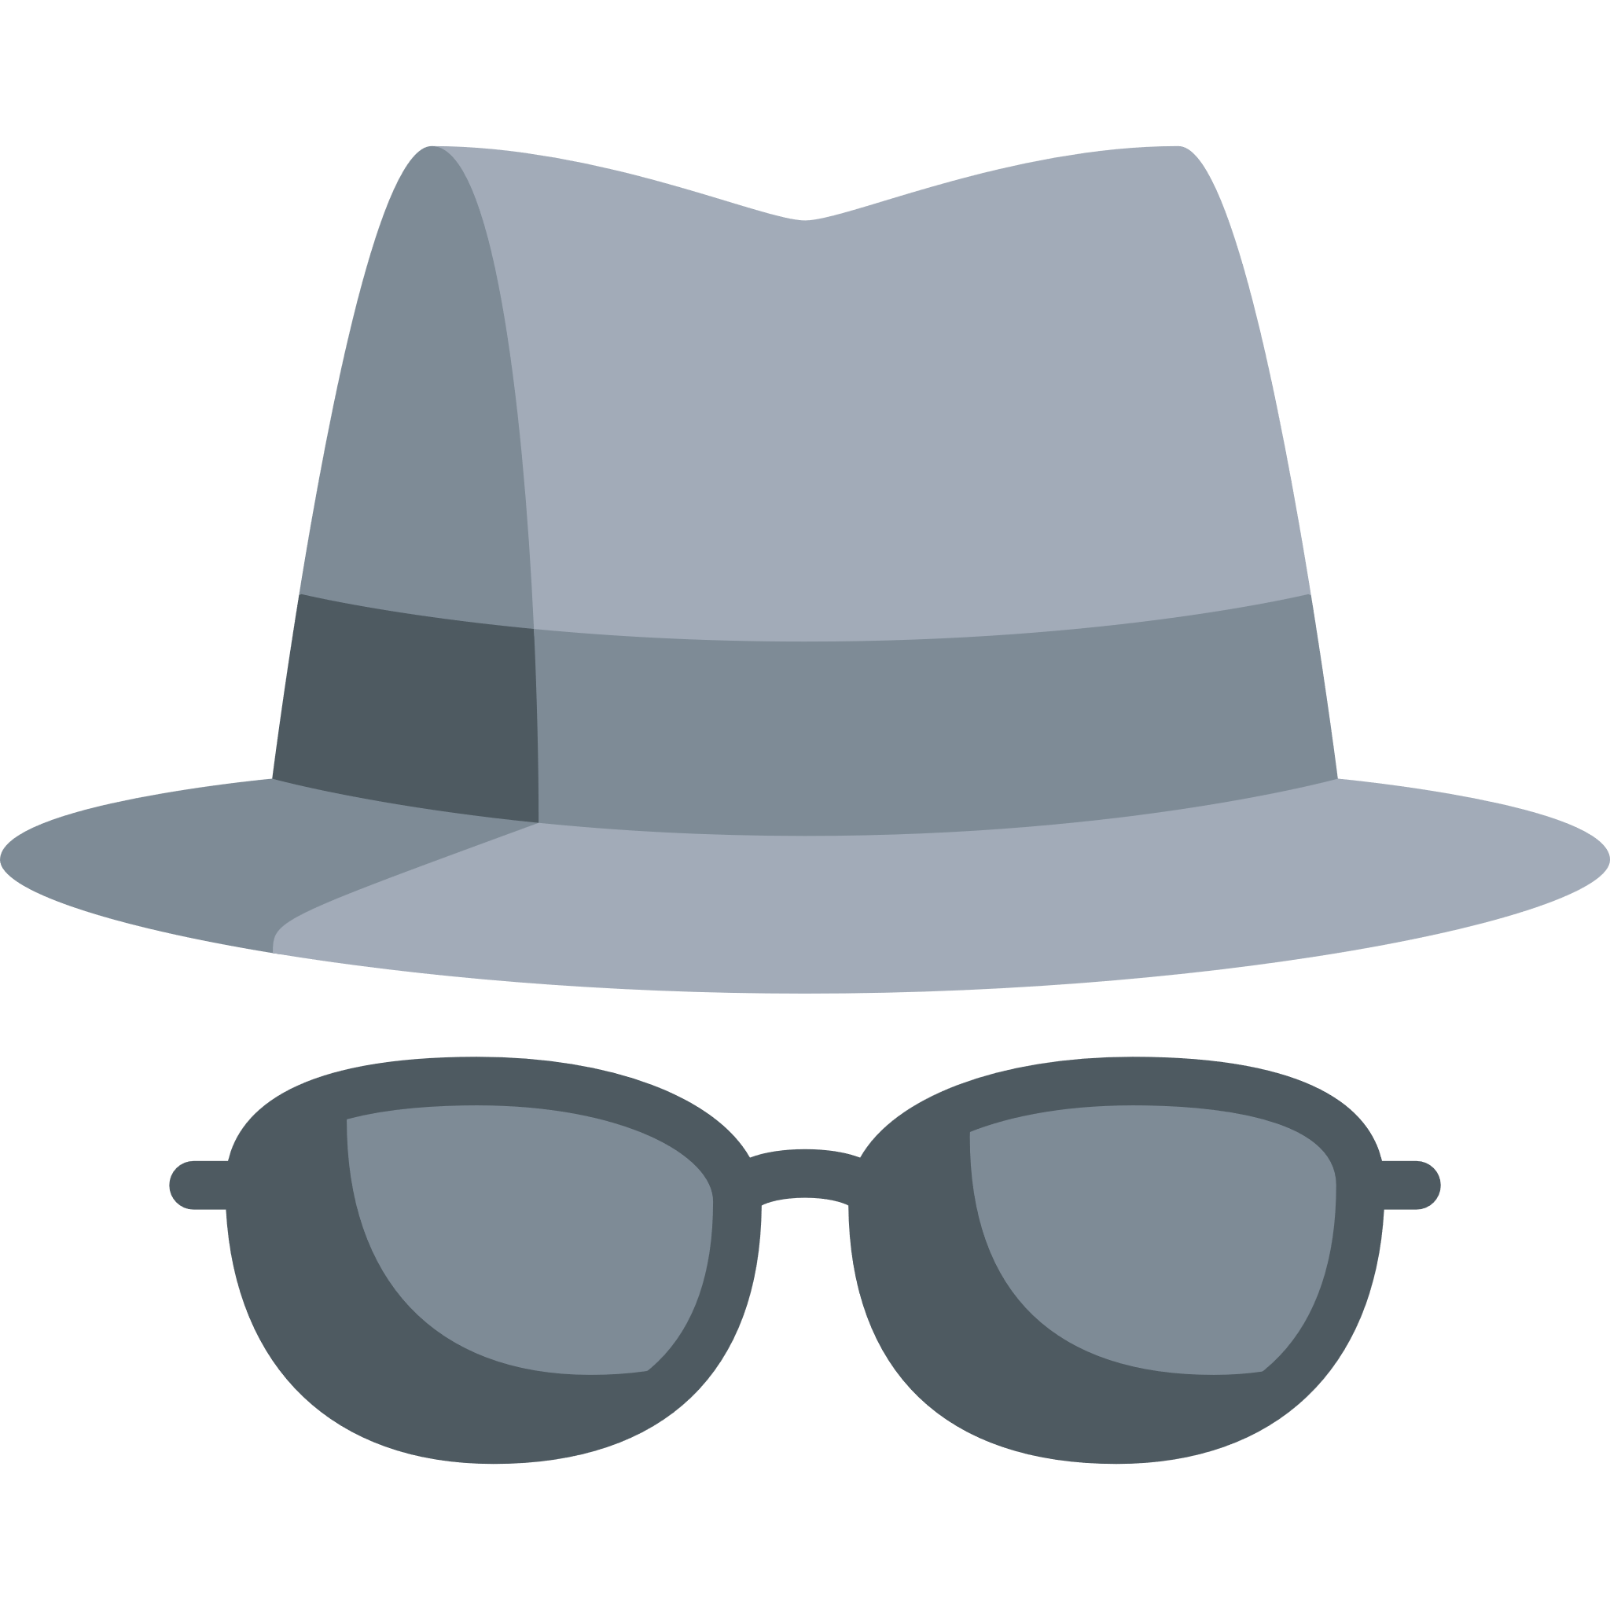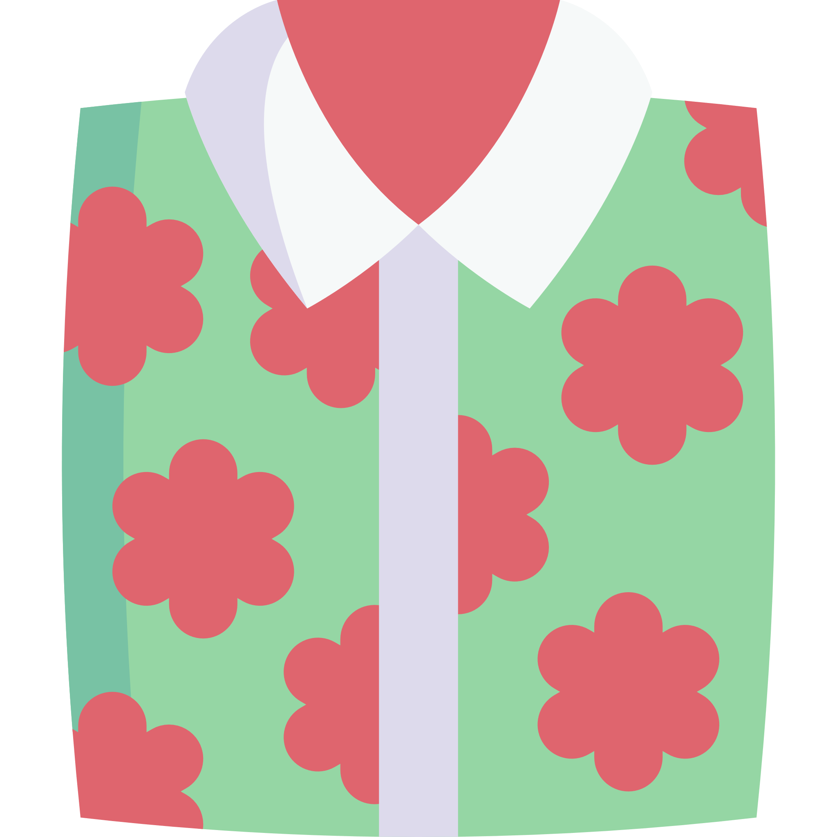

**My Smart Outfit Design**

**Before you draw your design, think about:**

* What occasion is your outfit going to be worn to?
* What colours will you use?
* Will you have a pattern on your outfit?
* What will the shoes look like?
* Will you have any accessories such as jewellery, a hat, scarf, bag, watch, glasses?

