

**Living Statues**

Have you heard of a living statue? They are people who pose as statues. They often wear statue-like make-up and can stand very still! Look at the pictures of some living statues below.

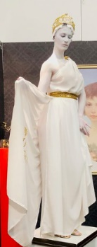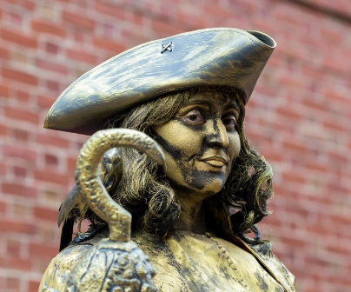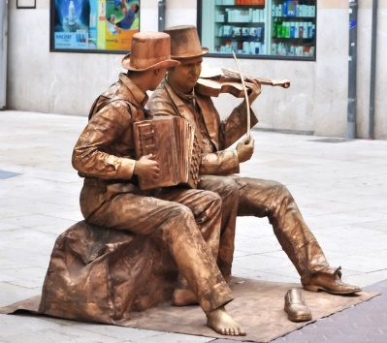



*Source: E Rinaldi*

Photographs or drawings of your statue poses

* Can you pretend to be a statue?
* What will you wear?
* What position will you stand in?
* How long can you remain still for?
* Can you time it?

*Source: J Hoey*

*Source: M Verch*