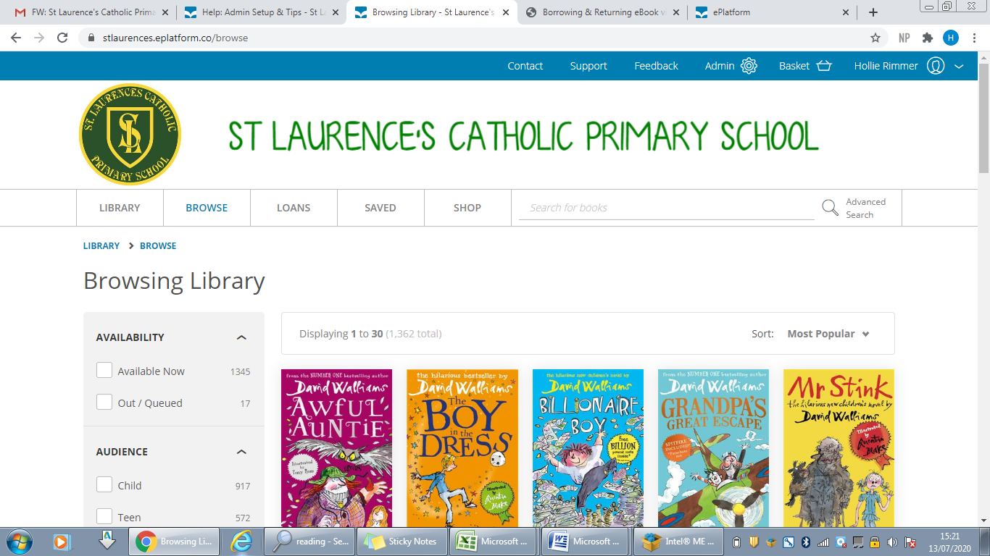
Dear Parent/Guardian,
Students are now able to borrow eBooks and Audiobooks from our exciting new eBook library, found here:
The library catalogue is full of bestselling, popular fiction titles and will offer your children a 24/7, 365 library in addition to our well stocked print library in school. Students can have 2 books out on loan at any one time, and they will automatically return after 2 weeks, or children can return them early in order to loan a new book.
We have age rated the books which means your children can only read books that are age appropriate. There are also settings that can be customised to enable children who suffer with reading difficulties to enjoy reading without specialised equipment or books – we will be working with those children affected to setup their preferences.
The eBooks can be read on a computer, laptop, or through the free App on your tablets or smartphones.
Reading through your web browser on a laptop or computer
To access the eBook library students need to login using their pre-assigned username and password, (see below). Children can browse the collection or search for a specific book title, author or publisher and loan the book they choose. It is then assigned to them for the 2 week period.
Reading through the App
To download the App, search “eplatform” in the App store and download. You will then need to enter the username and password assigned and, as above, search for a book to read. Using the App, the books will be temporarily downloaded to the device so children will not need internet connections once the book has been loaned to read, great for travelling abroad!
User names and passwords
Your child has a unique username and standard password readily created to log in. User names are generated by using your child’s last name followed by a full stop and first initial. For example ‘John Smith’ would have a user name of ‘Smith.J’, all passwords are set to ‘ebook’ (lowercase). If for any reason you are having trouble logging in please contact the school directly and you will be given confirmation of your child’s user name and password. You can also find a step by step guide to loaning books on our school website and Google Drive. For extra help, follow the link to this video https://www.youtube.com/watch?v=dy58SBw0tuM.

