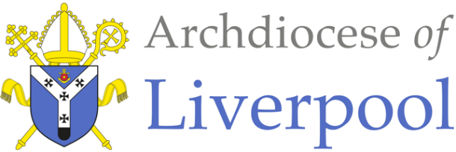
Belonging – A Sacramental Topic
*Note to parents.
This work comes from the Come and See Religious Education programme which is taught in all Catholic schools in the Archdiocese of Liverpool. We have given a general guide to the learning opportunities that your child may have come across in school and have only suggested and selected a small amount of the programme. The activities aim to keep Religious Education practical and fun. They are in Year groups however, there is no harm in completing other lower year group work as well as this will help your child to remember and strengthen their learning.
The first part of learning is called – EXPLORE. This shares your child’s everyday experiences and helps them to see how the Catholic faith is lived in their everyday lives as the theme progresses. The second part, called – REVEAL shares bible stories, religious teachings, lives of saints etc. that can relate to their everyday life. There are suggested activities for each section. Choose those you wish to do and record them as best as you can sending any work undertaken to school.
This theme is a Sacramental theme and focuses on the Sacraments of Baptism (and Confirmation, Marriage and Holy Orders). We understand that not every child or parent will have been baptised, so alongside this document are notes about the Sacrament of Baptism that you may find useful. All the other information you will need is here.

YEAR 1 - BELONGING - EXPLORE
Belonging to different groups

- Children may talk about their experience and feelings about belonging to different groups.
- Children may say what they wonder about belonging and what that means.
- Children may be able to ask and answer questions about their own and others experiences of belonging to different groups.

- Talk about the different groups that your child may belong to e.g. swimming, Rainbows, Beavers, dancing, football, choir etc. and what they do together in these groups. Discuss how they feel in the group and who helps them to feel that they belong. Talk about how someone would know that they belonged to that group – do they wear a uniform, have a badge etc. Ask them how they could make someone new to the group feel that they belong.
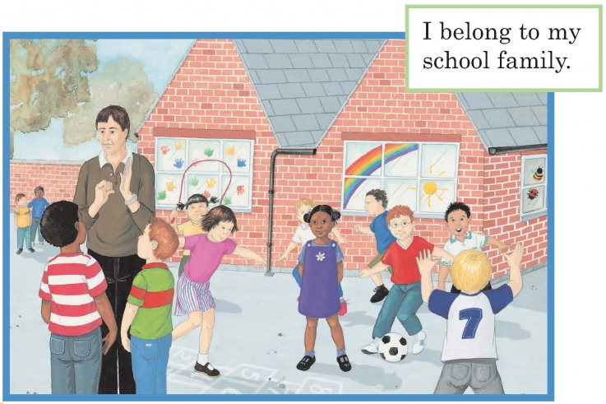
- Talk about the different ways of belonging shown in the picture e.g. a team playing together, a pair playing hopscotch together, the teacher signing, two children with their arms around each other, the artwork of handprints on the window.

Activity:
Make a badge to show that you belong to one of the groups or to your own family.

YEAR 1 - BELONGING - REVEAL
Baptism is an invitation to belong to God’s family

- Children may be able to recognise and use some religious words and phrases to begin to describe some actions and symbols used in Baptism e.g. pouring water, lighting the Baptismal candle, anointing with oil etc.
- Children may be able to recognise that Baptism is the beginning of life in the Church community.

- If your child has been baptised, share memories of the day together and look at any photographs or videos you have of the day. Alternatively, read the story about Matthew’s Baptism above. Talk about who was present on the day, who the Godparents were and what the priest said and did.
Explain how the lit candle, stands for the presence of Jesus. Jesus said, “I am the light of the world,” so the candle is a symbol of this. With light we see things more clearly. In Baptism, a lit candle is given to one of the parents as a sign of how they hope the child will always try to live Jesus’ way of love.
At the end of the Baptism everyone says the family prayer of the Church, the ‘Our Father’. This is a sign that the child belongs of the family of the Church. The priest blesses the mother and father and all the people in the church.
Read the extract below:
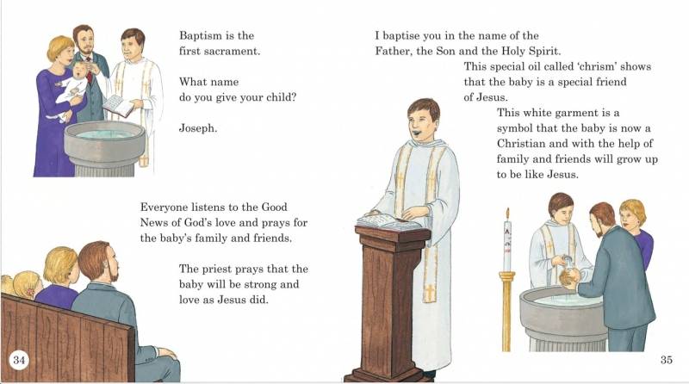

Activities: (choose any you would like to do)
- Make a congratulations card for a newly baptised child. Use suitable symbols that are used at Baptism. Talk about why they have chosen the symbols and what they represent.

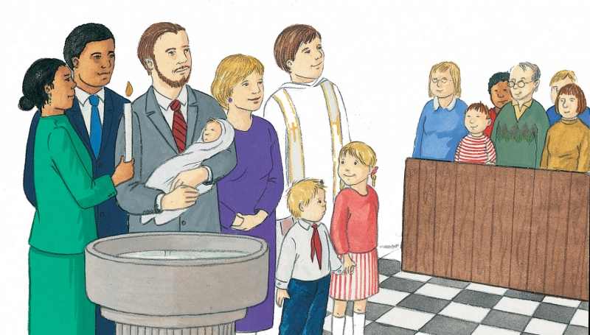
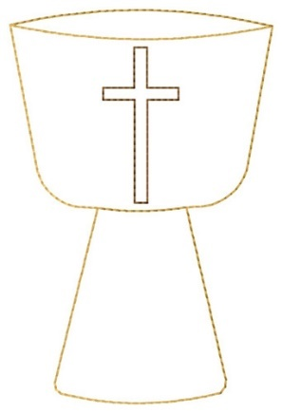
- See if your child can recognise and label all the people and symbols they see in the Baptism picture below:

- On a template of a Baptismal font, write what belonging to the Church family means

At the end of all the work you have done about BELONGING, say together:
For the family I belong to ….. Thank you, Father God
For the groups that I belong to ….. Thank you, Father God
For the Sacrament of Baptism that enables people to belong to God’s family in a special way …..
Thank you, Father God.

