St Laurence’s Catholic Primary School
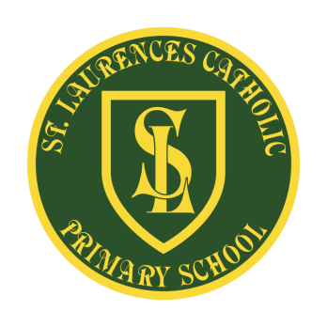
E Mail: stlaurence@knowsley.gov.uk
Website: www.stlaurences.co.uk
Twitter: @slaurences
Leeside Avenue
Southdene
Kirkby
L32 9QX
Telephone: 0151 546 4733
Headteacher: Miss SJ Carroll
Date: Monday 19th October 2020
Dear Parents/Carers,
This letter aims to update you on our preparations within school in response to the spread of Coronavirus (COVID 19). Updates from the Department for Education, Knowsley Council and Public Health England have been used as a basis for our planning.
As we are all taking advice from the government, we understand that some children may currently be self-isolating. In an effort to provide activities for children to access at home where able, they can now do this through our Google Classroom. This has been set up after having feedback from our school community about children wanting further communication between themselves and class teachers. Google Classroom is similar to the Google drive; however it allows feedback to be given directly to pupils on tasks. We will now only use Google Classroom to provide home learning and homework from Monday 9th November (for years 1 to 6).
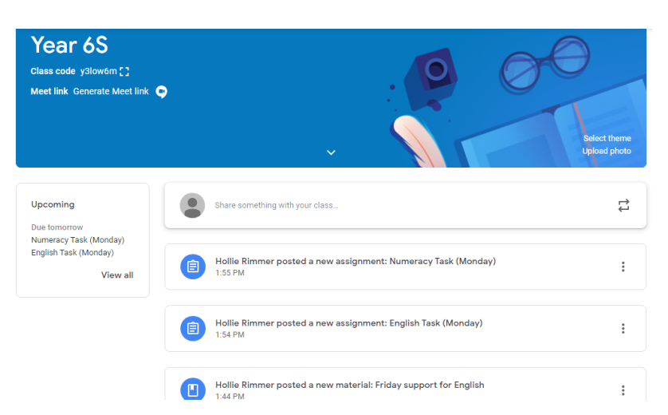
To access this, type Google Classroom into your internet provider search. Use your child’s email and password that has been provided by the class teacher. When logged in, and you have accepted the invite to your child’s class, you should have access to a page similar to the one seen below. From here you, will be able to receive updates from the class teacher, download work to be completed and children can receive feedback. Google classroom apps, include: Google docs, slides, sheets, drawings and forms.
A material is a resource which can help you complete a task or give you detailed explanations.
An assignment is a task that needs to be completed by the pupil. It will have a deadline date so you know when to complete it by.

Upcoming announcements help you know what is due and helps break up what needs completing.

If you are having trouble accessing this please contact the school directly. For more help please watch this video to see if it answers your queries. https://www.youtube.com/watch?v=xfgqtCi7hdo Thank you for supporting our home learning efforts during this difficult time.

St Laurence’s Staff

