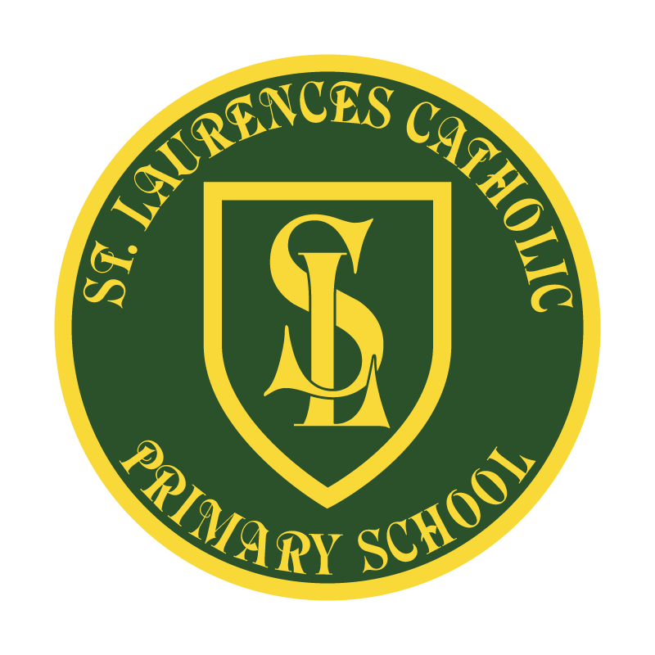

St Laurence’s Catholic Primary School

Policy Statement
for
English

This policy was reviewed:

By name:
Position:
Signature:

Our Mission Statement

1. We aim to celebrate our partnership with the families we serve and the community we live in.

2. We aim to provide an education that enables each child to reach their full potential.

3. Our aim is the creation of an atmosphere where all are valued, gifts and talents are celebrated and the gospel values of love, respect and justice are at the heart of all we do.

Our Vision
Everyone feels a sense of belonging,
Has the opportunity to shine,
To enjoy their teaching and learning
But most of all – to dream big!
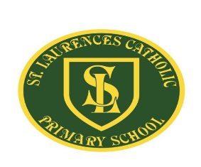

St Laurence's Catholic Primary School English Policy

This policy needs to be read alongside other school policies including:
- Homework policy
- Early Years Foundation Stage policy
- Special Needs policy
- Reading for pleasure policy

This policy also should be read alongside the new National Curriculum in England (published September 2014) and other documents from the Standards and testing Agency.
Our Curriculum overview, medium and short term planning can help support this policy, as will a look at these relevant schemes of work:

- Phonics
- Grammar and Punctuation Long Term Plan
- Spelling Long Term Plan

Rationale:
The National Curriculum (2014) clearly states that teaching the English language is an essential, if not the most essential role of a primary school.

At St Laurence's Catholic Primary School we recognise that without effective communication, little achievement can be made. We know that we have a duty to ensure that English teaching is a priority and we recognise that this is necessarily cross-curricular and a constant through-out school life and beyond. It is part of the ‘essential knowledge’ (p6 National Curriculum) that is needed in society:

‘Teachers should develop pupil’s spoken language, reading, writing and vocabulary as integral aspects of the teaching of every subject. English is both a subject in its own right and the medium for teaching; for pupils, understanding the language provides access to the whole curriculum. Fluency in the English language is an essential foundation for success in all subjects.’ (p10 National Curriculum)

We are an inclusive school, we set high expectations and recognise the importance of accurate and regular assessment in order to support individuals at every part of their learning journey and in whatever circumstances. We use one to one support, small groups and cross-phase work to help with this. We plan teaching opportunities to help those for whom English is an additional language and those with disabilities outlined in the SEN code of practice. We agree with the statement of the National Curriculum, that ‘pupils…who do not learn to speak, read and write fluently and confidently are effectively disenfranchised’ (p13)

Spoken Language:
The National Curriculum states that pupils should be ‘taught to speak clearly and convey ideas confidently in Standard English’ (p10) Children should:
  - Justify ideas with reasons
  - Ask questions to check understanding
  - Develop vocabulary and build knowledge
  - Negotiate
  - Evaluate and build on the ideas of others
  - Select the appropriate register for effective communication
  - Give well structured descriptions and explanations
  - Speculate, hypothesise and explore ideas
  - Organise their ideas prior to writing

Our aims and connected provision

We encourage our pupils to speak clearly and confidently and articulate their views and opinions. We teach that children need to express themselves orally in an appropriate way, matching their style and response to audience and purpose. Listening and responding to literature, giving and receiving instructions. They develop the skills of participating effectively in group discussions.

Ways in which we support this include:
- Activities which are planned to encourage full and active participation by all children, irrespective of ability
- Children with specific speech and language and auditory problems will be identified and specialist help sought, where appropriate
- Encouraging talk-time at home by encouraging reading and talking about books
- Poetry recital in class and for whole school assemblies
- School Plays
- Class debates
- Weekly assembly
- Events within the community
- School Council
- Talk partners
- Book talk sessions
- Drama / role play
- PSHE and circle time
- Talk For Writing sessions
- Use of Power of Reading sessions

Phonics and Spelling
This part of the policy sets out the expectations of Phonics sessions, using the Read, Write, Inc. (RWI) scheme, and its approach in ensuring that all pupils are able to read and write, learning in a positive learning environment.
This Phonics policy also enables teachers to comply with the National Curriculum 2014 section 6.0 - set out by the DFE which states that:
‘All staff have a responsibility to develop pupils’ reading and writing in all subjects to support their acquisition of knowledge. Pupils should be taught to read fluently, understand extended prose (both fiction and non-fiction) and be encouraged to read for pleasure. Schools should do everything to promote wider reading. Pupils should build on what they have been taught to expand the range of their writing and the variety of the grammar they use. The writing they do should include narratives, explanations, descriptions, comparisons, summaries and evaluations: such writing supports them in rehearsing, understanding and consolidating what they have heard or read.’
Aims:
- To use Read Write Inc. so children learn to read effortlessly to enable them to put all their energy into comprehending what they read.
- To provide a safe, secure environment where all members of the community can flourish, thrive and feel a sense of belonging and fulfil their potential.
- To ensure that all staff are aware of the structure of RWI.
- To promote self-discipline and learning behaviours.
- To promote a positive environment of praise, reward, celebration and encouragement
- To provide information regarding Read, Write Inc. to staff and parents
- To monitor teaching and learning of RWI, Progress and Assessments

About Read, write, Inc:
'Read Write Inc.' produced by Ruth Miskin, is a method of learning centred around letter sounds and phonics, blending them together to read and write words and using these learnt sounds in their reading and writing. In Reception, Year 1 and Year 2 children will follow a daily phonic programme to create fluent, enthusiastic readers, confident speakers and willing writers. In KS2, some children who are not yet fluent readers and accurate writers will complete a 1:1 or a group intervention programme that equips them with the skills to read and understand texts confidently, write fluently, think critically and articulate thoughts and ideas clearly.

Read, Write Inc. has 5 underlying principles – the five Ps:
1. PACE – no time is wasted during teaching sessions. Children are active and involved in a fun and creative way. The aim is for the children to complete the programme and embed the skills as quickly as possible.
2. PRAISE – teachers praise the children constantly throughout the teaching sessions. Children learn more quickly when they are praised for what they do well, rather than told what they do wrong. The children are encouraged to praise each other.
3. PURPOSE – each activity has a very clear purpose. The teacher will set this purpose at the beginning of the lesson so that the children know exactly what they will be learning.
4. PARTICIPATION – all children take part in all parts of the lesson. Full participation is gained through partner work and choral response.
5. PASSION – as a staff we are passionate about our teaching and the benefits of the Read, Write Inc. programme. We love teaching the sessions and this enthusiasm rubs off onto the children. This is because we know it has an impact.
At the core of the programme we deliver vigorous teaching of synthetic phonics. Children learn the 44 common sounds in the English language and how to sound-blend words for reading (decoding) at the same time as developing handwriting skills and spelling (encoding). The children also have the pleasure of reading story books perfectly matched to their level – so that they have early success in reading. Children are given home reading books which match their RWI level.
The children follow a structured programme of reading activities in small groups. All staff in school have been trained in the delivery of this programme. It begins in Reception, and once the children are reading fluently (100 words per minute) they will have completed the programme.
The children are assessed and grouped according to their ability. They will work with a Reading Teacher (teacher/TA) on the RWI programme. At the end of each half term, the children will be assessed again and put into new groups. In addition to the RWI programme, children in Y2 will also access a comprehension programme when ready.
All RWI teaching areas, and KS1 classes display the speed sounds posters to ensure pupils apply their phonic knowledge whilst writing. This is in a prominent place, and is referred to during lessons.
RWI Lead and Governors:
- Ensure that the School complies with this policy.
- Ensure that this policy is implemented in a fair and effective way.
- Ensure lessons are monitored.
- Track the progress of each child and groups.
- Identify children at risk and organise intervention to enable them to make progress.
- Ensure that all staff receive appropriate support and CPD

Staff:
- Be consistent in the teaching and learning of RWI.
- Be a positive role model for pupils.
- Ensure they are fully prepared for each session.
- Feedback to the RWI lead about the progress of their pupils.
Parents/carers and pupils:
- Read their school books at home applying skills taught in RWI sessions.
Spelling:
In KS2 children are taught spelling through ‘Spelling Shed’. These lessons continue to build on KS1 skills. Children will learn orthography through adult-led discussion and investigation. Children will become more secure in their knowledge of English orthography based on the frequency and position of the sounds within words. Morphology lessons throughout the scheme that consolidate children’s knowledge of common morphemes such as root formations, prefixes and suffixes. As well as entomology, children will be able to see how the English language has, over time, borrowed and integrated words and spellings from a range of source languages. For example, the latinate verbs which follow Latin prepositions in English words such as: -act (do), -pute (think) or -opt (choose). These lessons take place during English sessions as well as guided read through teacher input and explored through use of spelling lists and games. Pupils are then tested on particular words so the class teacher can keep a record of patterns or word lists which may need further teaching throughout the year.

Reading:
The National Curriculum states that pupils should be taught to read fluently, understand extended prose and be encouraged to read for pleasure. Reading is singled out as of extreme importance since through it ‘pupils have a chance to develop culturally, emotionally, intellectually, socially and spiritually’ (p13) Reading allows pupils to ‘acquire knowledge’ and to ‘build on what they already know’ (p13).
Schools are expected to have library facilities and support and encourage reading at home.

The 2014 Curriculum divides reading skills into two dimensions:
- Word reading/ decoding
- Comprehension
We recognise that both these elements are essential to success and we support the acquisition of both sets of skills through various methods. We recognise that these areas are clearly linked to the other aspects of English learning: speaking and listening, writing, grammar and vocabulary. We also understand that reading is a developmental process and part of life-long learning and we encourage and praise children at every stage of it.

Our aims and connected provision

- Pupils learn to read easily and fluently through daily phonics in EYFS & Key Stage One, regular reading to adults in school, reading partners and an incentive to read at home
- We utilise whole school schemes such as Read Write Inc to ensure our learners become fluent readers by the end of KS1.
- Any pupils who do not reach this are then tracked and given daily phonics sessions until they pass the PSC.
- Pupils develop skills in reading for understanding using the regular Guided Reading sessions. We have adapted this to meet the needs of our pupils. In essence, pupils study a range of texts and teachers provide various follow ups, inference and deduction questions to showcase what pupils have gained. These books may be more challenging than those which they might be able to read independently. They will use this book as the basis for reading, writing, speaking and listening tasks.
- Pupils are encouraged to read widely, through our use of differing class texts, library visits and attractive reading areas in classrooms.
- Pupils are encouraged to read for pleasure using reading partners, quiet reading time, listening to an adult read and the various methods outlined above.
- Pupils have access to our bespoke reading spine, which includes vocab rich texts chosen by class teachers to fit in with our whole school commitment to culture capital.
- Pupils also need to read to find information in all lessons and comprehension is assessed in a formal way every half-term.
- Pupils are exposed to a range of texts from their literacy heritage during their school career.
- Pupils making low progress are given targeted intervention and read to with an adult daily.
- We celebrate reading through whole school events such as World Book Day and Shakespeare week.

Reading celebration calendar

- Each month a new reading value is presented to the children to promote a love of reading both in and outside the classroom:
January – I can describe a character
February – I can recommend a story
March – I can read aloud
April – I can compare stories I have read
May- I can read a poem
June – I can discuss what I have read to a group
July – I can read a non-fiction book
August – I can read at home
September – I can respond at an illustration
October – I can make predictions
November –I can retrieve and record information
December – I can explain characters feelings

- Reading in KS2 is taught through comprehension, cross curricular exposure, English lessons, shared and guided reading. Grammar and spelling patterns are taught following the GPS long term plan. All children will have a guided reading session each week and will be listened to individually as often as possible. Children will take home books on a regular basis, as agreed on in each year group, moving from Oxford Reading Tree books to individual choices as their reading skills develop. All children will have the opportunity to develop their comprehension skills weekly. Children who have difficulties with reading will be targeted for reading and comprehension interventions dependant on their need. Our lowest 20% of children are completing reading for pleasure with a designated adult. Reading is now taught through cross curricular links working alongside our whole school reading spine. Children are exposed to a variety of writing linked to topics including: STEM, geography and history.

- Writing:
The National Curriculum states that pupils should:
- Develop the stamina and skills to write at length
- Use accurate spelling and punctuation
- Be grammatically correct
- Write in a range of ways and purposes including narratives, explanations, descriptions, comparisons, summaries and evaluations
- Write to support their understanding and consolidation of what they have heard or read

The 2014 Curriculum divides writing skills into two dimensions:
- Transcription (spelling and handwriting)
- Composition (articulating ideas in speech and writing)
We recognise that both these elements are essential to success and we support the acquisition of both sets of skills through various methods. We recognise that these areas are clearly linked to the other aspects of English learning: speaking and listening, reading, grammar and vocabulary.

Our aims and connected provision
- We teach grammar as a separate lesson where necessary
- We correct grammatical errors orally/ written work (where appropriate)
- Teachers plan and deliver editing lessons for pupils to develop what they have learnt.
- We have a systematic approach, we revisit key learning and build upon it in all areas from phonics, through to grammar and spelling
- We use high quality texts through the use of CLPE and the Power of Reading, modelling and shared/ collaborative writing to demonstrate good practice. This works within our bespoke writing and reading spine.
- We encourage and promote ‘talk for writing’ in EYFS
- We provide writing frames to support the least confident
- We provide time for planning, editing and revising
- We use marking codes for pupils to edit their word independently (p=punctuation ; g=grammar; s=spelling)
- We use checklists for pupils to self assess or peer assess, when appropriate so they can evaluate effectively.
- We use drama and hot-seating to help pupils to think about another point of view.
- Support for pupils with learning and motor difficulties
- Meetings with parents to help them support their child
- Teachers regularly reflect on writing by completing whole staff meetings on moderation.
- Writing lead is also a local authority moderator.

- In EYFS & KS1, writing will be taught using a CLPE and Power of Reading high quality texts over a period of time. This enables children to become familiar with a text, re-tell stories and use the structure of the text to write their own stories. Children will be encouraged to become independent writers using resources from around the class to support them e.g. phonics displays, word banks, working walls etc. Children will be encouraged to read and perform their work and edit to improve. Writing will be given a real context where possible so that children are writing for a purpose. Grammar will be taught through phonics and English lessons. Children who have difficulties writing will be targeted for intervention. Children also write each day in their RWI lessons. They write words containing the sound they are learning that day, as well as words which contain previously taught sounds.

- In KS2, we use CLPE and the Power of Reading to ensure that writing is taught using a high quality text over a period of time. This enables children to become immersed within a text, develop empathy for characters, view first-hand how an author structures their text and to embed that structure in their own writing. Our reading spine whole themes is at the heart of this and shows clear progression between year groups. Using the termly themes pupils build on vocab and writing whilst making links to SMSC themes which we feel benefit our children. Children will continue to be encouraged to become independent writers and to develop their stamina for writing longer pieces as they progress through the Key stage. They will be able to use resources to support their writing e.g. dictionaries, thesauruses, displays, word banks, working walls etc. Children will be encouraged to read and perform their work and edit to improve. Writing will be given a real context where possible so that children are writing for a purpose. Grammar will be taught through English lessons. Children who have difficulties writing will be targeted for intervention.

4. Vocabulary Development:
The National Curriculum makes clear that learning vocabulary is key to ‘learning and progress across the whole curriculum’ (p11) since it allows pupils to access a wider range of words when writing and for them to understand and comprehend texts efficiently.
Vocabulary teaching needs to be:

- Active
- Progressive/ systematic
- Making links from known words
- Develop understanding of shades of meaning
- Include ‘instruction verbs’ used in examinations
- Subject specific- accurate mathematical and scientific words

Our aims and connected provision:
We encourage our pupils to have a wide and growing vocabulary in a number of ways, these include:
- Spelling lists/ key words to take home and learn
- Display of key words linked to topics and subjects
- Using the correct vocabulary orally
- In-depth word based lessons looking at patterns
- Using dictionaries, thesaurus and similar programmes
- Carrying out systematic testing and providing feedback to pupils
- Targeted one to one/ small group support, where appropriate
- Vocab checks are used at the start of topics to showcase progression. Within EYFS & KS1 these are shown as displays which are added to throughout the topic. Within KS2 these are shown through a traffic light system (Green = I know the word and can use it in a sentence; yellow = I know the word but am not confident to independently apply it yet and red = I don’t know the word) After the topic children must ‘prove it’ that they can have all words as green but using it independently within a sentence.

5. Planning and Assessment:
Planning:
- Whole school over views work as our reading spines and long term writing progressions which are adapted each year.
- Medium term (half –termly) planning, using CLPE’s Power of Reading teaching sequences as a basis, form the outline for weekly plans
- All children are given a reason for writing through the development of audience and purpose for writing. We outline writing into four main principals: entertainment, inform, persuade and discuss at the start of the topic. Writing happens both within literacy but also within cross curricular lessons.
- English is planned for separately to other subjects using the proforma in the appendix. (Attach to this document at the end)
- Schemes of work for phonics, grammar and spelling are used to ensure developmental learning building on prior knowledge. RWI is the validated phonics scheme which is taught in our school. Teachers know how to teach even the most struggling reader – including older children. All children will develop reading fluency so they can read with comprehension and develop the co-operative behaviour necessary for them to articulate their ideas and understanding.

- Short term planning is flexible allowing for assessment for learning after each session/ group of sessions.
- Pupils may be grouped by ability for some sessions/ types of homework/ support.
- Pupils entitled to Pupil Premium funding will be given additional English support, which is tracked and monitored termly, where appropriate.
- Pupils with EAL will be given additional English support, which is tracked and monitored termly, where appropriate.

Assessment:
- Staff assess pupils learning during and as part of every session, they adapt their practice accordingly
- Weekly extended writing tasks are completed in a variety of text types and subjects.
- Formal assessments of Reading Comprehension ability are carried out, tracked and monitored at least termly
- Writing is moderated as a whole school termly to check progress led by our writing lead who is also a LA moderator.
- End of Key Stage Assessments are analysed by the Co-ordinator and Head teacher and feed into the school SEF, development plan and performance management.

6. Professional development:
- The English team consist of : H Rimmer – Reading and English Lead, H Hill – Writing Lead and J Farrell – Phonics Lead. All members of the team attend termly training and report back to all staff.
- The local cluster has an English group which meets termly, where possible.
- Staff are expected to attend relevant courses during the school year
- Moderation takes place in house, within the cluster and with support from county.
- A writing moderation file is held in the office for consultation.
- All staff are given refresher courses of the POR to reflect on new teaching sequences and new texts which may be used within their classes.

7. Specific groups:
- Analysis of English achievement is carried out termly, pupils who are slow moving or making little or no progress are discussed and plans made.
- Pupils entitled to pupil premium are given additional English support and this is monitored for effectiveness termly.
- Pupils with EAL are given additional support in all aspects of English.
- Pupils who are gifted and talented receive additional support with a differentiated curriculum.
- Pupils with SEN will have English based targets on their PPP. These are reviewed termly.
- Bottom 20% pupils complete daily reading for pleasure to support learning.

8. Reading for pleasure: Please see separate document for an in depth look at this.

- At St Laurence’s we believe that every child can learn to read with the right teaching and support.
- To ensure our classrooms and learning environment encourage a text centered approach to reading.
- We understand that not all children will have has the opportunity to develop a love of reading at home, so this has to be taught and encouraged at school – just like any other area of the curriculum.
- Place reading and books at the center of all learning.
- Building time every day for all children to read at different levels to support their learning.
- Ensuring children have time to talk about books with each other and with adults.
- Promote reading values of the Month ~ encouraging children to read at home and school to ensuring you keep a record of them reading at home.
- Promote national reading events as often as possible and cease as many opportunities to expose and immerse children in the written word.
- Regularly reflect on our reading offer through pupil, parent and staff voice. Ensuring we are using quality texts enjoyed by all.
- Choose books and texts which inspire, develop and challenge learners by exposing them to a world different to that in which they live.

REVIEW OF POLICY
The effectiveness of this policy will be reviewed annually by the Senior Leadership Team and every three years by the Governing Body. If changes are made to the policy, the Governing Body will ratify amendments.

This policy was reviewed: September 2022

Signed: on behalf of the governing body

Designation: Chair of Governors

Date: 22nd September 2022

