St Laurence’s Catholic Primary School

SEND Information Report
School Offer for Children with Special Educational Needs and Disabilities (SEND)

This policy was adopted: | October 2022
By name: | Mr John Holmes
Position: | Chair of Governors
Signature: | J. Holmes

Our Mission Statement
We aim to celebrate our partnership with the families we serve and the community we live in.
We aim to provide an education that enables each child to reach their full potential.
Our aim is the creation of an atmosphere where all are valued, gifts and talents are celebrated and the gospel values of love, respect and justice are at the heart of all we do.

Our Vision
Everyone feels a sense of belonging,
Has the opportunity to shine,
To enjoy their teaching and learning
But most of all – to dream big!

Update in light of COVID-19

The situation in which we find ourselves is constantly changing, as such, please note that this report is based on information available in October 2021 and is subject to change
In view of the ongoing disruption caused by Covid 19, we acknowledge the impact on the Social, Emotional, Mental Health and learning needs of our children.
We are therefore adapting our approaches and provision as needed on an individual basis. This means that although we have a thorough, detailed risk assessment, we are aware that adjustments may need to be made to accommodate the needs of children for whom the new school year is more of a challenge.
This may impact how your child comes into school, what support your child is offered during the school day and what additional resources might be offered in order to ensure each child feels safe and happy.

What if there were full School Closures again?
Keeping schools open is a Government priority. However, in the event of a full school closure due to Covid-19 parents would immediately be able to access remote learning which is fully aligned with their in school curriculum. For children with SEN this offer is outlined in more detail below. During the prior period of a full National Lockdown children with an EHCP were invited in to school along with the children of Key Workers and our more vulnerable pupils. In the event of a full school closure due to a directed lockdown, St Laurence’s would follow the current guidance at the time regarding the potential attendance of children.

How can I support my child’s learning at home?
If your child has an identified SEN (EHCP or SEN Support), the class teacher will take account of their needs when planning for and providing work to be completed at home. This will include:
• Using the targets from your child’s Personal Provision Plan to plan activities
• Suggesting different ways in which children can present their work
• Giving more detailed instructions
• Providing parents with suggestions to make tasks more practical in nature
• Providing alternative work which is targeted at their level of need where they may not ordinarily access curriculum subjects at age expected levels.

Overview
The Children and Families Bill underpins wider reforms to ensure all children and young people can succeed, no matter what their background. The Bill will reform the systems for adoption, looked after children, family justice and special educational needs.

The Government is transforming the system for children and young people with special educational needs and disabilities (SEND), including those who are disabled, so that services consistently support the best outcomes for them.

A child or young person has a learning difficulty or disability if he or she:
Has a significantly greater difficulty in learning than the majority of others of the same age, or has a disability which prevents or hinders him or her from making use of educational facilities of a kind generally provided for others of the same age in mainstream schools or mainstream post-16 institutions.

As part of the SEN reform programme Local Authorities must publish their Local Offer, providing a comprehensive, transparent and accessible picture of the range of services available. Local partners, including schools, are required to co-operate with the Local Authority in the development and review of their Local Offer.

Link to the Local Offer
https://www.knowsleyinfo.co.uk/categories/knowsley-local-offer-send

All Knowsley maintained schools have a similar approach to meeting the needs of pupils with special educational needs and are supported by the Local Authority to ensure that all pupils, regardless of their specific needs, make the best possible progress in school.
This document outlines our School Offer and the SEN Information required as stated in the SEN Code of Practice 2015.

Our school provides support for pupils across the 4 areas of need as laid out in the SEN Code of Practice 2015 :
- Communication and interaction
- Cognition and learning
- Social, emotional and mental health difficulties
- Sensory and/or physical needs

St Laurence’s Catholic Primary School is a one and a half from entry school, which makes provision for children from Nursery to Year 6. We strive to support all our children and enable them to reach their full potential. In order to do this, many steps are taken to support them through their learning journey. Quality First Teaching is vital; however, for some children there are occasions when further additional support may be needed to help them achieve their targets. We are committed to safeguarding and promoting the welfare of children, with all staff and volunteers sharing this commitment.

We have an inclusive ethos and work in partnership with children, parents and other agencies to provide the best possible educational outcomes for all pupils. We ensure that all children have access to good quality planning and teaching and we provide an enriching learning environment. All children are treated as individuals and the class teacher, alongside other support staff, plan an appropriately differentiated curriculum for children with additional needs to ensure high quality teaching and learning with effective support and resources. All SEND provision is over seen by the Head Teacher and Senior Leadership Team in school; it is co-ordinated by the SENDCo Mrs McClelland.

We have set out our School Offer / SEND Information Report through a series of questions through which you can get more information.

1. How does the setting know if my child needs extra help?
All pupils are rigorously tracked and monitored. If there are concerns about a child’s progress or if a child needs additional support then this will be identified and acted upon. This may mean small group intervention work or individual support.

Obviously, outside factors have a massive impact on learning so we look at any attendance issues or any other factors that may influence the child such as a parent being ill etc.

These interventions will be monitored closely and if the child is still not making the expected progress then he/she may be placed on the SEND register. Once the child is placed on the register, targets are then set to address specific needs, these will be monitored closely and reviewed. This support could involve outside agencies depending on identified need.

Parents are kept informed at every stage of the process as we work in partnership to share vital information to address need and provide appropriate support. Parents will be invited to discuss the child’s need with the class teacher, SENDco/Safeguarding and Pastoral lead and outside agencies depending on the identified need. Necessary targets or programme of work would be set after discussion and areas where school and home could support each other would be identified.

The Graduated Approach is adapted here throughout school and is used to Plan, Do, Assess and Review for all pupils.

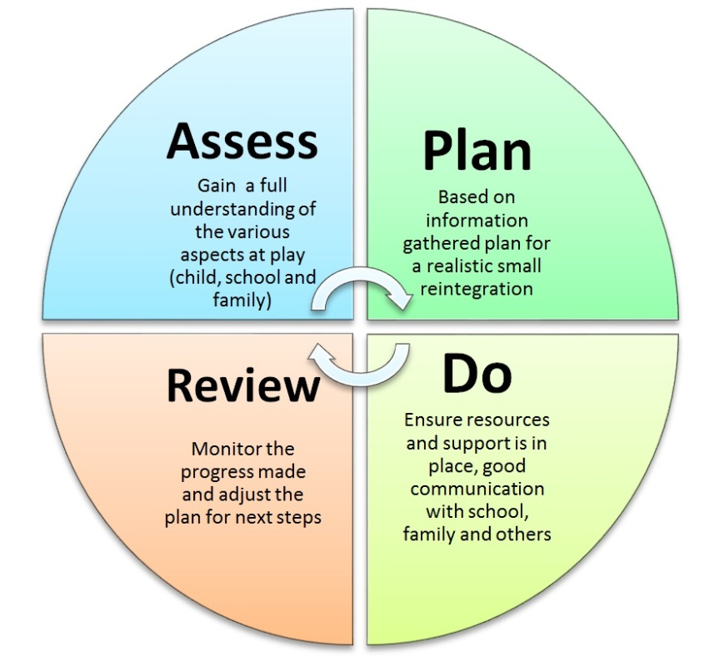
The graduated approach starts at whole-school level. Teachers are continually assessing, planning, implementing and reviewing their approach to teaching all children.
However, where a potential special educational need has been identified, this process becomes increasingly personalised.

For identified SEND pupils, the graduated approach draws on more personalised learning, more frequent reviews and more specialist expertise to tailor interventions to meet the particular needs of children and young people. Children who require a highly individualised programme of study will have Personalised Provision Plan issued which the SENDCO; class teacher, parents/carers and support staff involved will review termly.
Targets will be sent home for parents to sign and a copy returned back to school.

All individual targets are shared with pupils and they are asked to comment on these. Parents/carers are kept informed of their child’s progress through parent’s evenings, annual reviews, community assessment meetings or multi agency meetings where necessary.

2. How can I let the setting know that I am concerned about any area of my child’s development?
If you have concerns or think your child may have an additional or a special need that has not already been identified by the school, then you can contact the class teacher initially or discuss your concerns with the SENDCO or Safeguarding and Pastoral lead.

The class teacher will share any concerns with the SENDCO or Safeguarding and Pastoral lead. Any planned actions will be discussed with you and implemented appropriately. All programmes will be monitored and reviewed by class teacher and SENDco.

School Governors are involved in reviewing the SEND policy and procedures. They ensure that these are in line with the SEN. Code of Practice (C.O.P.), ensure pupils with additional needs are fully integrated into school life, inform parents about the school’s SEND policy and provision and also ensure that Statutory Reviews are managed by a `responsible’ person.

St Laurence’s Catholic Primary School will not discriminate against pupils on the grounds of SEN or disabilities.
We take into account the Disability and Discrimination Act. The Governing Body are committed to the provision of appropriate training for staff and modifications to the building when needed.

3. How will teaching be matched to my child’s needs?
All pupils in school receive quality first teaching. This means that a range of teaching and learning styles are used and that appropriate learning objectives are set for all children with a curriculum personalised to their needs.

The school recognises that children are at different stages in their learning and also learn in different ways. To support all children, the school delivers a wide and varied curriculum.
Class teachers differentiate the curriculum to meet the needs of the range of learners in their class, during their daily teaching utilising small group intervention or individual support. These interventions may be daily or two to three times a week and will vary in time depending on the intervention.

In school we adopt a ‘graduated response’ to meeting children’s needs, in line with The Code of Practice. This means that the response to special educational needs is dependent on the progress made by individuals. We understand that children learn at their own pace so interventions are closely monitored and if the child is still not making the expected progress, or if it is insufficient despite the support offered, the child could receive additional SEN support. The SENDco will meet and review the pupils targets and then contact parents for consultation. At this stage the SENDco may refer to other external agencies such as health for specialist assessments and support.

From September 2015, all children and young people from age 0-25, who have significant special educational needs will undergo an Education Health and Care (EHC) Assessment (unless their parents, carers or the young person opt out of the new system). This will lead to an EHC Plan instead of a Statement of SEN. This is a legal document that outlines the pupil’s needs, how they can be met, and the provision and resources necessary to achieve this.

At St Laurence’s, we recognise the importance of early intervention, along with the need for parents/carers to be fully involved at all times, and for pupils to be consulted about the help they are receiving.

4. How will I be informed of my child’s progress?
At St Laurence’s Catholic Primary School we recognise the right of all parents and carers to be made aware of their child`s progress, any difficulties they might be experiencing and strategies being employed to enhance progress. We welcome the opportunity to work in partnership with parents valuing their key role in their child`s education. We promote the importance of parents` roles at
Nursery & Reception Induction meetings and explain ways in which parents can help.

Parents are invited to come into school for parent meetings to discuss their child’s progress in school. This will include behaviour, attendance and attitude to school as well as learning.

Reports are shared with parents at the end of the school year. Parents will also be invited into school to review and discuss progress against targets set for both learning and behaviour. This is reviewed by either the class teacher, 1:1 support teacher and the English Support teacher. They will discuss ways forward, how parents can support the child at home and set new targets where necessary.

If your child is working with an outside agency eg .Educational Psychologist reviews would also be set to discuss observations, reports etc.

Parents are invited to Annual Reviews of EHC plans where all agencies and the Local Authority can monitor progress and decide on the necessary support for your child needs.

There are informal opportunities daily for you to see your child’s class teacher where any concerns of the day could be passed on. Also for some children we find it beneficial to have a Home School link book where we can share successes and concerns.

At St Laurence’s we have an open door policy. The SENDco and Headteacher are available for discussions every day. If a longer meeting is needed, it will be arranged as soon as possible. We give information about the L.A. Parent Partnership Service which is there to support parents through the SEN process.

5. What support do you have for me as a parent to support my child?
Adult and Family Learning opportunities are in abundance at St Laurence’s. We run a range of courses and activities throughout the year where parents can develop their own skills working alongside their child. Examples of courses are; English, Maths, Arts and Crafts. We also offer Family Learning opportunities.

Meet the teacher meetings early in September provide opportunities for parents and staff to share planning, learning tasks and opportunities, teaching methods as well as tips that help us work in partnership with parents. Leaflets outlining all of the above are distributed at these meetings.

The Seesaw and Tapestry app is used to showcase teaching and learning, demonstrating methods and providing handy hints about how you can help your child.

6. What support will there be for my child’s overall wellbeing?
We have a very experienced team of people available to support your child at school; class teachers, Teaching assistants, Safeguarding and Pastoral lead and SENDco. Throughout all year groups your child will have the opportunity of joining small nurture groups to help with social skills. The Safeguarding and Pastoral lead is able to work 1-1 with any child when the need arises and has close contact with outside agencies such as Social Care.

Any child entering school with an identified medical condition will be entered on the medical register. This will include children with asthma. It is the parent’s responsibility to inform school of any existing or changes in medical conditions. If your child has a condition that needs careful monitoring or medication given regularly such as diabetes or ADHD a meeting will be held with the SENDco and Office Staff to write a detailed Care Plan identifying key personnel to look after the child and the medication that is needed. School staff have received training from the School nurse and Alder Hey to work with a variety of conditions.

School will administer medicines after discussion with the parents
and relevant forms completed. All medicines given by recognised first aiders will be recorded. School will follow all Local Authorities guidelines.

Attendance is given a very high profile at St Laurence’s Catholic Primary School. All children and parents are made aware of the school target each week through our school newsletter.

There are a number of clubs before and after school, these include Cross Country, Football, Change 4 Life and Breakfast Clubs. For those children where their attendance is a cause for concern, school will work with the LA Officer and Governors to support parents.

Your child will have many opportunities in class to express their views through various cross curricular activities and termly meetings with their class teacher.
Children at St Laurence’s are actively encouraged to join various groups where their opinions and views are valued. The children also have the opportunity to join the school council, Mini Vinnies and Science Club.

7. What specialist service and expertise are available at or accessed by the setting to support my child?

A number of staff have received specialist training in working with a variety of medical needs such as diabetes, epilepsy and asthma.

Staff are trained in Positive Handling and de-escalation techniques. At St Laurence’s Primary School we recognise the need for external expertise and support if we are to provide a high level of education and care for our pupils. The SENDco makes all referrals with advice from all staff working with particular children and with the consent of parents. External intervention and referrals can be discussed and made at the termly planning and review meetings.

We commission support from CAST (Central Area Support Team) where we can access the following agencies:
Learning Support Service
Specialist support for SpLD pupils
Educational Psychologist (We also commission traded support)
Inclusion Support Worker

We commission support from ISES (Inclusion Standards & Effectiveness Services) where we can access:
Behaviour Support
Training for staff re Safeguarding and including Inclusion Cluster Network Meetings

Medical referrals are made through and to:
Sensory Impairment Services;
Motor Control Support Services;
Clinic / school nurse;
Speech & Language Therapy.
Physiotherapy
Occupational Therapy
Continence Service
CAMHS (Child and Adolescent Mental Health Service)
Referrals regarding children`s welfare are made to:
School Attendance Service;
MASH Team
Social Care;
Portage;

The Learning Mentor is the point of contact for Child Protection referrals.
MASH (Multi agency Strategic Hub) Safeguarding Issues
Targeted Youth Service

St Laurence’s School can also access support from :
Parenting programmes; Family First , Stronger Families
Multi-Agency assessment (allocation of support from most appropriate agency).

Mental Health Support
We recognise the importance of supporting children who suffer with anxiety and mental health. As a school we have adopted different ways of supporting your child.
Sensory room sessions
Therapy Dog
ELSA sessions with trained staff

The Governors and Headteacher recognise the importance and necessity of CPD, (Continual Professional Development) and as such actively promote training and professional development whether in house or with external agencies. The SENDco attends regular Cluster Network and SENDco meetings to learn about new developments, share good practice and develop links with outside agencies. This is shared with school staff and Governors at relevant meetings.

All staff members in school receive ongoing training to respond to the needs of the children and staff attending the school at any point in time. This may include Speech and Language, Dyslexia Training, ALK, ASC awareness training, medical training eg use of defibrillators etc.

SEN budget is based on pupils need as identified through provision mapping, PASS (Pupil Attitude to Self and School) data and monitoring outcomes. Pupil Premium information and expenditure is available on the school website.

8. How accessible is your setting and how will my child be included?
St Laurence’s has wheelchair access at a number of points throughout the school including; main front entrance, nursery, reception and school hall. There is disabled parking at the front of the school.

The School’s Access Plan is reviewed every three years to ensure it can meet the short, medium and long term needs of the pupils. The Governing Body are committed to the provision of appropriate training for staff and will explore modifications to the building based on need.

Where possible, provision will be made for all pupils to access all areas of the curriculum including extra-curricular activities and residential visits. You would always be contacted before a planned activity/trip which would be away from the school site. Prior to offsite activities/trips, a risk assessment is undertaken. If your child has specific needs then a specially trained member of staff could accompany your child to administer specific care, medication etc. or if appropriate, you may be invited to accompany your child on the activity or trip.

9. How will the setting prepare my child for transitions on to the next stage of education and life?
You will be invited to look around the school and meet school staff. Your child will also be invited to visit and stay for a short session before starting school. There are Nursery & Reception induction meetings where the Headteacher, Foundation Lead, SENDco and Safeguarding and Pastoral Lead will be available.

We will contact any early years settings, other schools and any specialist services that your child has accessed. There will be a ‘Team Around the Child' (TAC) transition meeting to ensure that we are working in partnership to achieve the best outcomes for your child and to gather all information about their needs. This will also include information regarding any active CAFs. (Common Assessment Framework).

At St Laurence’s we have a comprehensive transition plan in place to support all pupils when moving to new classes and year groups within school.
On transition to a new school or at the end of year 6, we will work closely with the new school, any agencies involved with your child and yourselves to ensure that we are working together to support your child. Your child will have the opportunity of visiting their new school, meeting key members of staff and becoming more familiar with their new environment.

All paperwork, reports, targets etc will be handed over to the new school. When moving to a new class or a new setting, if appropriate, a personal transition plan will be written. This will be in partnership with you, your child, the new setting/class and staff supporting your child to ensure that they enjoy as smooth a transition as possible.

10. How are parents/carers/families involved in the setting?
Parents are regularly invited to assemblies, religious celebrations and end of term productions.
There is also a comprehensive range of activities parents can become involved in eg; Stay and Play, (Nursery and Reception) School Bingo, and Parent and Child Art and Craft sessions.

11. Who can I contact for further information?
If you would like to talk to a member of staff please contact your child’s teacher. Phone the school 0151 546 4733
Headteacher – Mrs Carroll-McKevitt
SENDCO - Mrs McClelland
Safeguarding and Pastoral Lead - Mr Cushion
Governor in charge of SEND - Mrs Witan
Knowsley SEN team Contacts: Dan Arnold 0151 443 5126
Kelly Carey 0151 443 2978

The Local Offer can be found on the Knowsley Council website
https://www.knowsleyinfo.co.uk/categories/knowsley-local-offer-send

Glossary of Terms

ASC | Autistic Spectrum Condition
CAMHS | Child and Adolescent Mental Health Service
EP | Educational Psychologist
PPP | Personal Provision Plan
Pastoral Lead | Supports children with social/emotional/behaviour needs
QFT | Quality First Teaching – an excellent standard of teaching, enabling all pupils to make progress
EHC Plan | Education, Health and Care Plan referred to as Knowsley One Plan
SALT | Speech and Language Therapy/Therapist
SEND | Special Educational Needs and Disability
SEN Code of Practice | The legal document, which sets out the requirements for educating children with special educational needs.
SENDco | Special Educational Needs Co-ordinator – organises and monitors provision for children with special educational needs.

REVIEW OF POLICY
The effectiveness of this policy will be reviewed annually by the Senior Leadership Team and every three years by the Governing Body. If changes are made to the policy, the Governing Body will ratify amendments.

This policy was reviewed:
Signed: J Holmes

Designation: Chair of Governors

Date: 20th October 2022

