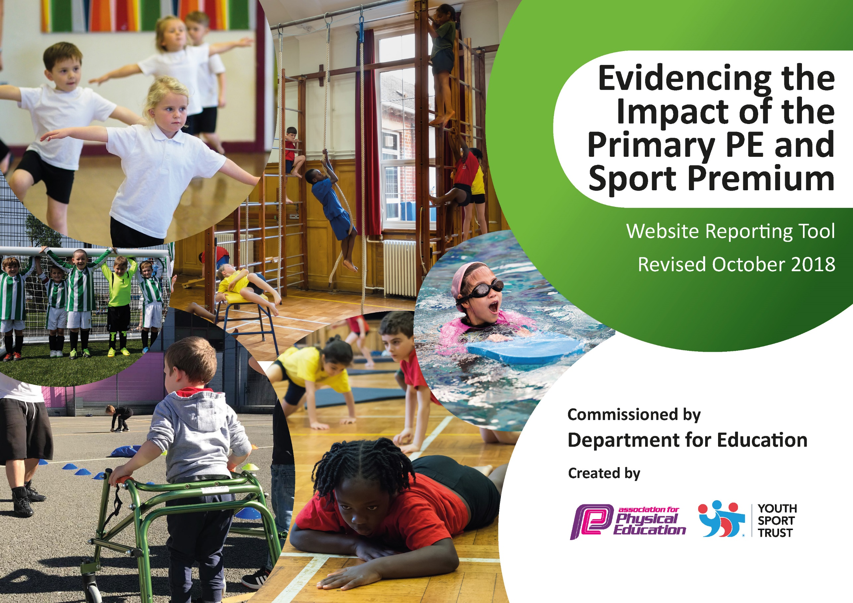
St Laurence’s Catholic Primary School
2018-2019
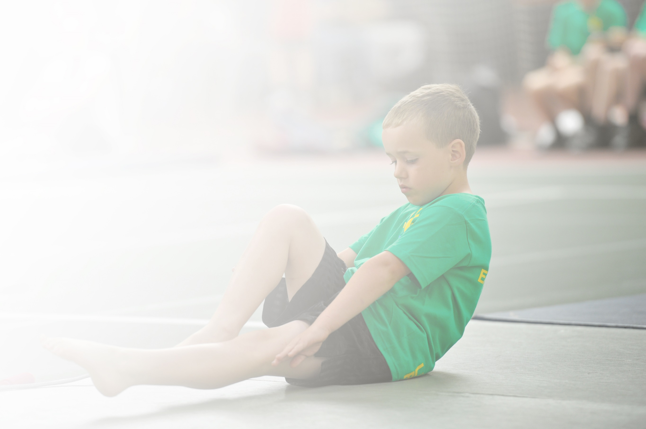
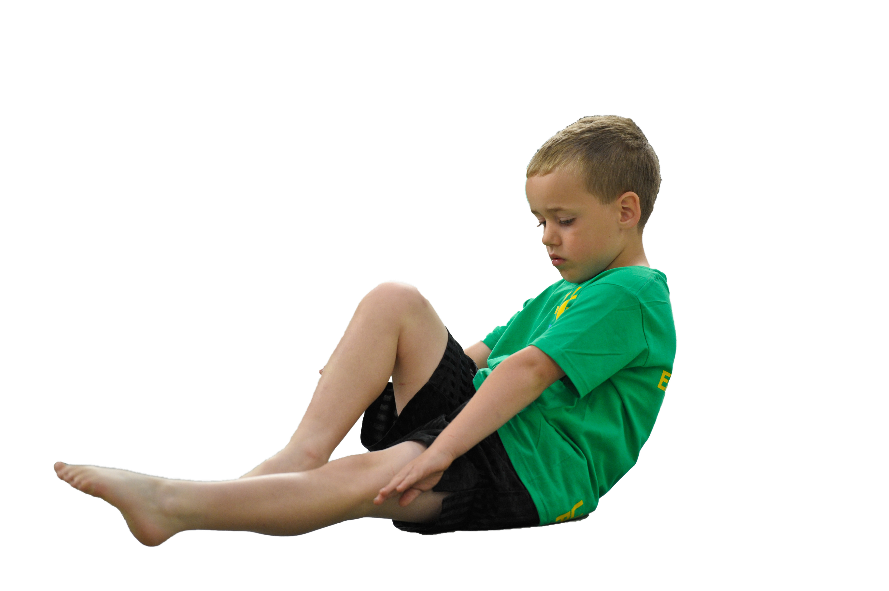
Schools must use the funding to make additional and sustainable improvements to the quality of Physical Education, Sport and Physical Activity (PESPA) they offer. This means that you should use the Primary PE and Sport Premium to:

- Develop or add to the PESPA activities that your school already offer
- Build capacity and capability within the school to ensure that improvements made now will benefit pupils joining the school in future years

Please visit gov.uk for the revised DfE guidance including the 5 key indicators across which schools should demonstrate an improvement. This document will help you to review your provision and to report
your spend. DfE encourages schools to use this template as an effective way of meeting the reporting requirements of the Primary PE and Sport Premium.

We recommend you start by reflecting on the impact of current provision and reviewing the previous
spend. Under the Ofsted Schools Inspection Framework, inspectors will assess how effectively leaders use the Primary PE and Sport Premium and measure its impact on outcomes for pupils, and how effectively governors hold them to account for this.

Schools are required to publish details of how they spend this funding as well as on the impact it has on pupils’ PE and sport participation and attainment by the end of the summer term or by 31 July 2019 at the
latest.
We recommend regularly updating the table and publishing it
on your website throughout the year, as evidence of your
ongoing review into how you are using the money to
secure maximum, sustainable impact. To see an
example of how to complete the table please
click HERE.
Support for review and reflection - considering the 5 key indicators from DfE, what development needs are a priority for your setting and your students now and why? Use the space below to reflect on previous spend, identify current need and priorities for the future.

Key achievements to date: | Areas for further improvement and baseline evidence of need:
*Continuation of CPD for staff across the school in their chosen areas of development.  *Attendance at the YST conference.  *Introduction of Active Maths of the day across all Key Stages.  *Implementation of the Daily Mile at least 3 times a week.  *Promotion of active, healthy lifestyles for all children.  *In-school physical activity programme for Key Stage 1 children and parents through Family Fitness  *We offer a range of sports during curricular and extra-curricular time, including athletics, football, high fives and gymnastics.  *Extra-curricular activities are popular and there are a good proportion of pupils eligible for free school meals who take part in each of the activities from Key Stage 2.  *Improved quality and variety of PE resources and equipment.  *All pupils are engaged in PE during curricular time (this is supported by our specialist advisor from Knowsley Schools Sports Partnership)  *We have maintained participation in intra-schools competitions, with our school having won Kirkby Indoor Athletics Championships eleven years in a row and our football teams doing consistently well in the Kirkby and Knowsley leagues and competitions.  *In school competitions including Speed Bounce and Skipping  *All of our extracurricular activities are free and completed by staff within school except for Dance and Judo.  All pupils have a 2 hour timetabled session of PE each week. There are further opportunities for PE at lunch times, through a range of clubs.  *School achieved the School Games Award Platinum (judged by KSSP) in recognition of participation and quality provision in sport. | *Ensure SEN pupils are being selected for competitions.  *PE wall display to include certificates and awards.  *Continue staff CPD in areas of weakness.  *Encourage more KS1 children to attend clubs.  *Complete PE survey to see what clubs the children would like to see.  *Re-introduction of Play Leaders for KS1 – think about dinner times for KS2 and implications.  *Send dinner time staff on CPD for encouraging positive play at lunch time.  Review of Sports Day. Consider how the flow of events can be improved and also add variation to events.
  *Separate sports days are organised for KS1 and KS2 pupils, allowing children greater opportunities to participate.
  *Separate sport days also ensures that events are suitable for the participating year groups.
  *Entered events to gain access to out of school companies such as the Everton FC Primary Premier League Tournaments.
  *Increase Daily Mile participation to at least 4 times a week.
  *Organise and run sports competitions with other local schools
  *Re-introduce daily wake up shake up sessions, possibly at end of weekly assembly

Meeting national curriculum requirements for swimming and water safety | Please complete all of the below:
What percentage of your current Year 6 cohort swim competently, confidently and proficiently over a distance of at least 25 metres?  N.B. Even though your children may swim in another year please report on their attainment on leaving  primary school. | 34/50 = 68%  HR – 20/24  KW – 14/26
What percentage of your current Year 6 cohort use a range of strokes effectively [for example, front crawl, backstroke and breaststroke]? | 29/50= 58%  HR – 17/24  KW – 12/26
What percentage of your current Year 6 cohort perform safe self-rescue in different water-based situations? | 28/50 = 56%  HR – 16/24  KW -12 /26
Schools can choose to use the Primary PE and Sport Premium to provide additional provision for swimming but this must be for activity over and above the national curriculum requirements. Have you used it in this way? | No

Action Plan and Budget Tracking
Capture your intended annual spend against the 5 key indicators. Clarify the success criteria and evidence of impact that you intend to measure to evaluate for students today and for the future.

Academic Year: 2018/19 | Total fund allocated: £18,730 | Date Updated: Autumn 2018
Key indicator 1: The engagement of all pupils in regular physical activity – Chief Medical Officer guidelines recommend that primary school children undertake at least 30 minutes of physical activity a day in school |  |  |  | Percentage of total allocation:
 |  |  |  | 23%
School focus with clarity on intended impact on pupils: | Actions to achieve: | Funding allocated: | Evidence and impact: | Sustainability and suggested next steps:
Encourage all pupils to partake in regular exercise, also ensuring PE kits are always in school and encourage healthy eating and lifestyles. | All classes have timetabled PE sessions during curriculum time and access to lunch time clubs.  Ensure all children participate within school curriculum PE lessons. This  Teachers provide extra-curricular sports before and after school. | £1000 approx | School Games Award Evidence.  PE subject Leader’s file.  Playground leaders to support children in the delivery of activities at break and lunchtimes. | Permanent PE Subject Leader  Development of PE Teaching in lessons through watching other PE teaching in school.
Playground improvements e.g. Court/pitch markings and also accessibility to adventure trail. To aid active break/lunchtimes and promote  healthier lifestyles in addition to  being utilised for curricular  and extra-curricular activities. | Ensure that access to the yard and areas for activity are completed by November 2018 | £800 approx | Children have the opportunity to develop their social, communication and organisation skills through engaging in orienteering, outdoor PE and FS activities. | Children being able to access other types of physical exercise within school.  Next steps:  Develop active travel to and from school  PE lead to develop partnership with Knowsley Schools 4 Health initiatives and look in to further awards/programmes.
To target less active pupils to encourage engagement in more physical activity | Update PE equipment to enhance provision in lessons and extra-curricular activity  Update lunch time equipment to encourage more physical activity  Improve permanent resources for PE and sport including:  *Access and fencing to a wooded area for orienteering and Forest School (FS) activities.  Encouragement of parents to join KS1 Family Fitness sessions. (purchase of healthy fruit etc to promote healthy eating) | £500 approx  £2000 approx  £100 approx | Children taking part in more structured activities that require social interaction with others.  Increased parent involvement. | Outdoor areas require maintaining in terms of equipment being updated etc.
Key indicator 2: The profile of PESSPA being raised across the school as a tool for whole school improvement |  |  |  | Percentage of total allocation:
 |  |  |  | 22%
School focus with clarity on intended impact on pupils: | Actions to achieve: | Funding allocated: | Evidence and impact: | Sustainability and suggested next steps:
Physical education prepares all children to be physically and mentally active, fit and healthy...for life. This is an important aspect of our school ethos.  Investing in equipment and resources has many benefits for all pupils such as:  Improved physical fitness, skill and motor skills development. It provides regular, healthy physical activity, teaches self discipline, facilitates development of student responsibility for health and fitness, influence moral development, leadership, co-operation with others, stress reduction – an outlet for releasing tension and anxiety, strengthened peer relationships, physical education can improve self-confidence and self-esteem, respect - PE helps you respect your body, classmates and teammates, experience in setting and achieving personal goals  Impact on positive behaviour. | Successes / participation of children in sports clubs outside of school to be highlighted and celebrated during assemblies. (Regularly recognise and reward sporting achievement through the presentation of awards throughout the year and at prize giving at the end of the summer term).  Maintain sports training, preparation for competitions and supervised activities during lunch times, before and after school. | £400 prizes and trophies | The participation of children playing in organised activities during lunch time in KS2 will be more structured, decreasing incidents of poor behaviour and low levels of activity from the children.  Children have the opportunity to develop their social, communication and organisation skills through leadership roles in PE and school sport with KS1 pupils. | Children inspired to participate in extra-curricular clubs and clubs outside of school  Next Steps:  Sports person of the week to form part of weekly celebration assemblies.
Use of PE across the curriculum, linking with other subjects (Active Maths). | Purchase and continued implementation of Active Maths | £1700 for three years (Active Maths) | Children wanting to learn in other subjects due to learning through PE activities. | Continued buy in for 3 years.
Continued involvement with Knowsley Children’s University SLA. (Children will earn University credits for every hour of extra-curricular activity they participate in and they will receive recognition when 30+ hours is reached). | Increased numbers of children attending ceremony in summer for recognition of their achievements in extra curricular activity. | £2000 Children’s University SLA | More children each year want to attend the Children’s University ceremony to receive a bronze, silver or gold award. Participation in clubs increases due to this. | Next steps:  Opening this opportunity up to all of KS2 children.

Key indicator 3: Increased confidence, knowledge and skills of all staff in teaching PE and sport |  |  |  | Percentage of total allocation:
 |  |  |  | 34%
School focus with clarity on intended  impact on pupils: | Actions to achieve: | Funding  allocated: | Evidence and impact: | Sustainability and suggested  next steps:
Provide high quality, focused continuous professional development for staff to support the delivery of high quality physical education and school sport. | Identify teaching strengths within our own staff and ‘buddy’ teachers up to develop each other.  To upskill staff to deliver high quality PE lessons to ensure sustainability of a High Quality PE & School Sport Programme.  To improve staff knowledge and understanding of Physical Education.  To develop staff confidence.  To keep abreast of new initiatives. | £2000 (supply cover included) | Watching quality teaching within the school (also observing others from collaborative schools).  Monitoring and observations.  Review by Knowsley, School Sports Partnership.  PE leader confident that PE provision is outstanding and has the means to support teaching and learning to bring about this aim.  Enhanced quality of teaching  higher standards of physical literacy.  Improved pupils’ attitude to PE.  Positive attitude to health and well. | Next Step:  PE lead observing lessons of good quality and practice and sharing these with staff across the school.
Greater range of resources available to staff to help them teach and prepare lessons. | Headteacher (previous PE lead) to work alongside new PE lead to develop his leadership skills. | £500 approx | PE teacher feels more confident in delivering PE lessons.  PE leader confident that PE provision is outstanding and has the means to support teaching and learning to bring about this aim.
Ensure staff responsible for teaching swimming attend appropriate course and gain qualifications in order to teach swimming effectively. | Access appropriate swimming course from KSSP | £2000 to fund course and pay for supply costs(possibly less). | Raise the number of children achieving expected standard for swimming at the end of primary school. | Staff to attend relevant training in preparation for their class attending swimming lessons.
Purchase a scheme of work to enable teachers to become more confident in teaching elements of PE to pupils. | Staff to use Imoves planning in their PE lessons to demonstrate skills of children, therefore enhancing their own teaching and the children’s learning experiences. | £1800 | Increased teacher confidence in delivering aspects of PE that are unfamiliar or weak e.g. Dance, Gymnastics.
Key indicator 4: Broader experience of a range of sports and activities offered to all pupils |  |  |  | Percentage of total allocation:
 |  |  |  | 25%
School focus with clarity on intended  impact on pupils: | Actions to achieve: | Funding  allocated: | Evidence and impact: | Sustainability and suggested  next steps:
Knowsley School Sports Partnership provides the co-ordination and delivery of regular high quality school and borough wide competitions in a wide and diverse range of sports, ensuring that the players/teams have the opportunity to link into county, regional and national competitions in line with national governing bodies of sport and the national School Games programme. The SLA also aims to increase the number of young people participating in competitive opportunities and the depth of competitions offered. | Continued development of extra-curricular activities, we currently offer a range of sports. Football occurs on a weekly basis, whereas other clubs will change term by term dependent on upcoming events and seasonal changes (for example cross country club changes to athletics club in the summer term).  Children will be recognised for their participation through gaining Children’s University credits | £1250 (SLA) | Monitoring and observations.  *Increased pupil participation  *Extra-curricular sports enhanced, extended and inclusive  *Improved standards in PE  *Positive attitudes to health and well-being  *Wide variety of sports offered  *Positive impact on whole school behaviour and safety
Provide after school sports clubs that are not part of the curriculum for lower key stage 2, e.g. judo  | Set up assembly for Year 2 and Year 3 children.  Create a new club for both year groups with outside agent. | £1200 | Children wanting to try new sports and attending clubs after school. Sharing their enthusiasm with others and joining outside clubs.
Complete a new sport not attempted before | Key Stage 2 children to take part in Quidditch tournament day | £1170 | Children who are hard to reach in terms of attending clubs to take an active role during the day.
Extra curricular activities for all year groups in one skilled area. | Dance for EYFS, KS1 and KS2 after school. | £1000
Key indicator 5: Increased participation in competitive sport |  |  |  | Percentage of total allocation:
 |  |  |  | 7%
School focus with clarity on intended  impact on pupils: | Actions to achieve: | Funding  allocated: | Evidence and impact: | Sustainability and suggested  next steps:
All children are encouraged to participate in competitive sport and any involvement in clubs outside of school is highlighted and celebrated. | Buy in to Knowsley SLA to give more opportunities to enter competitions  Buy new equipment to facilitate in house competitions  Plan sports competitions with other local schools (intra)  Lunch time coaching one session per week to focus on developing children for the next competition  Whole school sports day – competitive approach | £1250 (SLA) | Monitoring and observations.  *Increased pupil participation  *Extra-curricular sports enhanced, extended and inclusive  *Improved standards in PE  *Positive attitudes to health and well-being  *Wide variety of sports offered  *Positive impact on whole school behaviour and safety | Sustainability:  Continue to attend a variety of Knowsley competitions.  PE team to ensure lunch club focus is developing skills in readiness for competitions.  PE team to plan regular in school competitions

