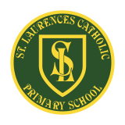**St Laurence’s Catholic Primary School Newsletter – Friday May 9th**

**Website**: [www.stlaurences.co.uk](http://www.stlaurences.co.uk)

**Email**: [stlaurence@knowlsey.gov.uk](mailto:stlaurence@knowlsey.gov.uk)

**Twitter**: @SLaurences

**Telephone**: 0151 546 4733

**Developing our gifts and talents for the good of all**

**This Week**

Another week has flown by at St Laurence’s as we race towards half term! The sunshine has been a real bonus, and the children have loved spending lots of time out on the field. With some new equipment to enjoy too, it’s been great to see them making the most of it.

We marked VE Day in school this week with a lovely themed lunch to remember the end of World War II. The children really enjoyed it, and we’ve got more activities coming up next week to help them learn about why it’s such an important moment in our history.

A big focus this week has been on our amazing Year 6s. They’ve taken part in a full week of practice SATs, following exactly the same routine they’ll have next week. They’ve all worked so hard – not just this year, but throughout their time at St Laurence’s – and we’re really proud of them. We know they’ll give it their best and do themselves proud.

**Year 6 SATs**

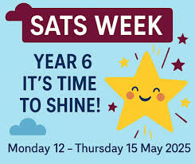Next week is SATs week at St Laurence’s, it is an extremely important week for our year 6 children. **It is vital that all year 6 children are in school at 8:40am each day** so that they can settle into a bit of early morning practice, speak to the staff who are there to reassure them and to have a bit of last-minute help with anything they need.

I’d like to ask all families to make sure year 6 children get a good night’s sleep each night as tiredness is often a barrier to children achieving the test scores they deserve.

Thank you parents and carers for all your support in this, and of course to all our staff (particularly those in year 6) who work their socks off to give every child the best opportunity they can to be successful. My own daughter is taking her SATs too and so I’ll be living the ‘parental panic’ alongside you all!!

**School Spider**

****A couple of parents have let me know on the gate that they can’t access the newsletter on School Spider. Could I ask that any parents or carer who has a similar problem please ask your child to let their class teacher know on Monday, that way I can see if it’s a wide-spread issue or just a few people needing help. There are always paper copies in the school foyer if anybody wants to come and pick one up. I’ll be looking into how we get the newsletter out to you all to make sure everyone can see it and will update you in due course.

If any parents have any other things they’d like us to look at please give myself, Mrs Barr or any member of staff a shout and we’ll see what can be done.

****

**Weekly Awards**

|  |  |  |  |  |  |
| --- | --- | --- | --- | --- | --- |
|  | **Kirkby Child** | **Star of the Week** | **English Star** | **Maths Star** | **Attendance** |
| **Nursery** | **Olivia Stott** | **Jude Kearns** |  |  | **93.8%** |
| **Reception** | **Lola Fuller** | **Nancy Twigg** | **Oliver Parry** | **Shaya Rafferty** | **100%** |
| **1S** | **Carter Goodwin** | **Penelope Mooney** | **Fredi Brown** | **Bobby Baines** | **99%** |
| **1L** | **Ethan Mawdsley** | **Skylah-Mae Smylie** | **Maggie Jones** | **Halle McPadden** | **95.2%** |
| **2S** | **Lacey-Mae Croxford** | **Nancy Walsh** | **Noah Jones** | **Oliver Austin** | **87%** |
| **2L** | **Harlen Farrell** | **Ollie Garcia** | **Maria Nascimento** | **Alfie Stott-Jennings** | **81.7%** |
| **3S** | **Caleb Rafferty** | **Aubyn Cassidy** | **Freddie Reid-Watkinson** | **Flynn Anderson** | **94.3%** |
| **3L** | **Abigail Lee Bibby** | **Sienna Downey** | **Phoebe Richards** | **Joel Jevons** | **92.7%** |
| **4S** | **Bobby Case-Cummins** | **Amiyah O’Korode** | **Theodore Dawkins** | **Duggy Faulkner** | **94%** |
| **4L** | **Jason Chean** | **Freya Appleton** | **Hayzel Townsend** | **Michael Walsh** | **80.5%** |
| **5S** | **Harvey Moss** | **Halle Carter-Smith** | **Charlie McSween** | **Freddie Stevenson** | **89%** |
| **5L** | **Ethan Karoui** | **James Murray** | **Lucas Gibney** | **Daisy Evans** | **87.5%** |
| **6S** | **Penelope Reid** | **Franky Walker** | **Scarlett Gee** | **Sonny Richards** | **98.1%** |
| **6L** | **Madison Farrell** | **Lennon Carey** | **Bobby Woods** | **Ryan Langstaff** | **99%** |

**Kirkby Child Award highlights children who are:** respectful, honest and truthful, show a positive attitude, resilient, confident, a good communicator, polite, committed and hardworking, aspirational and ambitious.

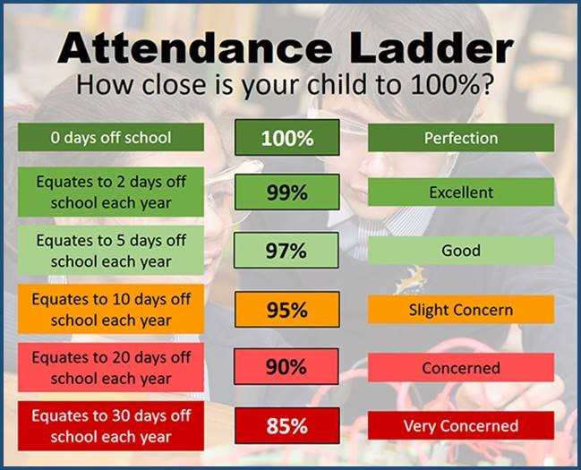**Attendance – Target is 96%**

Attendance in school is so important – every minute counts as learning begins at 8:40am! Please help your child by making sure they are in school and on time every day. Thank you to all of you who do so much to make this happen already – we appreciate your help.

Years 1 and 4 are completing assessments over the next two months and so for these children it is especially important that they are in class every day, on time and ready to learn.

*Year 4 complete their timestables check* and *Year 1 complete their phonics reading check* the week beginning Monday 9th June.

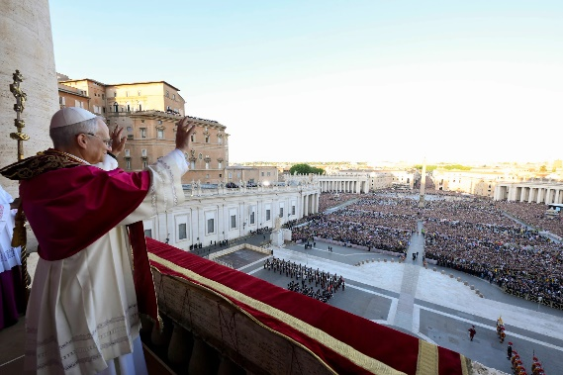**Pope Leo XIV**

I’m sure you all join our school community in welcoming our new Pope, Robert Provest, who has chosen Leo as his Papal name.



Here at St Laurence’s, we warmly welcome Pope Leo as he begins his special role leading the Catholic Church. We pray that God will guide him with wisdom, kindness, and strength as he helps people around the world to follow Jesus and live in love and peace.

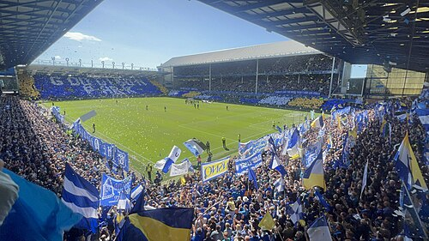**Goodison Park Visit**

We are incredibly lucky that children from our school got the chance to visit ‘The Grand Old Lady’ today on what I know is a very emotional weekend for Evertonians. I hope all of you Blues lucky enough to have a ticket enjoy the match before the move to your amazing new stadium!

Our year 3 children have been at an event with author Chris Madley who has written a book, ‘Cones and the New Stadium’, all about the history of Goodison Park, family relationship and changes. They have really enjoyed their visit and learnt a lot about these important issues, and as always they were a credit to our school with their behaviour and involvement in the activities.

**After School Clubs**

|  |  |  |  |  |
| --- | --- | --- | --- | --- |
| **Monday** |  |  |  |  |
| **Tuesday** | **Football**  Year 2  Mr Gibson | **Sports Club**  Years 3 and 4  EFC in the Community |  |  |
| **Wednesday** |  |  |  |  |
| **Thursday** | **Choir**  Years 3, 4, 5 and 6  Mrs Faulkner | **Mini Vinnies**  Mr Folksman | **Cricket**  Mr Grant |  |
| **Friday** |  |  |  |  |

**We hope you have a fantastic weekend, and we will see you all bright and early on Monday morning.**

**From Mr Mackenzie and all the staff at St Laurence’s**