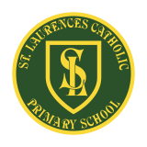**St Laurence’s Catholic Primary School Newsletter – Friday May 16th**

**Website**: [www.stlaurences.co.uk](http://www.stlaurences.co.uk)

**Email**: [stlaurence@knowlsey.gov.uk](mailto:stlaurence@knowlsey.gov.uk)

**Twitter**: @SLaurences

**Telephone**: 0151 546 4733

**Developing our gifts and talents for the good of all**

**This Week**

Hi everyone and welcome to this week’s newsletter. More lovely weather has seen our children once again enjoying plenty of time outdoors – hopefully we keep it for a lot longer too. Loads of amazing activities this week in St Laurence’s – year 5 drama lessons out on the yard, an amazing rendition of that Beatles classic ‘Black Bird’ by our choir during assembly and lots lots more!

A big highlight this week has been seeing our brilliant Year 6 children complete their SATs. They approached each day with such positivity, calmness and determination – we are incredibly proud of all of them.

Next week is shaping up to be a very busy one, with plenty of exciting activities and learning planned right across the school. We’re looking forward to making more great memories as we head towards a well-earned break!

**VE Day Celebrations – Thursday 22nd May**

We are getting ready for a fun-filled, colourful celebration to mark a slightly delayed but very special VE Day! Everyone is invited to dress in red, white and blue to show their pride and join in the spirit of the day.

In the afternoon, the whole school will head out to the field for a fantastic party packed with singing, dancing and laughter. Children will get creative by making their own celebratory flags to wave as they join in the fun. It’s set to be a joyful day of remembrance, thankfulness and coming together as a school family to celebrate this historic moment from our past.



**Half Term Next Week**

A reminder to all our families that school will close for the half-term holiday next Friday at the usual time of 3:15pm. We hope everyone enjoys a restful and fun-filled break, and we look forward to welcoming the children back to school on Monday 9th June. All staff at St Laurence’s wish all our families a safe, happy and peaceful half term!



**Parent Pay**

We are in the process of becoming a cashless school, a major part of this is introducing ‘parent pay’ as this is a secure and easy to use system which allows you to pay for school meals, trips and events quickly and easily from home. Please make sure you read this letter and follow the guidance – we appreciate your co-operation.

**Phonics Meeting**

We’ll be holding a short after-school meeting for parents and carers to explain how we teach phonics at St Laurence’s and to give you all the key information about the upcoming Phonics Screening Check, which takes place in Year 1.

Parents and carers in year 1 will receive a letter with a reply slip – however any parents and carers who interested in learning about this important part of your child’s education are more than welcome to come along.

Once you’ve collected your son/daughter just walk around and come into the hall through the front door. We look forward to seeing you all!

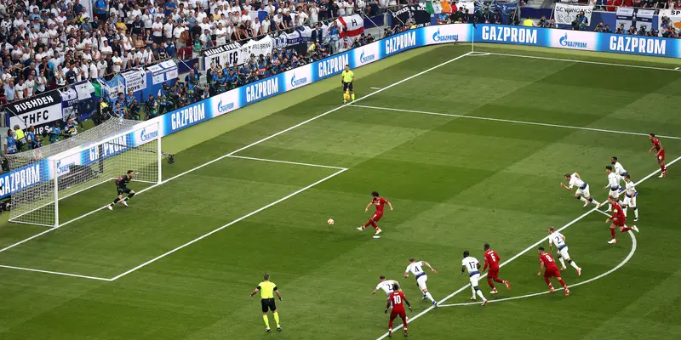**Beat the Goalie**

As the Premier League nears its conclusion – Liverpool lifting number 20 and Everton moving to a brand-new stadium – here at St Laurence’s children will get the chance to show they belong at one of our two famous football teams in our annual ‘Beat the Goalie’ competition.

It will take place next Thursday, children can pay £1 for three penalties and the chance to win themselves a football. Can you be like Mo Salah or Beto and bang one in?? We’ll see who has the skills to pay the bills!!

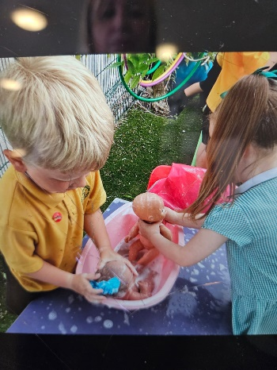**Nursery**

Down on the Costa del Southdene, our Nursery children have been making the most of the beautiful sunshine enjoying plenty of outdoor learning and play.

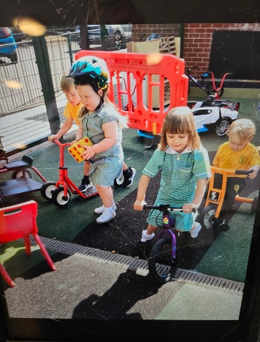

Building dens, camping out under blue skies, splashing in water trays and digging in the sand, it’s been just like a day at the beach!

The children have also been learning to share and take turns through role play and group activities, showing fantastic teamwork and imagination. It’s been a joy to see so many happy faces, curious minds and busy hands at work and play!

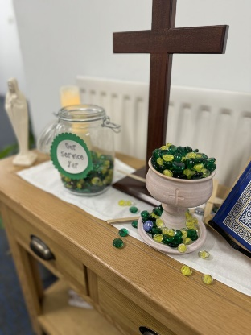

**EYFS Liturgy - Friendship**

We would like to warmly invite all parents and carers to our EYFS Liturgy taking place on Thursday next week at 9:15am. As always, it promises to be a lovely celebration led by our youngest children, sharing prayers, songs and reflections.

You are all very welcome to head straight to the hall after dropping your child off. There’ll be tea, coffee and a chance for a chat before we begin. We look forward to seeing you there and sharing this special moment together.

****

**Weekly Awards**

|  |  |  |  |  |  |
| --- | --- | --- | --- | --- | --- |
|  | **Kirkby Child** | **Star of the Week** | **English Star** | **Maths Star** | **Attendance** |
| **Nursery** | **Reuben Parry** | **Arna Shiers** |  |  | **91.8%** |
| **Reception** | **Sophie O’Rourke** | **Hallie Pollard** | **Taylor Sullivan** | **Jack Reynolds** | **96.5%** |
| **1S** | **Abigail Riley** | **Jack Martindale** | **Harper Jones** | **Lydia Richards** | **92%** |
| **1L** | **Lucas Doran** | **Frankie Stevenson** | **Aida Rawlinson** | **Star Balmer** | **96.2%** |
| **2S** | **Jaxx-James Siner** | **Noah Jones** | **Gabriel Dawkins** | **Bella Parry** | **100%** |
| **2L** | **Jaxon Dumbell** | **Rosie McSween** | **Leo Parry** | **Faith Bruen** | **83.1%** |
| **3S** | **Rosie Bradley** | **Davy Baines** | **Jack Tracey** | **Kara Cassidy** | **92.7%** |
| **3L** | **Connie Richards** | **Nevaeh Nugent** | **Leo Hackney** | **Oliver Sproule** | **99.3%** |
| **4S** | **Ronnie Baines** | **Ava Ventre** | **Harry Barnbrock** | **Isla Rossiter** | **91.6%** |
| **4L** | **Will Powell** | **Marcie Horrocks** | **Skye Balmer** | **Joshua Kearns** | **90%** |
| **5S** | **Lottie Mcveigh** | **Hallie Devine** | **Willow Jevons** | **Lorenzo Cortez** | **97.6%** |
| **5L** | **Tyler Gallagher** | **Jenson Devine** | **Jamie Dumbell** | **Reuben Croxford** | **95.8%** |
| **6S** | **Mia Rossiter** | **All of 6S** | **Ebony Edwards** | **Penelope Reid** | **100%** |
| **6L** | **Amaya Brooks-Miller** | **All of 6L** | **Jacob Ainsworth** | **Eva McIver** | **100%** |

**Kirkby Child Award highlights children who are:** respectful, honest and truthful, show a positive attitude, resilient, confident, a good communicator, polite, committed and hardworking, aspirational and ambitious.

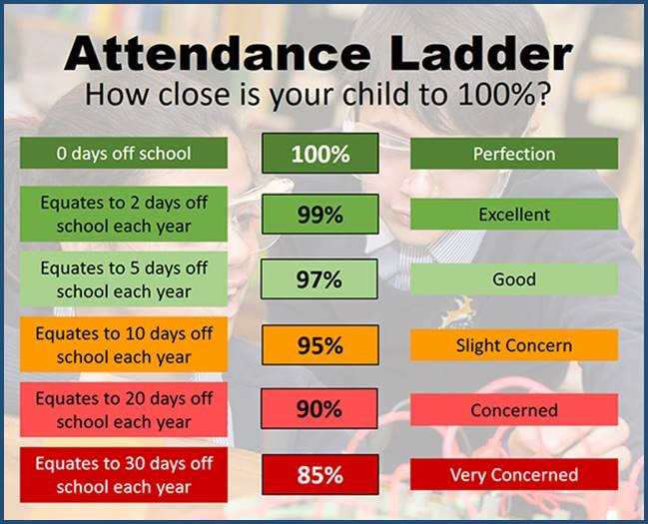**Attendance – Target is 96%**

Attendance in school is so important – every minute counts as learning begins at 8:40am! Please help your child by making sure they are in school and on time every day. Thank you to all of you who do so much to make this happen already – we appreciate your help.

Years 1 and 4 are completing assessments over the next two months and so for these children it is especially important that they are in class every day, on time and ready to learn.

*Year 4 complete their timestables check* and *Year 1 complete their phonics reading check* the week beginning Monday 9th June.

**After School Clubs**

|  |  |  |  |  |
| --- | --- | --- | --- | --- |
| **Monday** |  |  |  |  |
| **Tuesday** | **Football**  Year 2  Mr Gibson | **Sports Club**  Years 3 and 4  EFC in the Community |  |  |
| **Wednesday** |  |  |  |  |
| **Thursday** | **Choir**  Years 3, 4, 5 and 6  Mrs Faulkner | **Mini Vinnies**  Mr Folksman | **Cricket**  Mr Grant |  |
| **Friday** |  |  |  |  |

**And last, but most certainly not least …**

**OUR AMAZING FANASTIC ASTOUNDING BRILLIANT YEAR 6**

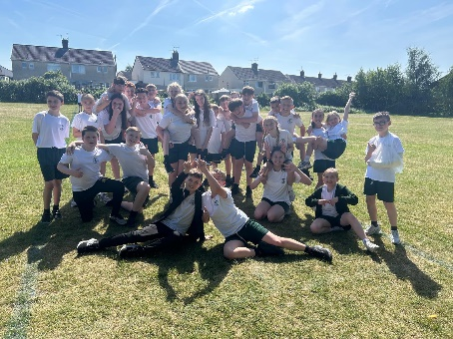What a week for our year 6 children! To have 100% attendance and everyone in on time has been fantastic and allowed us in school to prepare the children as best we can each day.

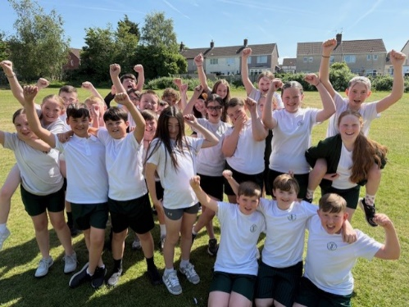We’ve seen dodgeball, training circuits and early morning revision practice to start each day. And our amazing staff have been busy cutting fresh fruit and making toast (white bread of course!) so that all our children were ready and raring to go. A massive thank you to everyone in school who has helped us this week, whether it’s been supporting children during tests or taking over whole year groups to help us out – you are all hugely appreciated and we couldn’t be without you!

And so, onto the stars of the show - our brilliant Year 6 children: we are so proud of your hard work, especially over the last few months. You’ve shown great focus and determination, but more than that, you’ve shown kindness, teamwork and a real drive to improve every single day. We know you will all get your rewards in July when we see those results.

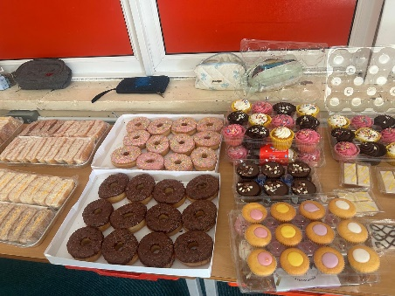While SATs are important it is always worth remembering what they don’t measure – there are a million things which make each and every one of you special. They don’t show your creativity when writing stories, drawing or crafting. They don’t show your kindness when you treat each other with respect and care. They don’t show your sporting talents like sprinting, gymnastics, dance or football. They don’t show how you make our staff and each other laugh and smile every day. And they definitely do not measure any of the amazing things you will all achieve in your lives as your grow up.

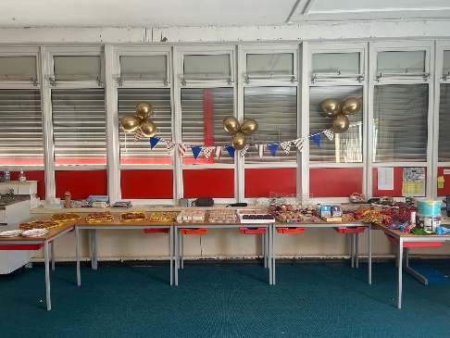

We see all of these things every day and we couldn’t be prouder of you.

We’re now looking forward to the final half-term, which will be full of fun and lasting memories. From our exciting PGL adventure at Ormside to preparing for Year 7 and enjoying your final weeks at St Laurence’s, we know this time will be full of joy. Well done, Year 6 – you are a credit to yourselves and to our school.

**A message from Mr Grant and Mrs Hill**

We just wanted to take a moment to say a huge well done to our fabulous year 6s at the end of SATs week. Over the last 8 months, you’ve shown fantastic effort, determination, and resilience – and it all culminated this week with the completion of your SATs tests.

You have all tried your absolute hardest and we are incredibly proud of the positive attitude you’ve shown throughout the years.

Remember, these tests are just one part of your journey, and the growth you’ve shown as learners and individuals is what truly matters.

Now it’s time to look forward to all the exciting things ahead in your final weeks at primary school. You’ve earned it!

Well done, Year 6 - Mr. Grant and Mrs Hill

**We hope you have a fantastic weekend, and we will see you all bright and early on Monday morning.**

**From Mr Mackenzie and all the staff at St Laurence’s**