**St Laurence’s Catholic Primary School Newsletter – Friday September 5th**

**Website**: [www.stlaurences.co.uk](http://www.stlaurences.co.uk)

**Email**: [stlaurence@knowlsey.gov.uk](mailto:stlaurence@knowlsey.gov.uk)

**Instagram**: @SLaurences

**Telephone**: 0151 546 4733

**Developing our gifts and talents for the good of all**

**Welcome Back!!**

We are absolutely thrilled to see everyone back in school after the lovely weather during our summer holidays. It’s been wonderful hearing so many stories from the children about what they’ve been up to – from exciting trips and family days out to simply enjoying time with friends.

As usual, a return to school sees the return of rain – however we are all looking ahead to a brand-new term full of opportunities, learning and special events. There is so much to look forward to, and we can’t wait to share the journey with you all.

**Key Dates**

As part of your responses to the parent/carer survey at the end of last year, you told us that it would be helpful to have a list of important dates as early as possible. Well your wish is our command! Alongside this newsletter is a list of important dates up until Christmas, please make a note of any that apply to you. More will be added as the year progresses, and we will let you know as soon as anything is booked in.

**Communication**

As we said at the end of last year, all parents/carers need to ensure that you are signed up to ***school spider*** as this is our main method of written communication – it is essential that you can access this programme. We also use ***Instagram*** (stlaurencescps) to show the work children are completing in school with photos, videos and comments made by the staff. If there is anything you are unsure about, you can always email or call school to speak to one of lovely admin staff who are happy to help.

**PE Timetable and Clothing**

Please make a note of your PE day for this first half term. On this day your child must come to school in their PE kit. Currently there is a lot of building work going on around school and this means that the sports hall and main school hall are not able to be used. As long as the ground is dry, all PE will be outside regardless of the temperature. Can I politely ask that as we move through autumn and winter, and the weather begins to turn a little colder, can you make sure your child has suitable layers so that they are able to take part in outdoor PE lessons.

|  |  |
| --- | --- |
| **Day** | **Class** |
| Monday | 3S, 3L |
| Tuesday | 5S, 5L, 6S, 6L |
| Wednesday | RS, RL, 1L |
| Thursday | 2S, 2L, 4S, 4L |
| Friday | RS, RL, 1S |

**Collection for Years 2 and 4**

We are working to make the end of the day smoother and, most importantly, safe for everyone. At the moment, all four classes (Years 2 and 4) leave through the staff car park, which is a very busy area. To keep things moving well, please could we ask for your support with the following arrangements:

**Year 4 parents** – please line up on the pavement and walk down to the classroom door to collect your child. Once you have done so, continue around the railing, through the car park, and straight to the gate.

**2L parents** – please line up along the windows and up the stairs facing the classroom door. After collecting your child, walk down the ramp and across the car park to the gate.

**2S parents** – please line up along the brick wall with the St Laurence’s sign. After collecting your child, walk down the ramp and across the car park to the gate.

We kindly ask that once you have collected your child, you leave the car park promptly. It’s important that this area is kept clear to ensure the children’s safety and to allow staff cars to exit safely.

**After School Clubs**

Next week we will be organising our after school clubs for the first half term. These will be affected by the building work also, so may be a little different to what we have provided previously. Once we have organised these clubs we will give children the opportunity to sign up for them – watch this space!

**Nursery and Reception**

We are really looking forward to seeing our reception children stay for a full week – I am 100% certain that come Friday your son or daughter will have had an amazing, fun-filled week of learning (and will likely be absolutely shattered too!) And of course we welcome our brand new nursery children for their first few days at St Laurence’s, we can’t wait to see you take your first steps along your journey with us!

**First Week Photos**

Just a few photographs of our first week back – Instagram is the main place to see more images so please make sure you follow us on there!

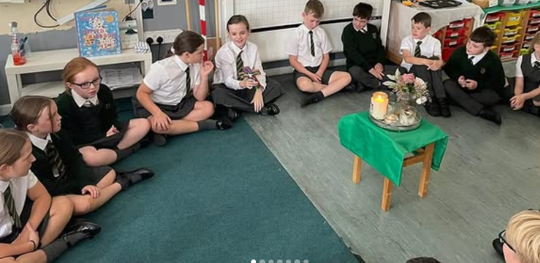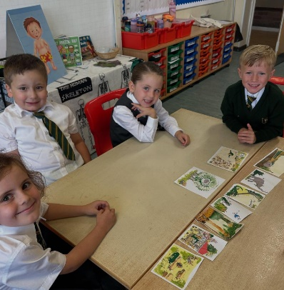

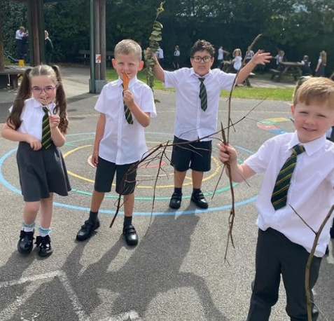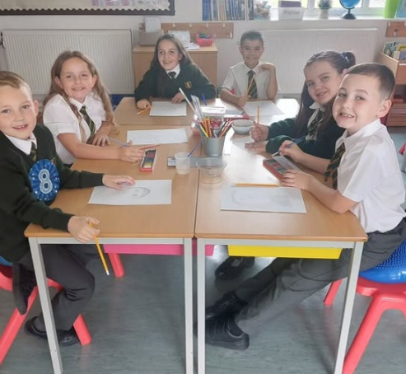

**

**Weekly Awards**

|  |  |  |  |  |
| --- | --- | --- | --- | --- |
|  | **Kirkby Child** | **Star of the Week** | **English Star** | **Maths Star** |
| **1S** | **Freya Shaw** | **Kyrah Okorode** | **Jack Reynolds** | **Antoni Rudnicki** |
| **1L** | **Lucas McCaig** | **Elsie Bagan** | **Hallie Pollard** | **Rosie Clarke** |
| **2S** | **Harley Gibney** | **Jack Martindale** | **Levi Kitamura** | **Lydia Richards** |
| **2L** | **Star Balmer** | **Noah Caulfield** | **Cienna Rafferty** | **Carter Thompson** |
| **3S** | **Evelyn Fitzsimmons** | **Tyler Greaves** | **Rosie Atkinson** | **Oliver Austin** |
| **3L** | **Millie Haddley** | **Sadee Taylor** | **Logan Sutherland** | **Noah Kearns** |
| **4S** | **Abigail Bibby** | **Sophia Konieczna** | **Esme Willaims** | **Jasper McNabb** |
| **4L** | **Kara Cassidy** | **Aubyn Cassidy** | **Esme Evans** | **Kaden Carr** |
| **5S** | **Marcus Greaves** | **Theodore Dawkins** | **Ava Ventre** | **Isla Rossiter** |
| **5L** | **Carter Roe** | **Aria Farrell** | **Luke George** | **Lois Martin** |
| **6S** | **Jala Ferguson** | **Tyler Gallagher** | **Harlow Noon** | **George Chrystal** |
| **6L** | **Lottie McVeigh** | **Darcy McCarthy** | **Archie Jones** | **Spencer Downes** |

**Kirkby Child Award highlights children who are:** respectful, honest and truthful, show a positive attitude, resilient, confident, a good communicator, polite, committed and hardworking, aspirational and ambitious.

**We hope you have a fantastic weekend, and we will see you all bright and early on Monday morning.**

**From Mr Mackenzie and all the staff at St Laurence’s**