**St Laurence’s Catholic Primary School Newsletter – Friday September 5th**

**Website**: [www.stlaurences.co.uk](http://www.stlaurences.co.uk)

**Email**: [stlaurence@knowlsey.gov.uk](mailto:stlaurence@knowlsey.gov.uk)

**Instagram**: @SLaurences

**Telephone**: 0151 546 4733

**Developing our gifts and talents for the good of all**

**This week at St Laurence’s**

Our first full week of school has been a real pleasure. Our nursery children have begun their journey with us and are already shaping up to be a fantastic bunch! Reception are beginning to build some lovely friendships and learning through play so sensibly. Throughout years 1 to 6 it has been amazing to walk around school and see so many boys and girls learning new things and enjoying themselves in their new classes. I must give a mention to Mr Kenny’s brand new low level lamps – the children in his class certainly seem to be revelling in the calming mood they help to create! Lots of important messages, as always, so please make yourself aware by reading the information carefully.

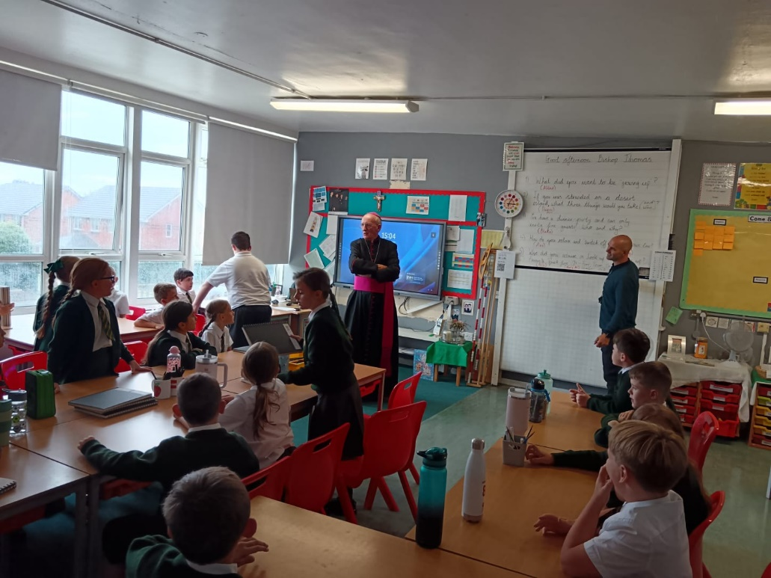

**Bishop Tom Williams**

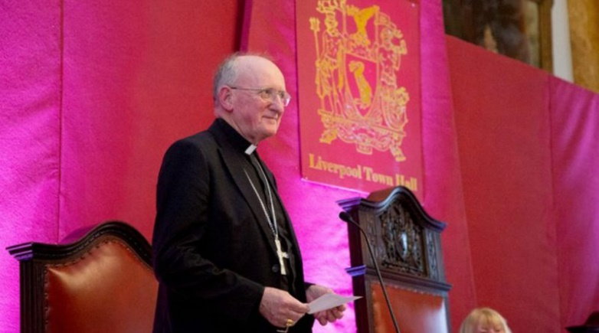It was wonderful to welcome Bishop Tom Williams and Fr Sean to St Laurence’s on Wednesday this week. Bishop Tom visited our year 5 and 6 classrooms to talk to the children about our mission – using our gifts and talents for the good of all.

As with all visitors, our children gave the Bishop a very warm and friendly welcome and asked some searching questions (he’s an Evertonian!) while learning some very important lessons about spreading our Catholic faith through our daily words and actions.

**Snack-tember**

We all know about Mou-vember and Dry January – well this September, we are launching SNACK-TEMBER (©Mr Folksman) as we begin moving towards healthier snacks and drinks in school.

Over the next few weeks, we will be encouraging all children to leave unhealthy snacks, such as crisps, at home and bring in a healthy snack, such as fruit, for their morning break. Eating a healthy snack gives the children the correct levels of energy they need for learning and play as well as helping them develop good habits for life. Many of our children will already have enjoyed the fruit on offer in school during their time in nursery and reception. We are excited to see the positive impact this will have on the health and wellbeing of our school community.

**After School Clubs**

|  |  |
| --- | --- |
| Mon |  |
| Tue | Football: Years 3 & 4  (Everton in the Community) |
| Wed |  |
| Thu | Football: Years 5 & 6  (Liverpool Foundation &  Mr Grant) |
| Fri |  |

As we have explained previously, the building works in school mean we are limited as to what we can offer for our after school clubs up until Christmas. The table opposite shows which clubs will be available next week. There is a limit of 20 spaces for each club with spaces allocated on a first come first serve basis. Parents will then be notified of which clubs your child is attending. Across the academic year we will ensure that as many children as possible are able to access the after school clubs they apply for, and more clubs will begin across the next two weeks.

**Year Group Parent Meetings**

An early reminder that our year group parent meetings take place the week beginning Monday 22nd September. These meetings are a really important part of the school year for yourselves as parents/carers but also for our staff as it is a chance for us to meet and talk to you.

These meetings will begin at 2.45pm and lots of information will be given regarding our expectations of the children and ways in which we can work together to help them achieve the highest standards possible. Please ensure that someone attends this important meeting to pick up the information for your child.

**Monday 22nd – Y6 Tuesday 23rd – Y5 Wednesday 24th – Y4 Thursday 25th – Y3**

**After School Club Booking**

After reviewing our after school club arrangements, we have noticed that some places are being booked but not used. We completely understand that last-minute changes can happen, however there are a number of families who need a place but have been unable to book. To make sure we can offer this service to as many children as possible, we kindly ask that places are only booked on the days your child will be attending. This will help us support more families and make the best use of the spaces available.

**Year 6 Super Saturday**

Tomorrow is the first opportunity for our year 6 children to visit All Saints and begin to get to know their local Catholic Senior School a little better. Having heard about these events and speaking to people who have experienced them in the past, it is an opportunity we believe all our year 6 children should take up. We will be looking at the social media account of All Saints to see how much fun you all have!

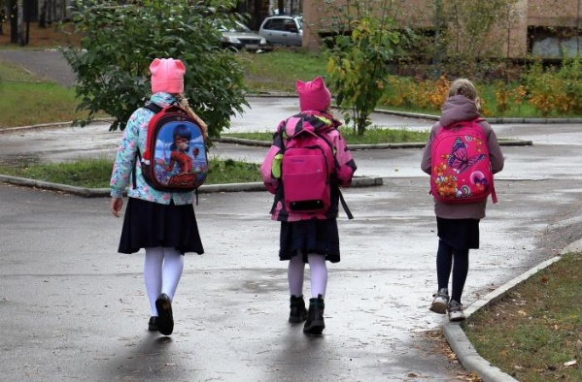**School Drop Off**

Now that we’ve settled into the first couple of weeks of term, we politely ask that from Year 1 upwards, children walk across the playground on their own in the mornings. We appreciate this may feel like a small change, but it is an important step in helping children develop their independence. It also allows staff to manage the busy start of the school day more effectively, ensuring a calm and smooth entrance for everyone.

**

**Weekly Awards**

|  |  |  |  |  |  |
| --- | --- | --- | --- | --- | --- |
|  | **Kirkby Child** | **Star of the Week** | **English Star** | **Maths Star** | **Attendance** |
| **Nur** | **Junior McNabb** | **Florence McKenna** |  |  | **89.1%** |
| **RS** | **Louie Nolan** | **Nevaeh Brennan** | **Everley Hughes** |  | **93.1%** |
| **RL** | **Isla Gibney** | **Christopher Blease** | **Olivia Forshaw** |  | **94.7%** |
| **1S** | **Arlo Farrell** | **Jack Reynolds** | **Amelia Walsh** | **Rosie McGorian** | **93%** |
| **1L** | **Nancy Twigg** | **Emily Duncan** | **Finley Stephen** | **Emma Madden** | **96%** |
| **2S** | **Amelia Challinor** | **Thomas Davies** | **Indie Nicholson** | **Noah Prince George** | **89.6%** |
| **2L** | **Frankie Stevenson** | **Iris McGorian** | **Bella Phillips** | **Lucas Doran** | **96.9%** |
| **3S** | **Esme Hedges** | **Annie McNamara** | **Stella Kitamura** | **Jacob Ventre** | **95.5%** |
| **3L** | **Maria Nascimento** | **Benji Jones** | **Harley Fiocca** | **Charlotte Lally** | **95.3%** |
| **4S** | **Phoebe Richards** | **Hunter Arnold** | **Luke Davies** | **Harrison Warwick** | **98.4%** |
| **4L** | **Nelly O’Brien** | **Omotoyin Omotosho** | **Leo Hackney** | **Flynn Anderson** | **95.4%** |
| **5S** | **Amiyah Okorode** | **Sophia Woods** | **Blake Murphy** | **Harry Barnbrock** | **96.8%** |
| **5L** | **Reuben Shaw** | **Freya Appleton** | **Leo Nolan** | **Jacob Sproule** | **100%** |
| **6S** | **Jamie Dumbell** | **Nancy Jones** | **Alyssa Mawdsley** | **Jenson Devine** | **89.2%** |
| **6L** | **Harper Farish** | **Archie Jones** | **Kaisha Reynolds** | **Elijah Greenhalgh** | **95.4%** |

**Kirkby Child Award highlights children who are:** respectful, honest and truthful, show a positive attitude, resilient, confident, a good communicator, polite, committed and hardworking, aspirational and ambitious.

**We hope you have a fantastic weekend, and we will see you all bright and early on Monday morning.**

**From Mr Mackenzie and all the staff at St Laurence’s**