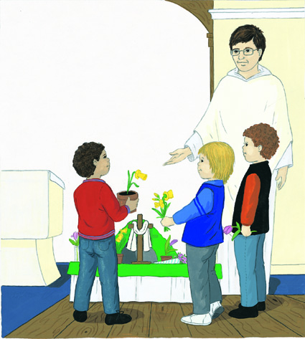

**This is the wood of the cross on which Jesus died.**

**Let us remember him.**

**Jesus, remember me when you come into your Kingdom.**

**Jesus, you are so good.**

**Help us to grow in goodness.**

**Jesus, you are so kind.**

**Help us to grow in kindness.**

**Jesus, you are so caring.**

**Help us to grow in caring.**

**Jesus, you are so loving.**

**Help us to grow in loving.**