
Personal Best
Challenge 1

Jumping Jacks

How many Jumping Jacks can you perform in 30 seconds?
Write down your score here: ___
Practice every day to see if you can improve your score. Every time you get a higher score write it down below:

______ ______ ______ ______ ______
Personal Best
Challenge 2
Through the Hula Hoop



How many times can you pass the Hula Hoop over your whole body in 30 seconds?

Write down your score here: ___
Practice every day to see if you can improve your score. Every time you get a higher score write it down below:

______ ______ ______ ______ _______

Personal Best
Challenge 3

Bean Bag Target

START
How many bean bags (or soft toys) can you throw into a hula hoop (or bucket or bowl) from a distance of 3 metres in 30 seconds?
Write down your score here: ___
Practice every day to see if you can improve your score. Every time you get a higher score write it down below:

______ ______ ______ ______ _______
Personal Best
Challenge 4

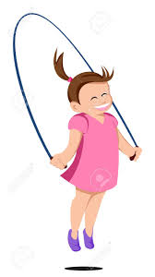
Skipping
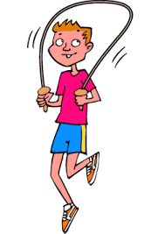

How many times can you make the rope go round in a full circle in 30 seconds?
Write down your score here: ___
Practice every day to see if you can improve your score. Every time you get a higher score write it down below:

______ ______ ______ ______ _______

Personal Best
Challenge 5
Bounce Overs

How many times can you jump two footed side to side over a line in 30 seconds?
Write down your score here: ___
Practice every day to see if you can improve your score. Every time you get a higher score write it down below:

______ ______ ______ ______ _______
Personal Best
Challenge 6
Two Hand Catch



How many times can you throw a bean bag (or soft toy) above your head and catch it in 30 seconds?
Write down your score here: ___
Practice every day to see if you can improve your score. Every time you get a higher score write it down below:

______ ______ ______ ______ _______
Challenge | Score | Score | Score | Score | Score | Score
1
2
3
4
5
6
You may want to challenge other members of your family to find their Personal Best

Can you think of some challenges of your own?
If so, please share them on Twitter using @KnowsleySSP so we can all try them!

Stay Safe, Stay Active!

