
Personal Best
Challenge 1

Bouncing Ball



How many ball bounces can you perform in 30 seconds?
Write down your score here: ___
Practice every day to see if you can improve your score. Every time you get a higher score write it down below:

______ ______ ______ ______ ______
Personal Best
Challenge 2

Sit-ups
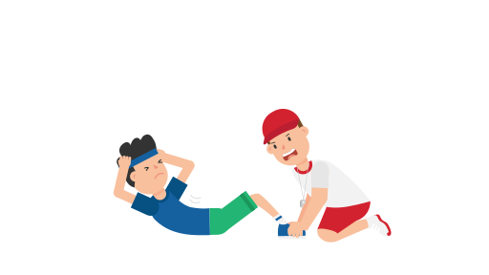
How many sit ups can you perform in 30 seconds?
Tips: Try to just bring your shoulders and upper back off the floor and keep your lower back stuck to the floor, this will make sure that you’re using your stomach muscles and not your lower back and hips!
Write down your score here: ___
Practice every day to see if you can improve your score. Every time you get a higher score write it down below:

______ ______ ______ ______ _______

Personal Best
Challenge 3

Press Ups
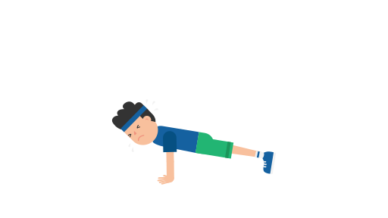
How many press up can you perform in 30 seconds?

Tips: Keep your shoulder blades locked down and back and don’t let your elbows flare out to the sides, try to keep a straight line from your feet to your head!
Write down your score here: ___
Practice every day to see if you can improve your score. Every time you get a higher score write it down below:

______ ______ ______ ______ _______
Personal Best
Challenge 4

Squats
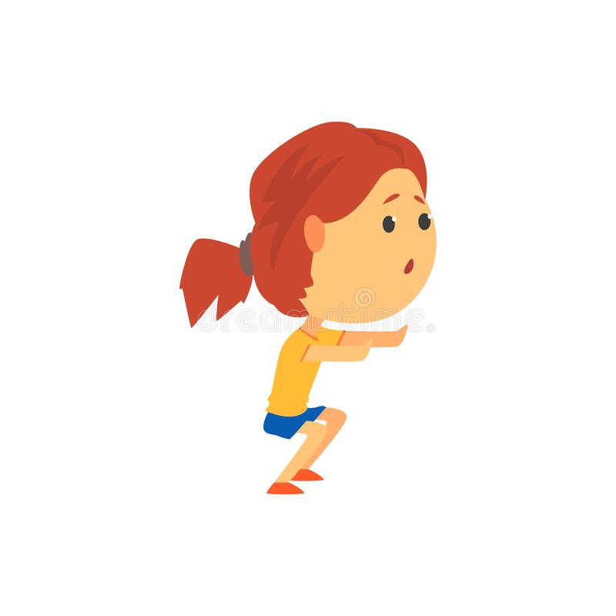
How many squats can you perform in 30 seconds?

Tips: Keep your stomach tense and think of sitting back into a chair, keep your chest high, push your knees out as you go down and don’t let your lower back round!
Write down your score here: ___
Practice every day to see if you can improve your score. Every time you get a higher score write it down below:

______ ______ ______ ______ _______

Personal Best
Challenge 5
Jumping Lunges

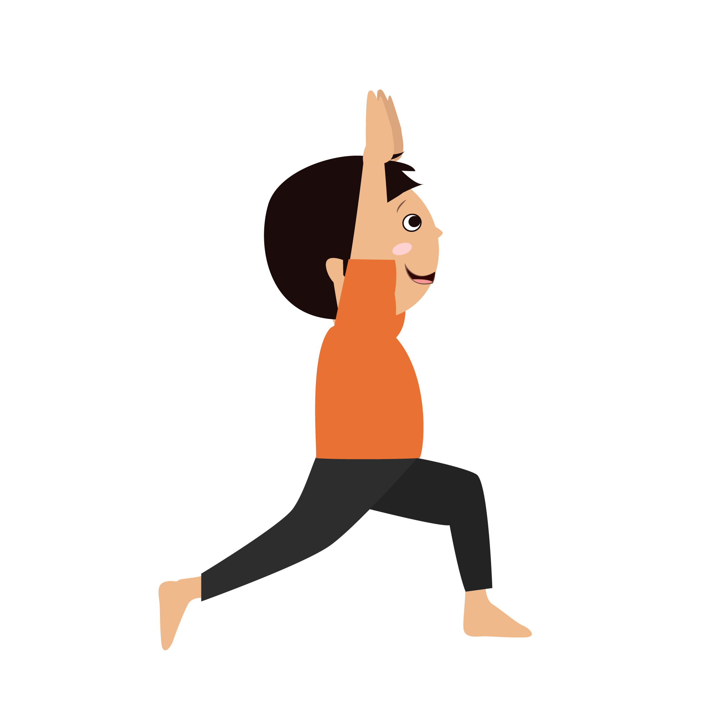

How many jumping lunges can you perform in 30 seconds?
Tips: Switch legs each time you jump, try to keep your weight centred and land softly each time, keep your stomach tensed throughout!
Write down your score here: ___
Practice every day to see if you can improve your score. Every time you get a higher score write it down below:

______ ______ ______ ______ _______
Personal Best
Challenge 6

The Plank

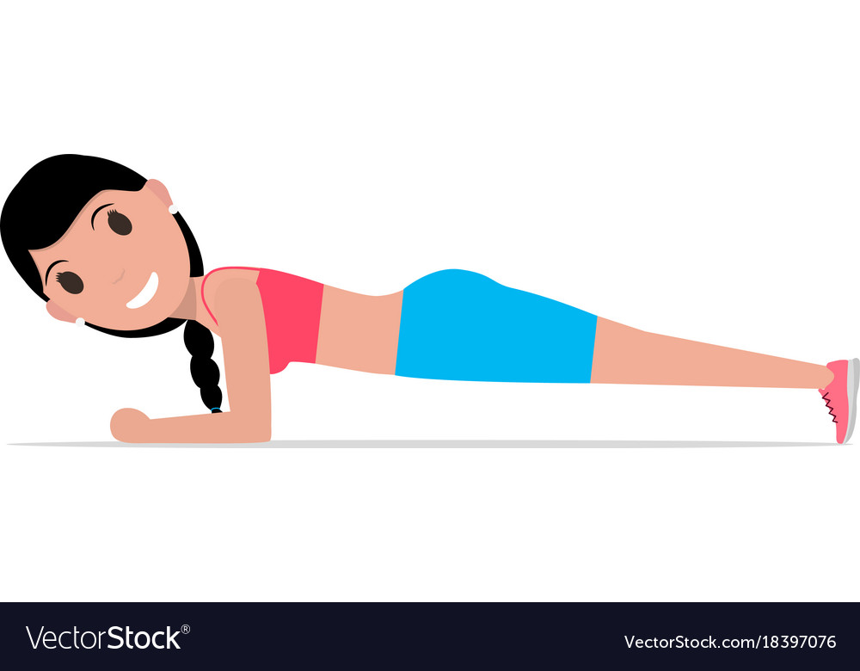

How many seconds can you hold the plank for ?
Tips: Try to keep a straight line from your feet to your head, squeeze every muscle and hold for as long as you can!
Write down your score here: ___
Practice every day to see if you can improve your score. Every time you get a higher score write it down below:

______ ______ ______ ______ _______
Challenge | Score | Score | Score | Score | Score | Score
1
2
3
4
5
6
You may want to challenge other members of your family to find their Personal Best

Can you think of some challenges of your own?
If so, please share them on Twitter using @KnowsleySSP so we can all try them!

Stay Safe, Stay Active!

