
Personal Best
Challenge 1
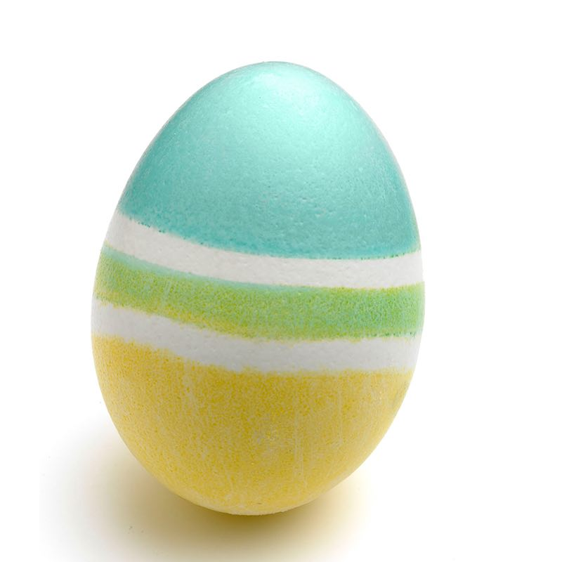

Bunny Hops

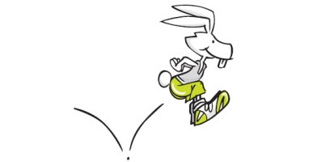

How many bunny hops can you perform in 30 seconds?

Write down your score here: ___
Practice every day to see if you can improve your score. Every time you get a higher score write it down below:

______ ______ ______ ______ ______
Personal Best
Challenge 2

Juggling
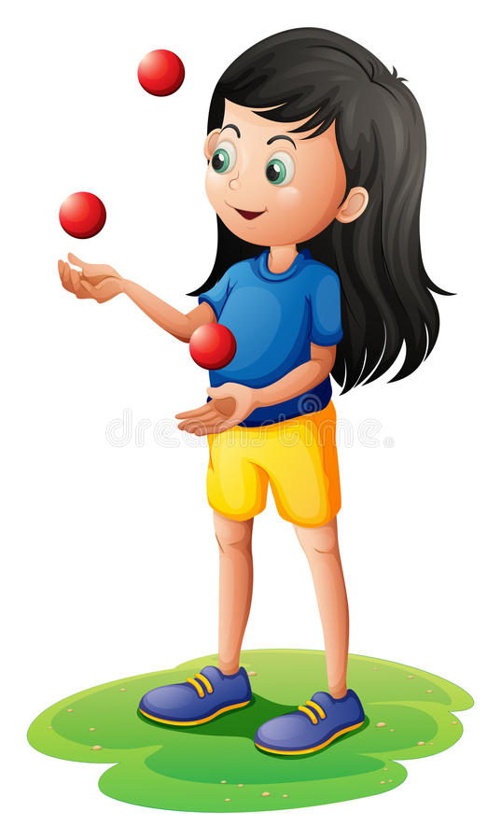
Can you juggle for 30 seconds?

Write down your score here: ___
Practice every day to see if you can improve your score. Every time you get a higher score write it down below:

______ ______ ______ ______ _______

Personal Best
Challenge 3

Bicep Curls

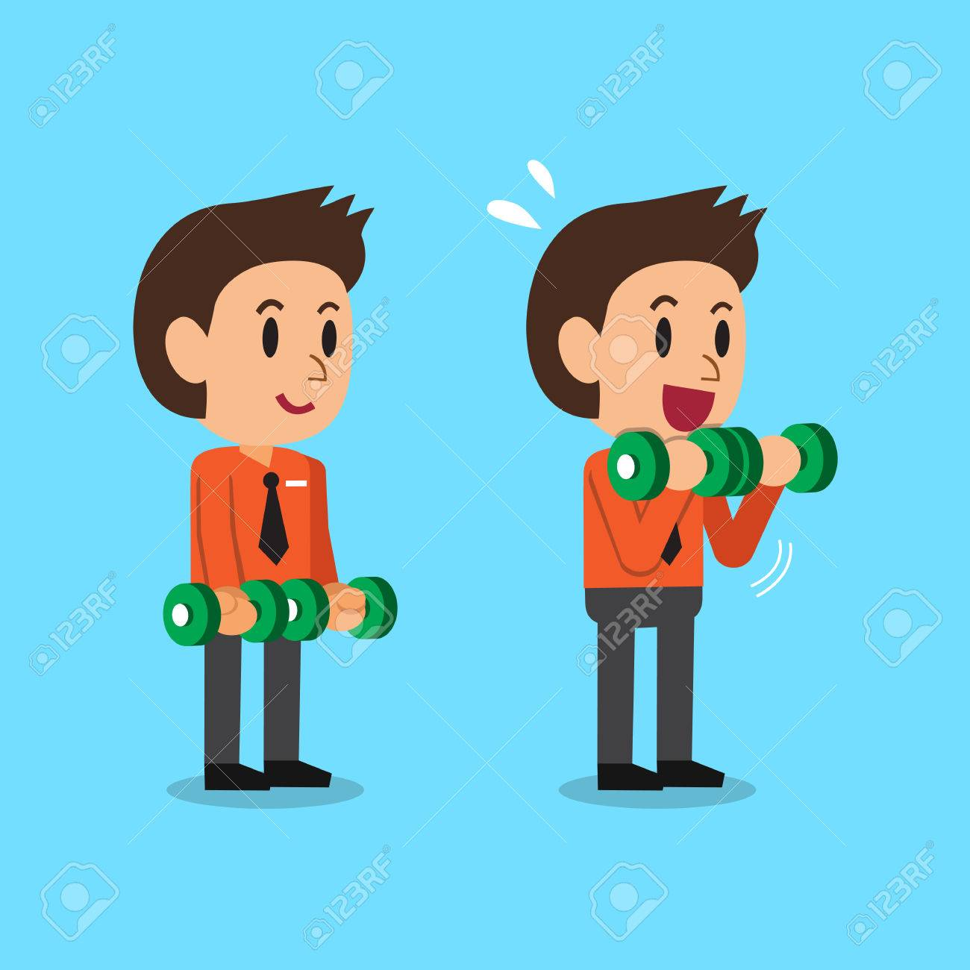
How many bicep curls can you perform in 30 seconds?

Tips: Use two water bottles but make sure they are full!

Write down your score here: ___
Practice every day to see if you can improve your score. Every time you get a higher score write it down below:

______ ______ ______ ______ _______
Personal Best
Challenge 4

Burpees
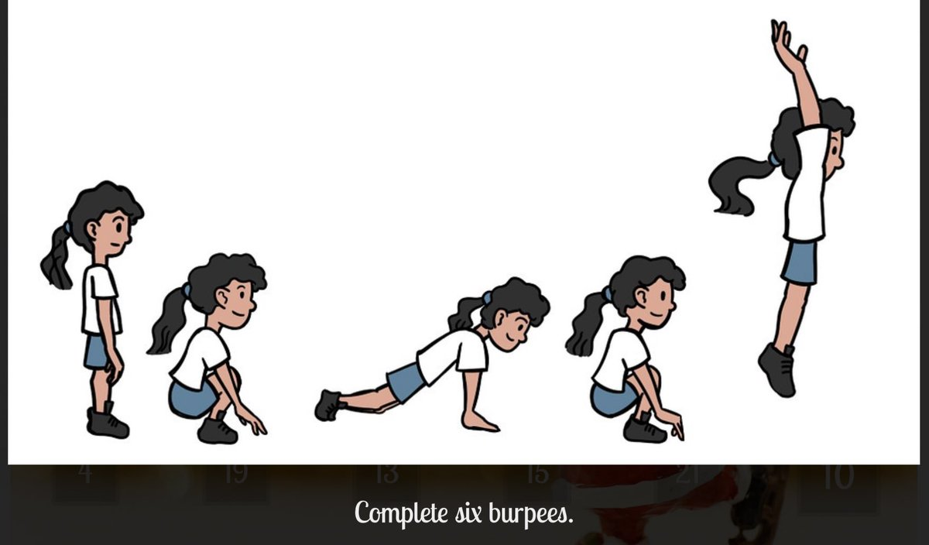
How many Burpees can you perform in 30 seconds?
Tips: Stand with your feet shoulder-width apart and lower your body into a squat. Place your hands on the floor directly in front of, and just inside, your feet. Jump your feet back to softly land on the balls of your feet in a plank position. Jump your feet back so that they land just outside of your hands. Reach your arms over head.
Write down your score here: ___
Practice every day to see if you can improve your score. Every time you get a higher score write it down below:

______ ______ ______ ______ _______

Personal Best
Challenge 5
Bouncing ball
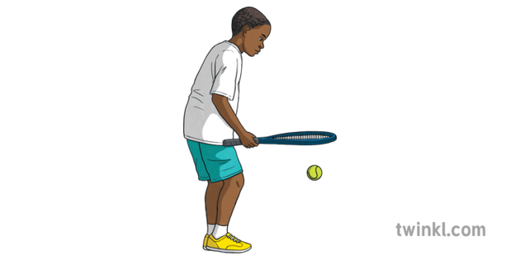

How many bounces can you perform in 30 seconds?

Tips: If you have not got a racket use a book

Write down your score here: ___
Practice every day to see if you can improve your score. Every time you get a higher score write it down below:

______ ______ ______ ______ _______
Personal Best
Challenge 6

Leg Raises
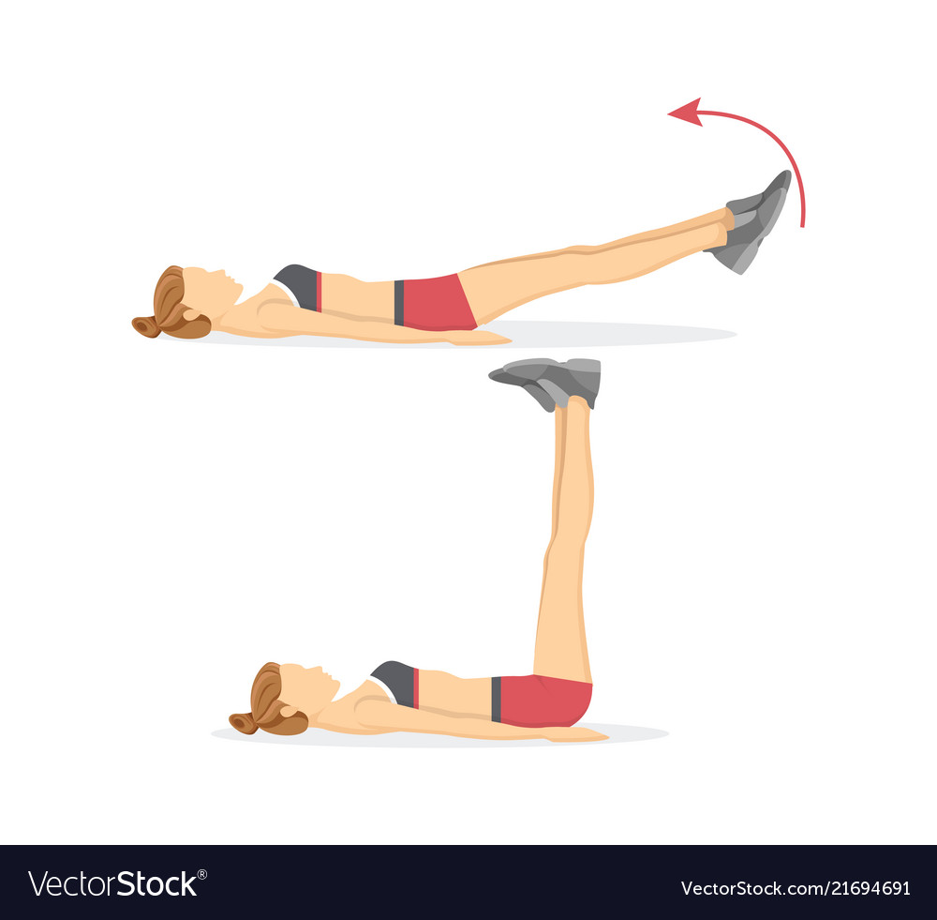

How many leg raises can you perform in 30 secs?

Write down your score here: ___
Practice every day to see if you can improve your score. Every time you get a higher score write it down below:

______ ______ ______ ______ _______
Challenge | Score | Score | Score | Score | Score | Score
1
2
3
4
5
6
You may want to challenge other members of your family to find their Personal Best
Also did you spot the Easter Eggs how many did you see? ___

Can you think of some challenges of your own?
If so, please share them on Twitter using @KnowsleySSP so we can all try them!

Stay Safe, Stay Active!

