Spanish
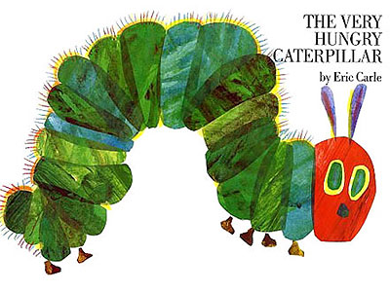
Food; days of the week; numbers to 5.
Go to https://www.youtube.com/watch?v=XeP8oyOEFSU

The story is LA ORUGA MUY HAMBRIENTA (THE VERY HUNGRY CATERPILLAR )

Listen to the story.
*At the end, draw some of the food that the caterpillar (la oruga) ate.
*Label the food in Spanish and English. Add numbers in Spanish.
*Add some more food to the story and find out what they are called in Spanish.
*Watch https://www.youtube.com/watch?v=3wyEjITKktU&feature=youtu.be and identify and learn other fruits.
*You could make some snap cards by drawing two or more of each food.
*Days of the week – write down the days of the week in Spanish.
*Make a picture like this one with days of the week, fruits AND numbers in Spanish.
