Spanish Alphabet

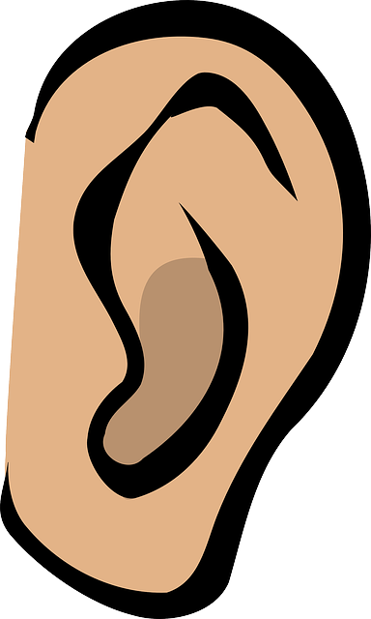
Watch Listen

Sing

Youtube: Spanish alphabet song - https://www.youtube.com/watch?v=fporIAdys9A

Extra idea...
After watching and learning, make your own Spanish Alphabet Book by writing the sounds for each letter and drawing a picture for each letter.
