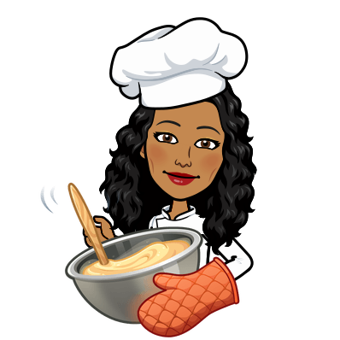
Mi pequeño libro de cocina española
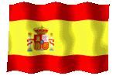
My little Spanish cookbook

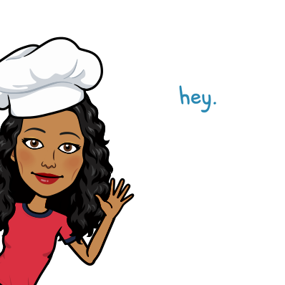Here is a recipe to start you off;
1. Magdalenas (Spanish Cupcakes)

Why don’t you find other Spanish foods to make. Remember to add:
a) Its name (Spanish and English)
b) Any information about it.
c) Instructions how to make it.

1. Magdalenas (Spanish Cupcakes)
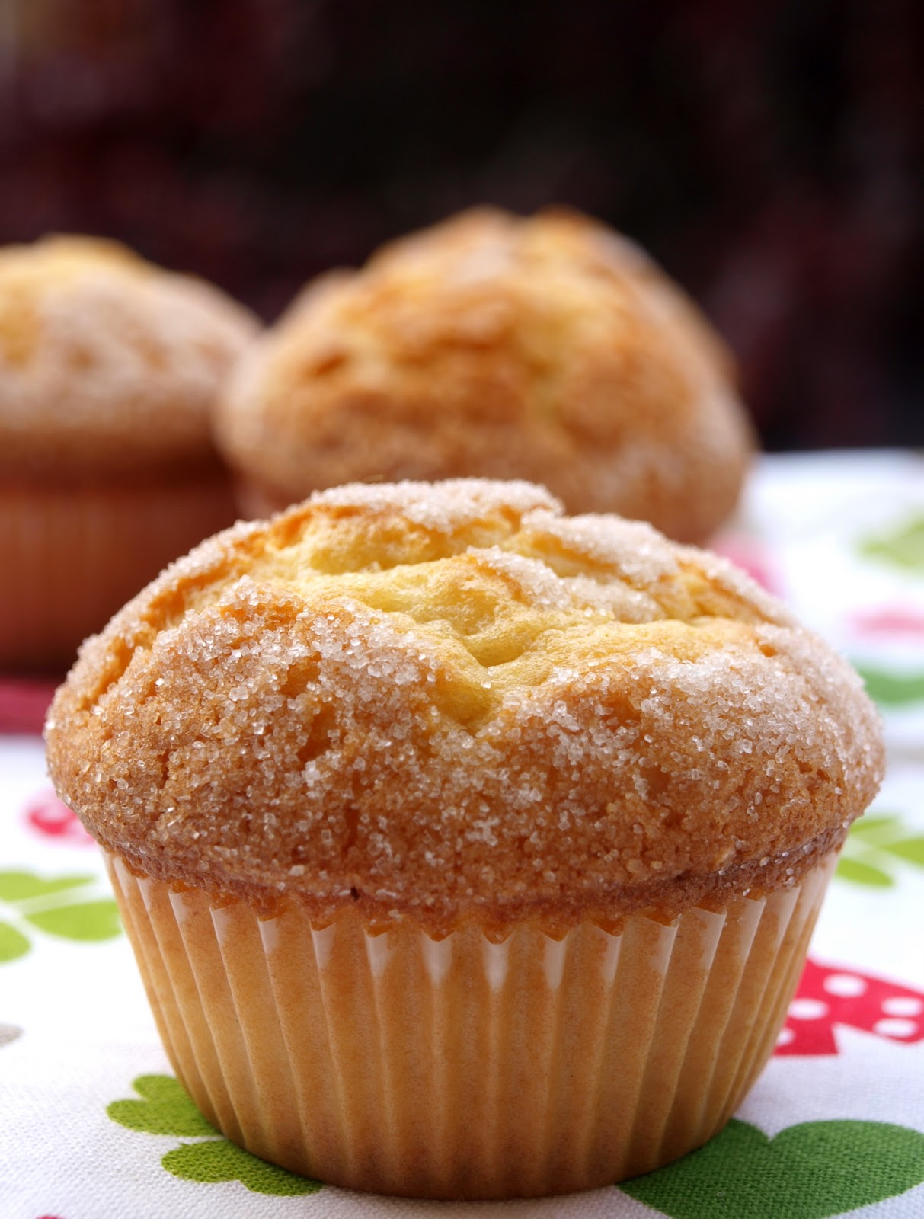
In Spanish, magdalenas simply means "cupcakes" or "muffins." This recipe makes a sweet tasting cake.
It is common to enjoy them at deysayuno (breakfast) with café con leche (coffee with milk).

Hola!Watch here: https://www.youtube.com/watch?v=V0F9zhU3GPE

Ingredients:
- zest of 1 lemon ( un limón)
- 3 eggs (tres huevos)
- 2 tsp baking powder (levadura en polvo)
100ml sunflower oil (aceite de girasol)
- 150g self-raising flour (harina)
- 150g caster sugar (azúcar) You will also need a cake tin and cases.

Method:
- Get an adult to preheat the oven to 180 degrees or gas mark 4.
- Beat (batir) the eggs and sugar together in a bowl (cuenco) until the mixture goes fluffy.
- Slowly add in the oil and stir (remover) the mixture until it becomes creamy then add the lemon zest.
- Add the baking powder and sift ( tamizar) the flour into the mixture, giving everything one final mix.
- Pour (verter) the mixture into paper cases until they are half (medio) full.
- Sprinkle some sugar on top and get an adult to place the tray in the oven for fifteen ( quince) to twenty (veinte) minutes.

