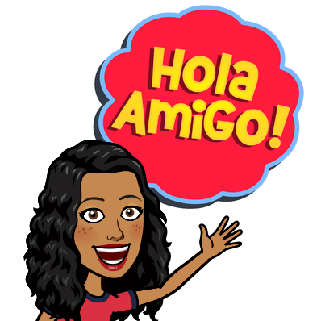
This week is fitness linked to Spanish.
1. Watch this clip:
https://www.youtube.com/watch?v=m_Clwq4osEQ
and get moving!


2. Play a game:
https://www.educandy.com/site/resource.php?activity-code=23e82
how many words can you remember!



