
Today we are going to look at one of the great painters - Pablo Picasso.

1. Watch this clip:
https://www.bbc.co.uk/bitesize/clips/zq34wmn
BBC bitesize KS2 Pablo Picasso clip




2. Play this quix:
https://www.educandy.com/site/resource.php?activity-code=23f5d

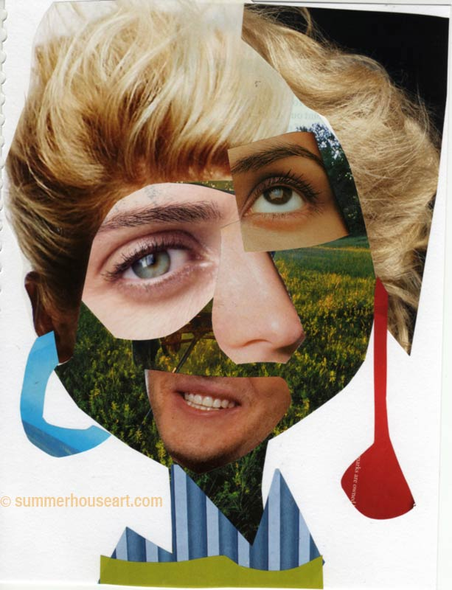
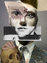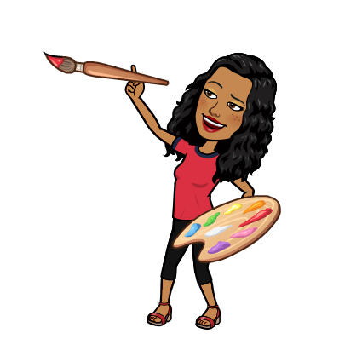
3. Art like Pablo:
a) Funny Faces – cut out some faces from magazines.
b) cut up the eyes; ears; mouth etc.
c) muddle the face pieces up and make a new face!
Upload any pictures to your class Seesaw.

