
Today we are going to take a holiday to Madrid – well a virtual one!

1. Open up
https://www.airpano.com/360photo/madrid-spain/
Airpano.com search Madrid




2. Click on the ? and find out what they are.
Have a tour around Madrid.
What do you think?


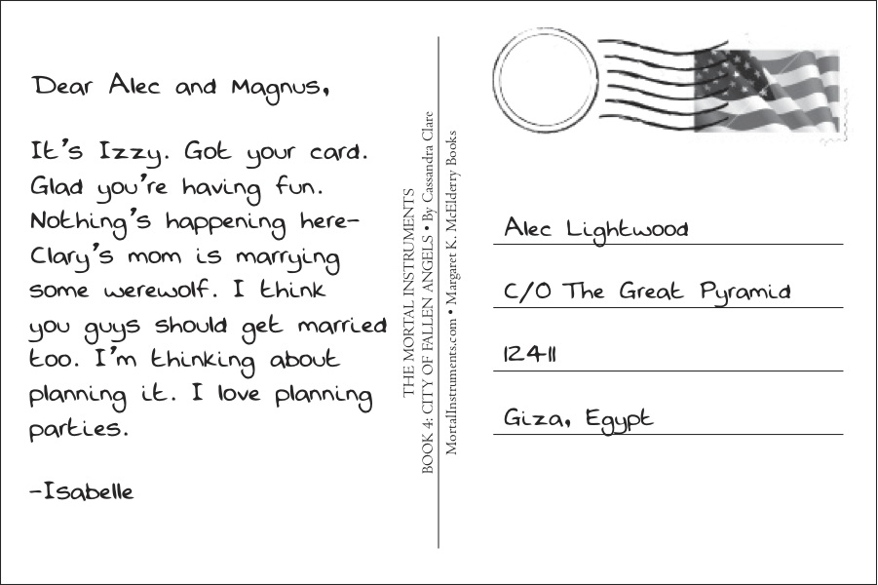

3. Choose one (or more) to do:
a) find out about one or more of Madrid’s famous landmarks.
b) draw/paint a picture of one of these landmarks.
c) Write a postcard to me about your visit to the landmark/s.

