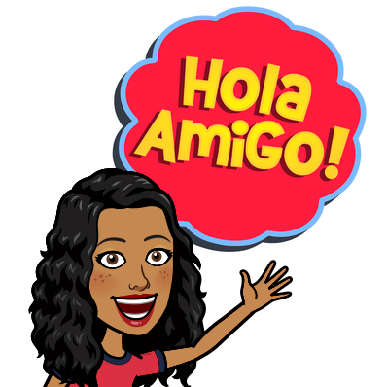
Today we are going to take look at Flamenco dance and music of Spain.

1. Watch
https://www.bbc.co.uk/programmes/p011mw7s
Spanish Flamenco BBC clips



2. Answer the Questions on Educandy:
https://www.educandy.com/site/resource.php?activity-code=26285

or move on.

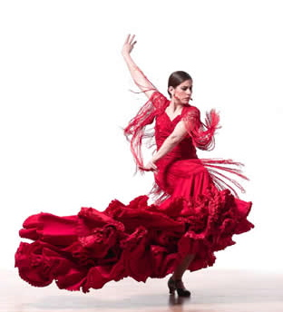

1. What do you think of the music? How does it make you feel?
2. What do you think of the dancing? How does it make you feel?
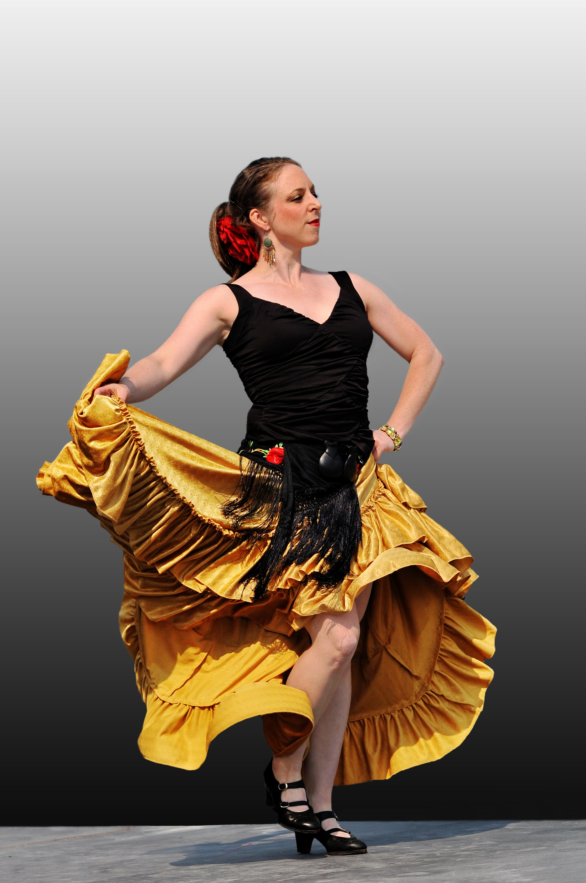
3. Look at some costumes for Flamenco dancers for both men and women.
Draw / paint a Spanish Flamenco dancer.
4. Have a go at Flamenco
dancing here:
https://www.youtube.com/watch?v=JbmgOfv84bg
https://www.youtube.com/watch?v=RhHFmbYaVAI

