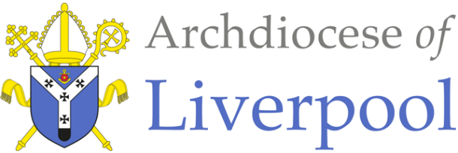
Belonging – A Sacramental Topic
*Note to parents.
This work comes from the Come and See Religious Education programme which is taught in all Catholic schools in the Archdiocese of Liverpool. We have given a general guide to the learning opportunities that your child may have come across in school and have only suggested and selected a small amount of the programme. The activities aim to keep Religious Education practical and fun. They are in Year groups however, there is no harm in completing other lower year group work as well as this will help your child to remember and strengthen their learning.
The first part of learning is called – EXPLORE. This shares your child’s everyday experiences and helps them to see how the Catholic faith is lived in their everyday lives as the theme progresses. The second part, called – REVEAL shares bible stories, religious teachings, lives of saints etc. that can relate to their everyday life. There are suggested activities for each section. Choose those you wish to do and record them as best as you can sending any work undertaken to school.
This theme is a Sacramental theme and focuses on the Sacraments of Baptism (and Confirmation, Marriage and Holy Orders). We understand that not every child or parent will have been baptised, so alongside this document are notes about the Sacrament of Baptism that you may find useful. All the other information you will need is here.

EYFS - WELCOME - EXPLORE
What it is to welcome and be welcomed

- Children may begin to talk about their own experiences and feelings of being welcomed.
- Children may be able to say what they wonder about how they can make others feel welcome.
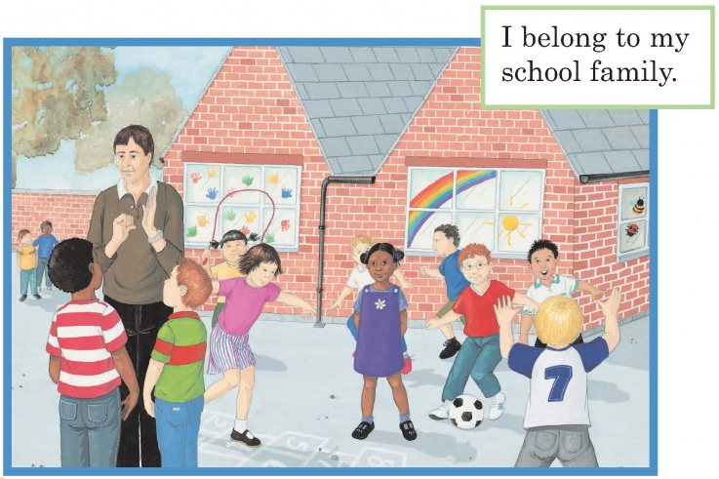

- Ask your child how their school and their teacher made them feel welcome when they started school in their new class. Talk about how they felt at the time.

- Talk about other ways of welcoming people into your house and how we make people feel welcome. How does that make us feel?

Activities:

- Role play inviting a friend to tea and find ways to make them feel welcome.

- Make and decorate a ‘welcome’ sign or mat for your front door using a symbol of welcome that would make someone feel welcome.

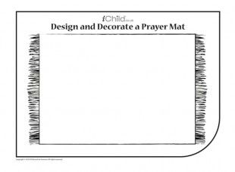
WELCOME

EYFS - WELCOME - REVEAL
Baptism: a welcome to God’s family

- Children may recognise some religious signs and symbols used in baptism.
- Some children may begin to use some religious words and phrases from the Rite of Baptism.

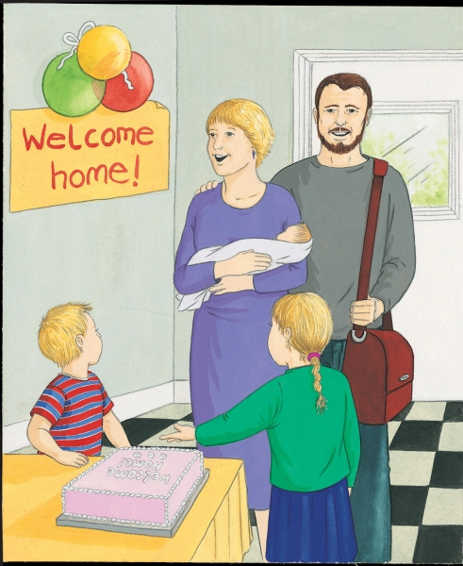
- As a parent, talk about how you welcomed your new baby child into your family at home. How were you and the baby made to feel welcome? Talk about the feelings of everyone in the family.

- Share photographs and any keepsakes you have of this.

- Recall how we show we are special by being given both an individual and family name as a sign of welcome to our family.

- Talk about how important a new baby is in a family and the love and joy they bring.

Activity:

- Draw a picture of your own family and talk about how you feel close to each other.
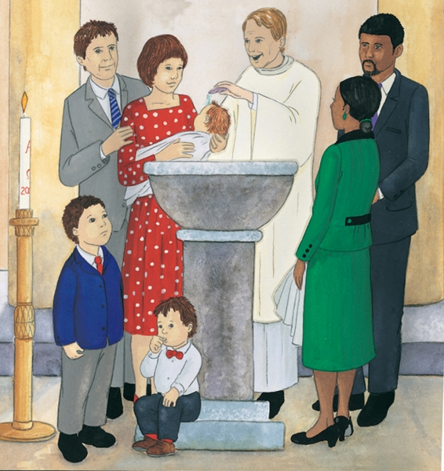
- If your child has been baptised, talk about how they were welcomed into God’s family through Baptism.

- Talk what happened at their Baptism focusing on the water and who was there and what they did. , Use the words the priest said: ‘N, I baptise you in the name of the Father and of the Son and of the Holy Spirit.’ (N- insert child’s name).

- Share photographs of their Baptism if you have any.

- Read this story to your child:

Matthew’s Baptism:

Philip’s mum, dad and little brother, Tom went to church with baby Matthew. It was baby Matthew’s Baptism. Auntie Sarah and Uncle Dave were going to be Matthew’s godparents. Godparents are people who promise to help parents to teach the baby all about Jesus and how to be his friend. Father Devine welcomed them to church and asked them, “What name have you given your child?” Mum and dad answered, “Matthew.”

The family gathered round the baptismal font and watched Father Devine pick up a little shell and dip it into the water. Mum held Matthew over the font and Father Devine poured water over Matthew’s head saying, “Matthew, I baptise you, in the name of the Father and of the Son and of the Holy Spirit.” Auntie Sarah put a white shawl around Matthew and Father Devine said, “Receive this white garment.”

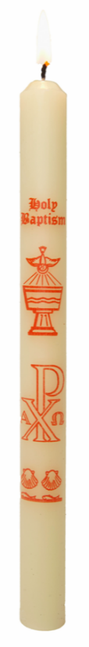
After church all the family gathered together for a party to celebrate Matthew’s baptism – his welcome into God’s family.

Activities: (Choose as many as you would like to do)

- Talk about the following and find them in the picture above:
Godparents, candle, font, water, white garment.

- Make a Baptism candle with a name and symbols of Baptism on it.

- Design a Baptism certificate for Matthew’s Baptism

- Encourage your child to recall what they heard in the story and role play
Matthew’s Baptism. You will need to provide a candle, a white garment, a doll, a bowl and some water.
Ask them to repeat the words of Baptism that the priest used.

- Have a Baptism party to celebrate!

At the end of all the work you have done about WELCOME, say together: Dear God, help us always to show a welcoming smile to others. Thank you for welcoming people into your family in the Sacrament of Baptism. Help them/us to be good members of this family. Amen!

