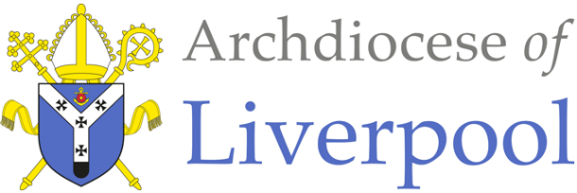
Belonging – A Sacramental Topic
*Note to parents.
This work comes from the Come and See Religious Education programme which is taught in all Catholic schools in the Archdiocese of Liverpool. We have given a general guide to the learning opportunities that your child may have come across in school and have only suggested and selected a small amount of the programme. The activities aim to keep Religious Education practical and fun. They are in Year groups however, there is no harm in completing other lower year group work as well as this will help your child to remember and strengthen their learning.
The first part of learning is called – EXPLORE. This shares your child’s everyday experiences and helps them to see how the Catholic faith is lived in their everyday lives as the theme progresses. The second part, called – REVEAL shares bible stories, religious teachings, lives of saints etc. that can relate to their everyday life. There are suggested activities for each section. Choose those you wish to do and record them as best as you can sending any work undertaken to school.
This theme is a Sacramental theme and focuses on the Sacraments of Baptism (and Confirmation, Marriage and Holy Orders). We understand that not every child or parent will have been baptised, so alongside this document are notes about the Sacrament of Baptism that you may find useful. All the other information you will need is here.

YEAR 6 - VOCATION AND COMMITMENT – EXPLORE Commitment in life

- Children may be able to show they understand what it means to be committed and be able to express why people make commitments.
- Some children will be able to show how their own and others’ commitment to the service and care of others is influenced by beliefs and values.

- Whatever you do in life, you need commitment to do it well. It is not only the high-profile jobs that require it. Whether you are a cleaner or a scientist, you can be committed and do your job really well.
- Think about some of the jobs people do - some paid and some voluntary. Copy this chart, complete it and add more jobs to the list.

Job | What does it involve? | What is the commitment? | What are the personal risks, if any? | How do you measure this commitment?
Parent

Doctor
Firefighter
Lifeboat crew

- Talk about why people choose to do these jobs and what level of commitment is needed for each.
- Discuss what makes a person committed to doing their job and how they show commitment to serve others in the jobs they do.
- Talk about what you and your child are committed to doing and how it feels to be committed and dedicated to something.

Activity:

- Research the training and level of commitment required to be a doctor or a member of a helicopter search and rescue crew or a member of a lifeboat crew.

- Make an advert for one of these jobs and in it, specify what qualities the applicant should have, what values they must adhere to and what they should be prepared to commit to.

YEAR 6 - VOCATION AND COMMITMENT – REVEAL
The vocation to the priesthood and religious life

- Children may be able to give reasons why Christians fulfil their baptismal promises by answering God’s call through their chosen vocation in various ways, including a vocation to the priesthood.
- Children may be able to show they understand how religious belief shapes the lives of Christians, in a variety of ways, through their chosen vocation notably through the priesthood.
- Children may be able to give reasons for the signs and symbols used in the Sacrament of Holy Orders.

- Like people who commit themselves to be friends or to be married, anyone entering religious life makes a commitment. People who get married make vows to each other and commit themselves to family life. A person entering religious life also makes a vowed commitment.

- Some people’s vocation is to marriage or the single life or to the religious life. Some people’s vocation is to become a priest. A priest chooses to follow Jesus in the service of others in the Church. This is his response to God’s call to a life lived with love for God’s people. The apostles were called by Jesus to follow him and, in response, they left everything to be with him. This is also true of every Christian and is especially true of the call to be a priest.

- If the man feels that God is calling him, he will need to apply and to be accepted by the bishop of the diocese. If he is accepted, then he will begin many years of training in a seminary. During this time, he will have the opportunity to pray, learn more about his Faith, how to celebrate the Sacraments, communicate the Good News and have experience of living and serving in the parish community.

- At the end of the training, diocesan priests make promises of celibacy and obedience to their bishop. They do not make a vow of poverty, but they do try to live simply so they can be of service to God’s people.

- At the end of his training, he will be ordained – that is he receives the sacrament of Holy Orders or Ordination. This sacrament is celebrated during Mass and it is the bishop who ordains. The man being ordained is called an ‘ordinand’. The ordinand’s family and friends gather for the celebration.
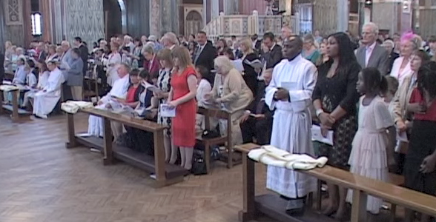
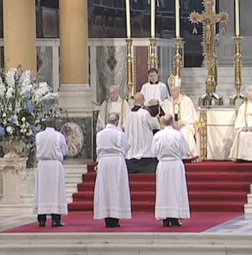

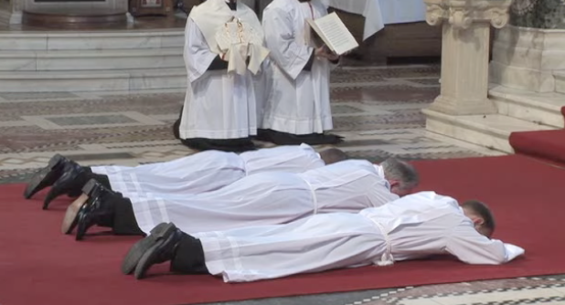
- After the Gospel and homily, the ordinand is called forward from the parish family to stand in front of the bishop who asks him if he has freely chosen to be ordained and will promise to be a good and faithful priest. The ordinand lies flat on the ground in front of the altar while the Litany of the Saints is sung.

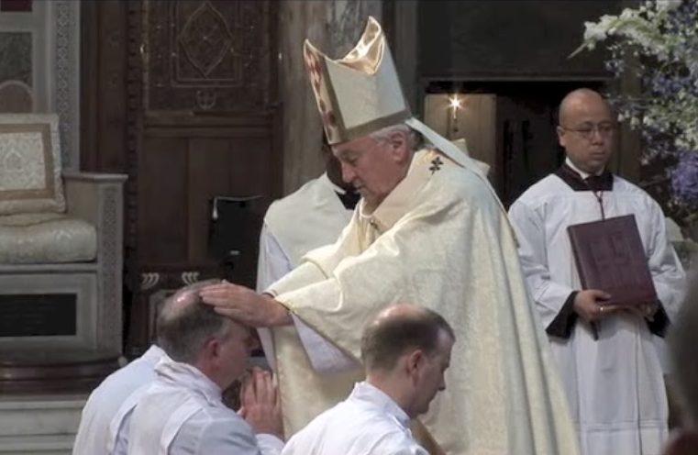
- The bishop lays his hands on the head of the ordinand and prays the prayer of consecration (a prayer asking God to bless and make holy the ordinand, to help him be a faithful witness and co-worker with the bishop.) The man is now ordained as a priest.

- The newly ordained priest receives his stole, (the garment that goes round his neck) and the chasuble, which is the top coloured vestment worn for the celebration of Mass.

- The bishop anoints the priest’s hands with the Oil of Chrism to make them holy. He is given a paten with a host on it and a chalice with wine in it. The bishop says, ‘Accept from the holy people of God, the gifts to be offered to him’.
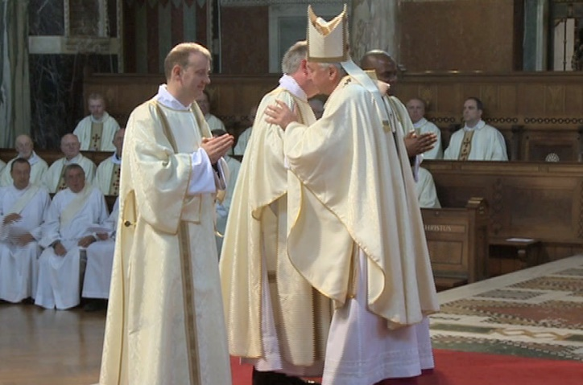

- The bishop and all the other priests present give the new priest a sign of peace to welcome and congratulate him. The newly ordained priest is now prepared to serve the family of God in the parish to which the bishop has appointed him.

Activities:

- Write a reply to a letter in response to a man who is wondering if he has been called to be a priest and wants to understand what is required in becoming a priest and how this would shape his life.

- Give the children a set of pictures (above) of the different stages in the ordination. Ask them to put them in order, saying what is happening in each, why it is happening and its significance.

- Research the life of Saint John Mary Vianney, the patron saint of priests. Write a prayer asking him to guide the life of a priest. Say this prayer at the end of all the work in this topic.

