St Laurence’s Catholic Primary School
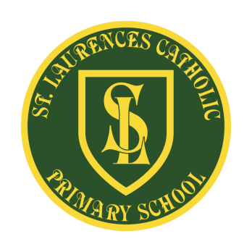
E Mail: stlaurence@knowsley.gov.uk
Website: www.stlaurences.co.uk
Twitter: @slaurences
Leeside Avenue
Southdene
Kirkby
L32 9QX
Telephone: 0151 546 4733

Headteacher: Mrs SJ Carroll-McKevitt
Date: November 2022
Dear Parents/Carers,
We have recently invested a lot of money in new books for the children to read in their Phonics lessons, and to bring home to read.
Whilst we are sure that you will do your utmost to look after the books, if they are lost or damaged then we will have to make a charge of £10 per book. This is to ensure that there are enough copies for other children to read.
If your child has not brought their books back into school, can you please return them ASAP. All staff have a record of missing books.

Many thanks for your support with this.

Mrs Farrell.

